|  |  |
| --- | --- |
| Galgotia Logo | **GALGOTIAS UNIVERSITY**  **Plot no.2, Sector-17A, Yamuna Expressway,**  **Greater Noida, Gautam Buddh Nagar U.P., India** |
|  |  |

**School of Computer Science and Engineering**

**Mini ORkut**

**ABSTRACT**

The main objective of the Orkut using java project is to allow the users to communicate (or chat) with each other. This project is a mini project. Hence, it includes only basic features of the real orkut website. The users can access this website through internet.

When a user runs ORKUT project, then orkut homepage will appear. This home page contains many features such as two label fields, two text fields and two buttons. User name and password are two text fields, where the user can enter his username and password respectively. Login and New user are two buttons.

If the user is a new one then he will hit the ‘new user’ button. Then, register frame will be displayed. The traditional orkut home page with the photos of creators of orkut project is displayed on left side of this page. Here, he can provide his details and can register to this website. After successful registration, he can login to this system. Then, he can communicate with his friends. The existing user can type his username and password and hit the login button. If username and password match with the database values then his homepage will be displayed. If they are not matching, then ‘login failed’ frame will be displayed.

**Introduction**

We plan to develop a live chatting module based on the group https://www.orkut.com .We studied the working of orkut in detail..and tried to extract important features in our project. Basically our project works on LAN while the real orkut works on internet. But the basic idea behind it is the same..that is to provide the user with a enjoyable and good-to-look means of communication.

The real orkut provide the users with lot of options such as add as a friend ,write scraps, add to crush list ,write testimonials, joining communities etc..but we plan to include only the basic options in our project which deal with communication purpose or rather the chatting purpose .

Hence our project will contain basic functions like add as friend, write scraps and uploading photo. Like in real orkut ,user will create his own account containing a unique username and password ,which he only can access .

If the user is a new one then he has to fill application form containing his personal information. Then only the user can log on to the system. The user can write scrap to any member of (our project) orkut at any point of time. He is also eligible to upload the photo of his choice, which can be viewed by all the members of (our project) orkut .

The album feature which is present in real orkut is not taken in our project as there is as such no need of it. Also users are allowed to upload only one photo of his choice, which will be displayed on his homepage .

The user, on finding his friend as member of(our project) orkut can send a friend's request to him. Now it depends on user's friend whether to accept him as a friend or to reject him..this is totally in hands of the user's friend!!!

All the user's friends will be displayed on rightmost top of our screen.so that he can know who are online and who are not?.The user on finding a person to be online can write scraps to him.(Even if user's friend is offline, user can write scraps to him.these scraps will be viewed by user's friend when he will access his account).

Scraps can be written by visiting the profile of his friend and writing scraps in his scrapbook..Similarly a person can view scraps written to him in his own scrapbook.User is eligible to delete the scraps written to him and the scraps written by him. Other's scraps can't be deleted!!!!!!!

If the user is currently online, then he has to refresh the page constantly so as to view the new changes made to his account(not his personal info)for eg :if new scrap is written by his friend, then the user has to refresh his scrapbook page so as to view this new scrap.thus chatting can be done on orkut.

The user ,at any point of time, can change his personal information or his photo!!!

To implement this project, sufficient knowledge of JAVA is needed. Along with that, knowledge of socket programming and JDBC is must. Lets see how they are implemented.

• Socket programming is needed to connect PC's together and exchange information between them.

• The code of the project has to be done in JAVA hence knowledge of JAVA is must!!!!

• Also all the information is to be stored in database, hence to connect the database with our source code, knowledge of JDBC is needed.

**OBJECTIVE**

The main objective of developing Orkut Java project is to create user-friendly friend Circle. This java application gives basic features of Orkut application.

This project contains basic communication between the friends like send messages, view other profiles, create group, create events, create photo albums, create profiles, add new friends, search friends.

This project creates security to the social networking site.

Orkut's features and interface changed significantly with time. Orkut initially allowed anyone to visit everyone's profile, unless a potential visitor was on a person's "Ignore List". Each member was also able to customize their profile preferences and restrict information that appears on their profile from their friends and/or others. Another feature was that any member can add any other member on Orkut to his/her “ignore list”.

When a user logged in, they saw the people in their friends list in the order of their login to the site, An Orkut user was also able to add videos to their profile .Users could also use a "like" button to share interests with friends.

**MODULES DESCRIPTION**

**ACCOUNT OBJECT:**

Account Object Each user who wants to use the site must create an account. This is the head class that all other objects use to determine what a user does and when the user did it. The account’s information has four purposes: hold the login information, hold friend information, hold proﬁle information, and hold privacy information with such a large amount of information to keep track of, the Account class would be very large and diﬃcult to work with. There is the actual account class which keeps track of login information and friend information. The only time the Account class needs to be updated is when the user changes his/her username and/or password. All other settings are handled by the Account Details.

**Account Details**

An Account Details object is a helper class created whenever a new Account object is created. The object contains all the information that shows up in the user’s proﬁle. If the user wants to edit his/her information after the account creation then he/she can do it and it will reflect on their home profile page.

**MESSAGE:**

**A Message object is created when a user composes a new message to be sent to a friend. After it is conﬁrmed that the friend is located in the database, the Message object adds its information to the database. When a user checks his or her inbox, a list of messages that were sent to the user will be shown in descending order of when they were received.**

**Wall Post**

**A Wall Post object works very similar to a Message object. The only diﬀerence is that the Wall Post objects are viewable to all friends of the user. If a user adds a wall post to his or her own account, their status will change to the new wall post. The user can post any number of pictures on their wall. He/She can also upload the profile picture so that others will know the user identity if they are willing to make friends.**

**FRIENDS :**

**The most important feature is being able to add and remove friends. In our Social Networking site, making friends is a fairly straightforward process. Sending a friend request after clicking on Suggested friends, User A will send friend request to User B by clicking a button that says Add Friend then it will Send Friend Request. Clicking on it will send an alert to User B that User A wants to be a friend. The friend request will now be in the friends list of User B, where he/she can either accept it or ignore it, letting it sit there indeﬁnitely. If user B accepts the request, User A will be added to User B’s friends list and vice versa. Being friends has its advantages. For example, only friends can chat to each other. Also, friends can view any part of a proﬁle that is marked as friends only. Finally, for a user to view his/her friends and incoming friend requests, he/she just clicks on the friends tab which brings up a frame.**

**ACCOUNT CREATION :**

**When a user accesses the site for the ﬁrst time, he/she must create an account before using any of the site features. The account creation process is broken into three sections. The ﬁrst section deals with the Sign up information and is required for the user to ﬁll out. This includes the email, password, and password conﬁrmation. The purpose behind the password conﬁrmation is to ensure that the user didn’t accidentally mistype when creating a password. The second section deals with information about who you are such as name, date of birth, and email. Most of these ﬁelds are optional except for your name and gender. It wouldn’t be much of a social network if everyone was named anonymous. The ﬁnal section deals with information about the users likes and dislikes, such as interests and activities. Unlike the other two sections, this section is completely optional.**

**CHATTING :**

**One of the advantages of having friends is the ability to have live communications with them via chat. When a friend is online, he/she will appear in the chat tab as an available friend to chat with. To start a chat session, simply click on the name of the friend which will begin a new chat session. The little bar at the bottom will change from chat disabled to chatting with friend name as seen in the ﬁgure below. Also, the friend receiving the chat will get a notiﬁcation that a new chat session has started. Then the two friends can chat with each other until one or both log out. When a user clicks on a friend name to begin a chat, a chat request is sent to the database. The name of the person is hown at the top bar we can also clear thw chat if we want to otherwise previous chats will display.**

**Messaging is implemented by storing a record of the message in the server. First a message object is constructed that takes in the to and from accounts, the message body.The message body is retrieved from a user submitted form, the from account is retrieved from the user session, and the receiver account is retrieved from the recipient email address. The receiver account is validated, to ensure the sender didn’t try to send a message to a non-existent receiver. Finally, the new message is stored in the server. Retrieving messages sent to the user is a simple method of querying the server for any messages that have been sent to the user, and this is done by checking the receiver id of each message against the account id of the user. Any matches are returned to the inbox of the user as shown in the ﬁgure below.**

**MODULES DESIGN AND ARCHITECTURE**

**ER Diagram**

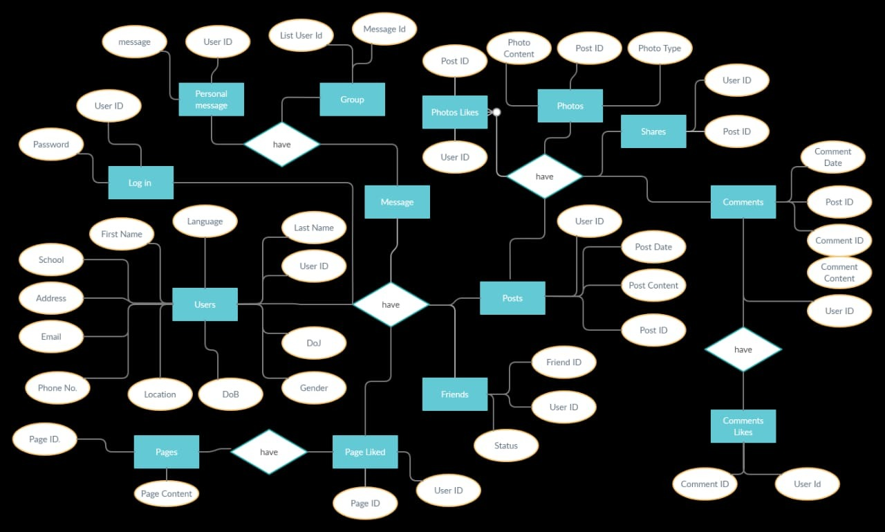

DATA FLOW DIAGRAMS

A graphical tool used to describe and analyze the moment of data through a system manual or automated including the process, stores of data, and delays in the system. Data Flow

Diagrams are the central tool and the basis from which other components are developed. The transformation of data from input to output, through processes, may be described logically and independently of the physical components associated with the system. The DFD is also know as a data flow graph or a bubble char

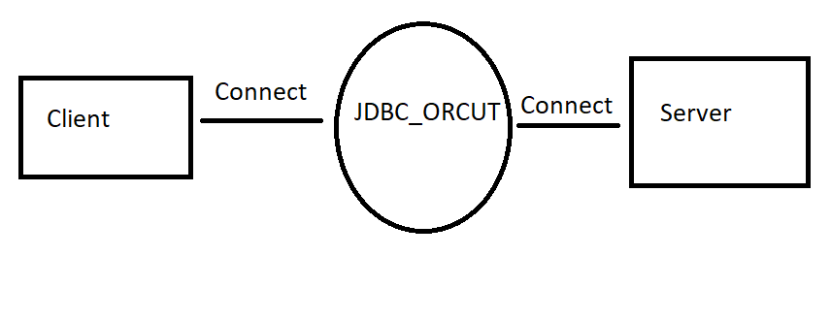

**MODULES IMPLEMENTATION AND SOURCE CODE**

**DATABASE:**

**Database Data base is used to store the relevant information of the individuals. A database is a collection of rows and columns in which rows indicates the tuple and column indicates the domain of table. Database design is the process of producing a detailed data model of a database. This logical data model contains all the needed logical and physical design choices and physical storage parameters. Need to generate a design in a data definition language, which can then be used to create a database. A fully attributed data model contains detailed attributes for each entity. The term database design can be used to describe many different parts of the design of an overall database system. Principally, and most correctly, it can be thought of the logical design of the relation of the base data structures used to store the data. In the relational model these are the classes and named relationships. However, the term database design could also be used to apply to overall process of designing, not just the base data structure, but also the forms and queries used as part of the overall database application within the database management system (DBMS).**

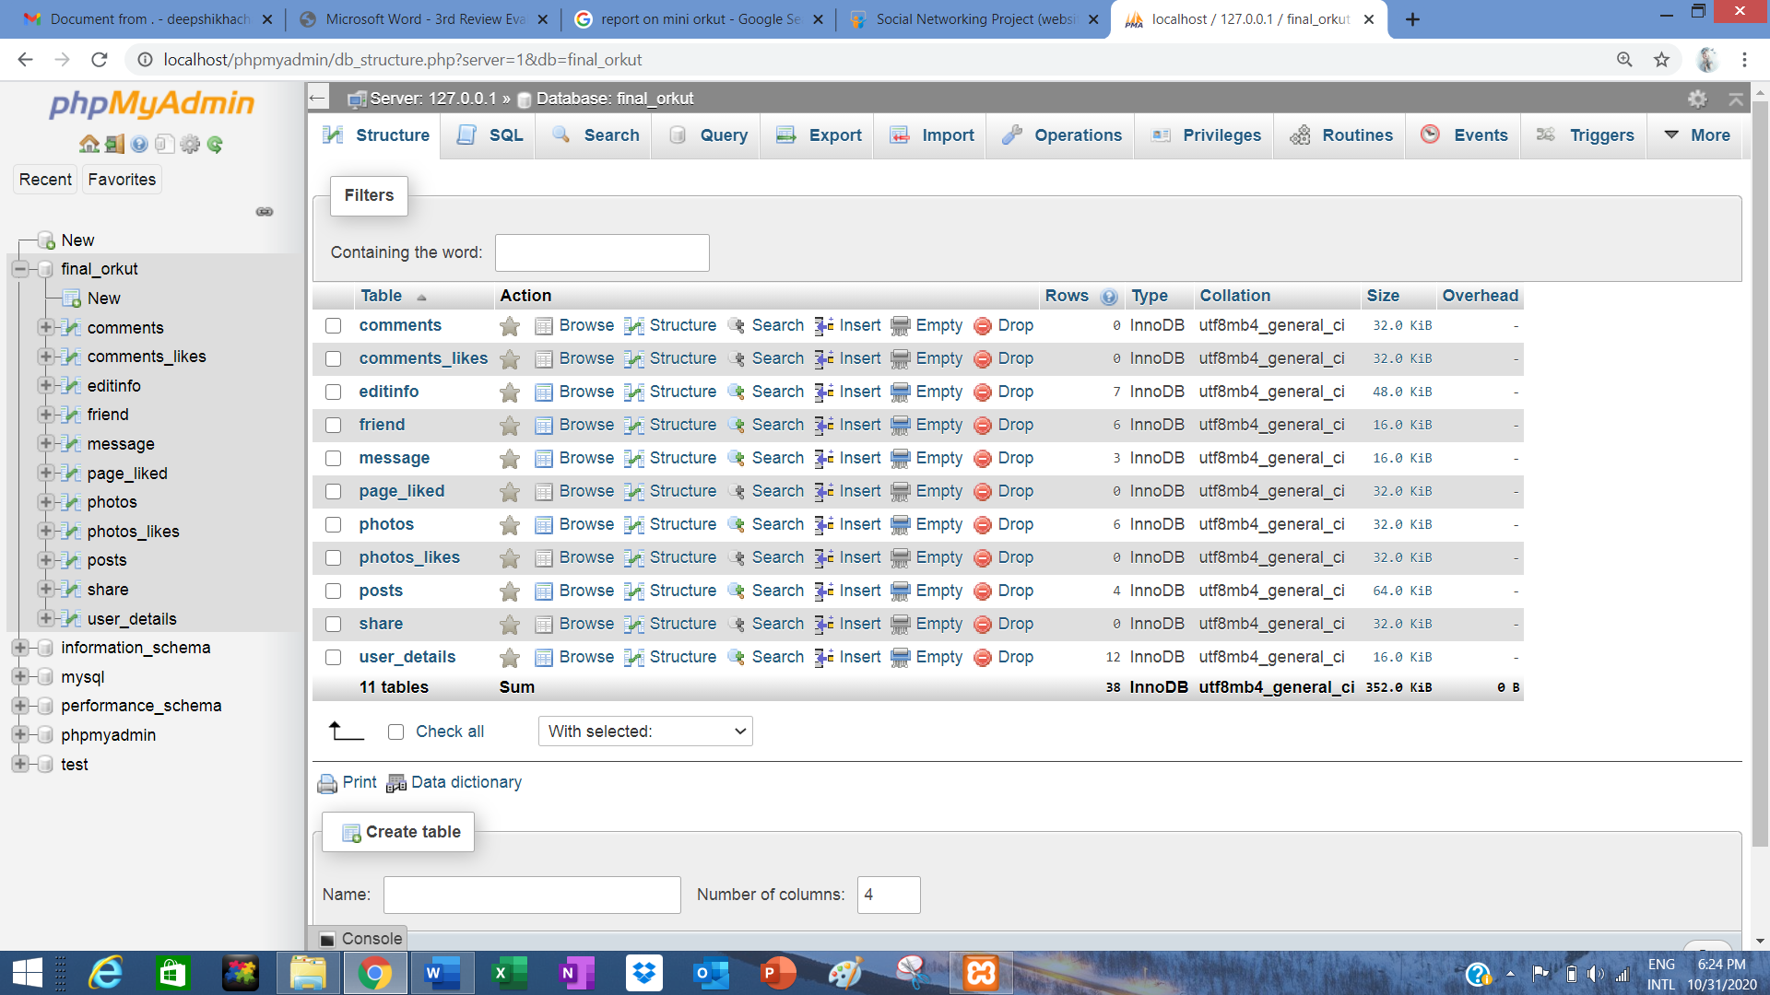

**COMMENT**

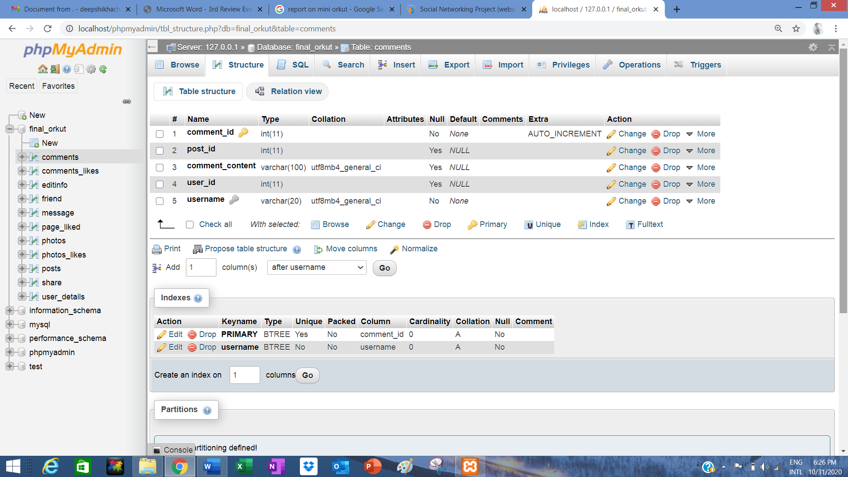

**EDIT INFO**

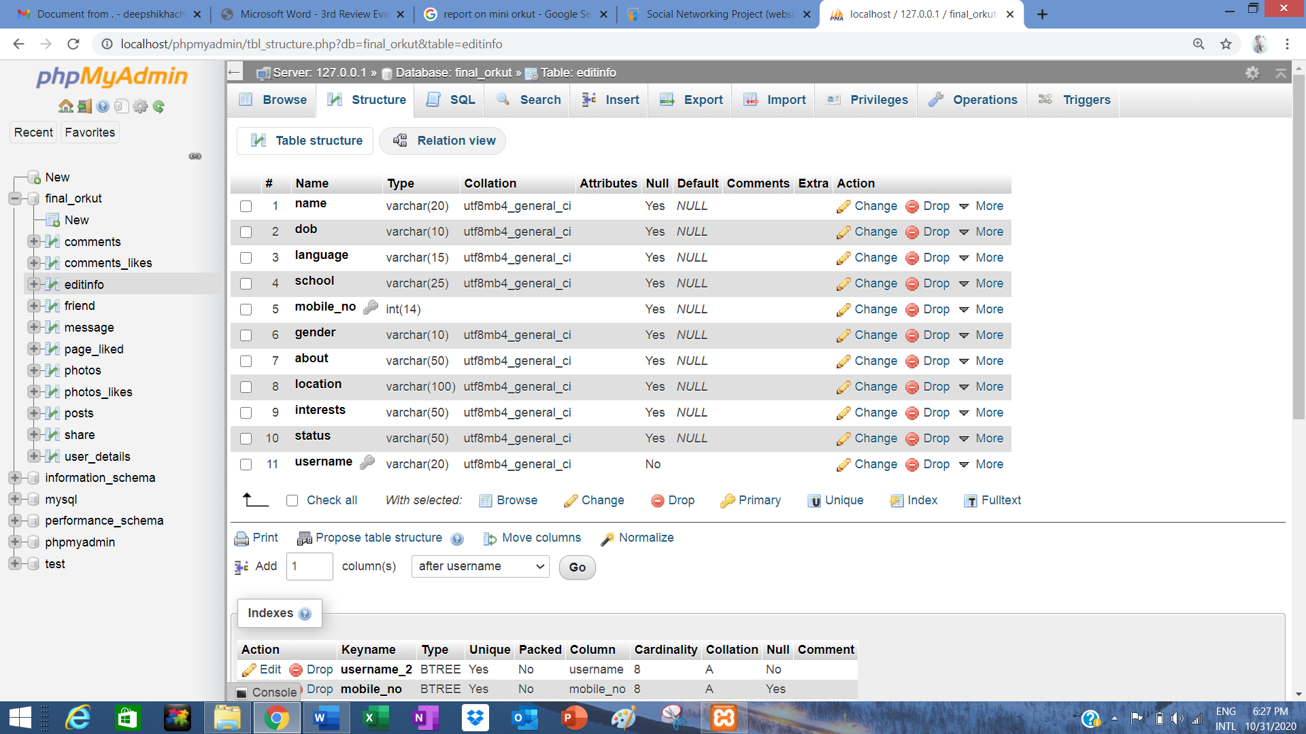

**FRIENDS**

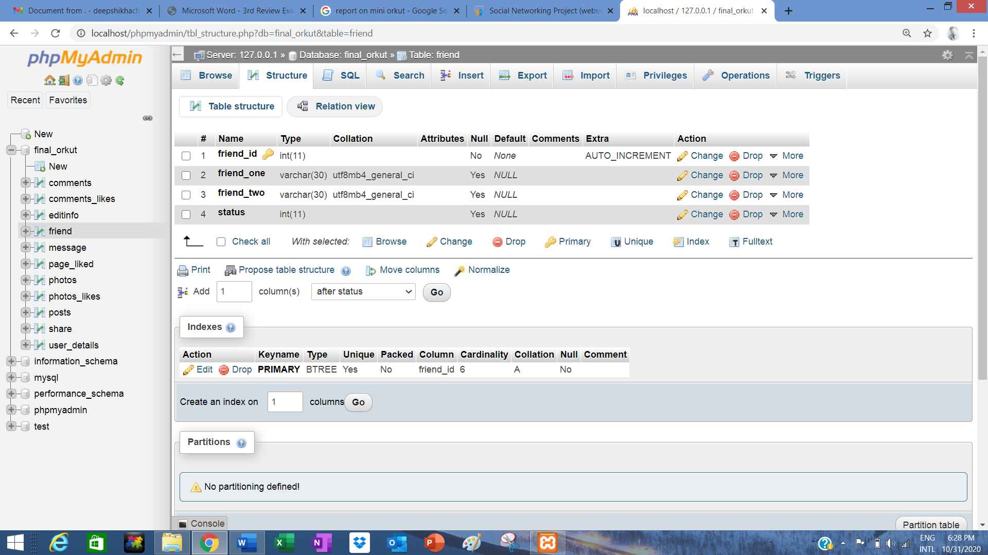

**MESSAGE**

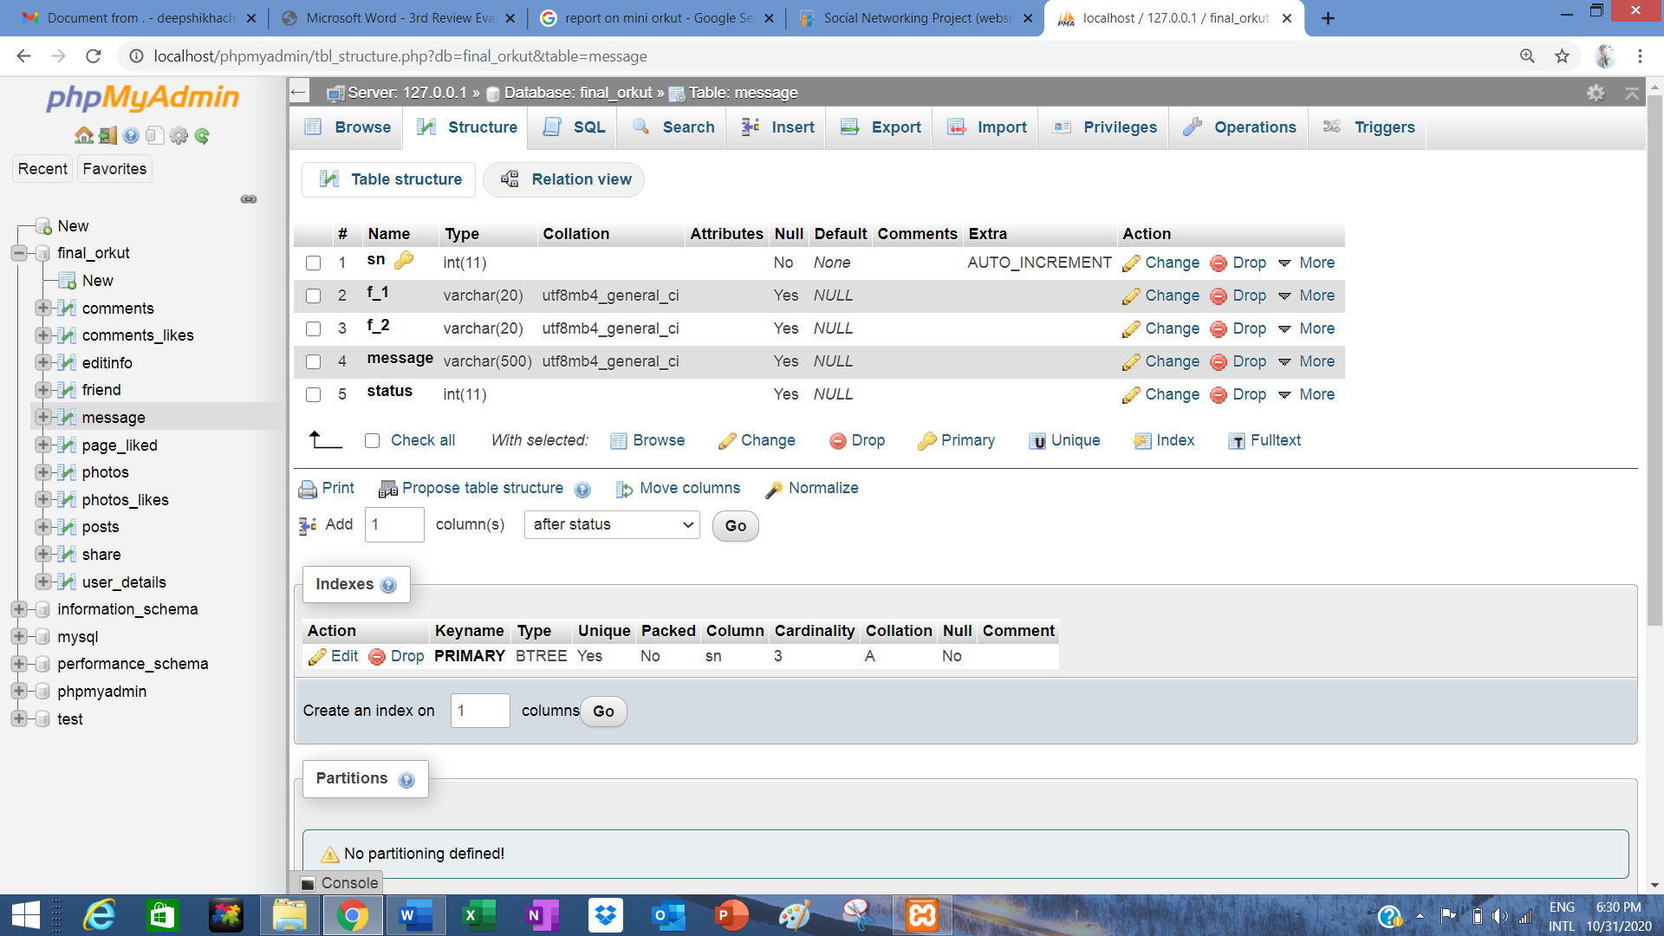

**PAGE LIKED**

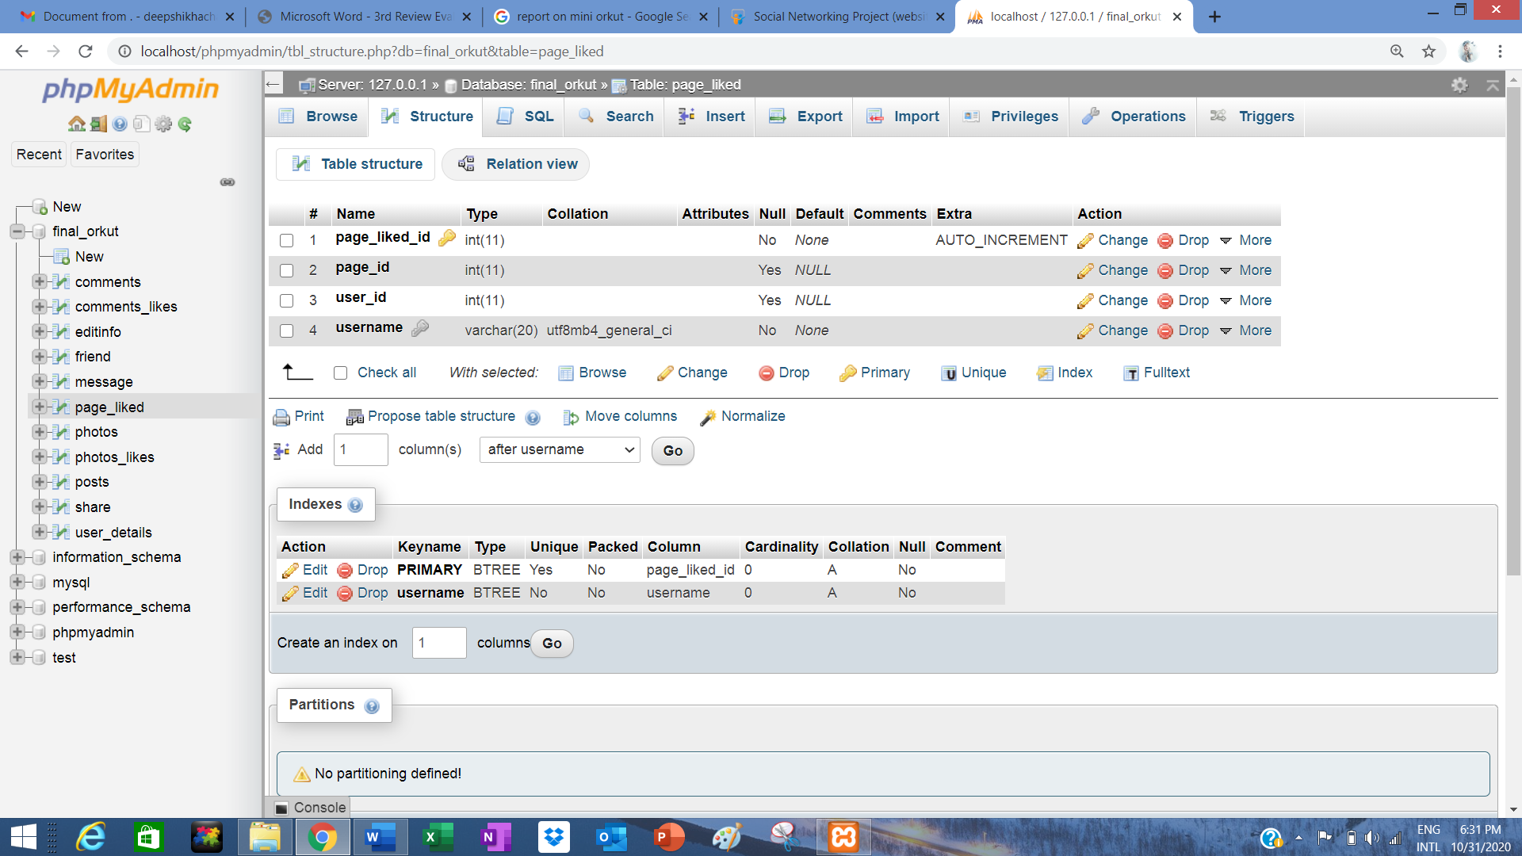

**PHOTOS**

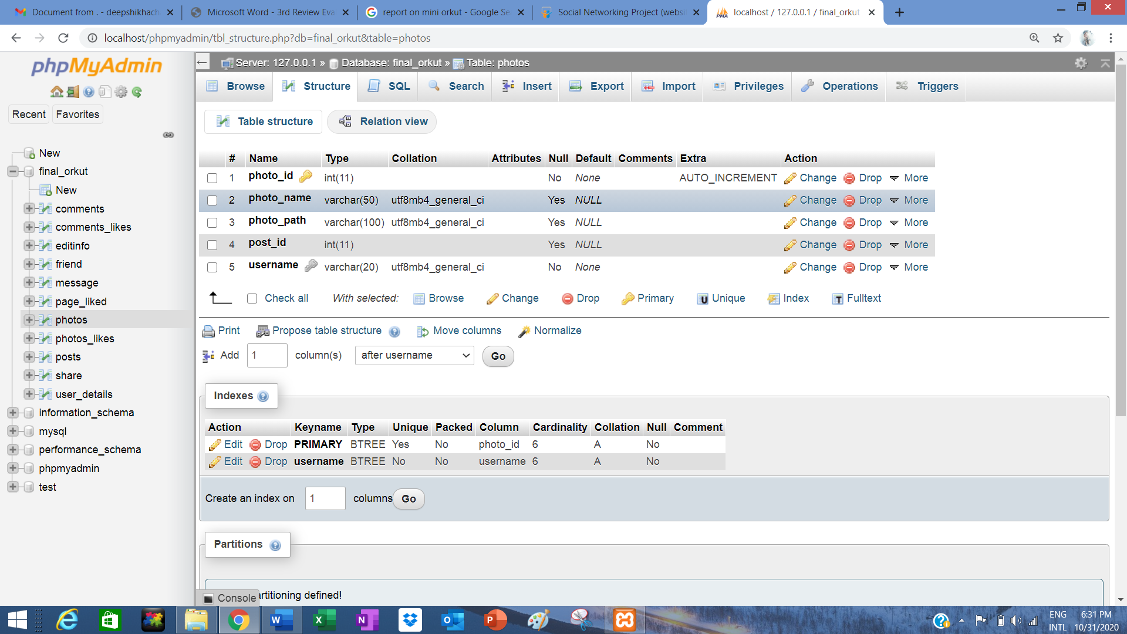

**PHOTO_LIKES**

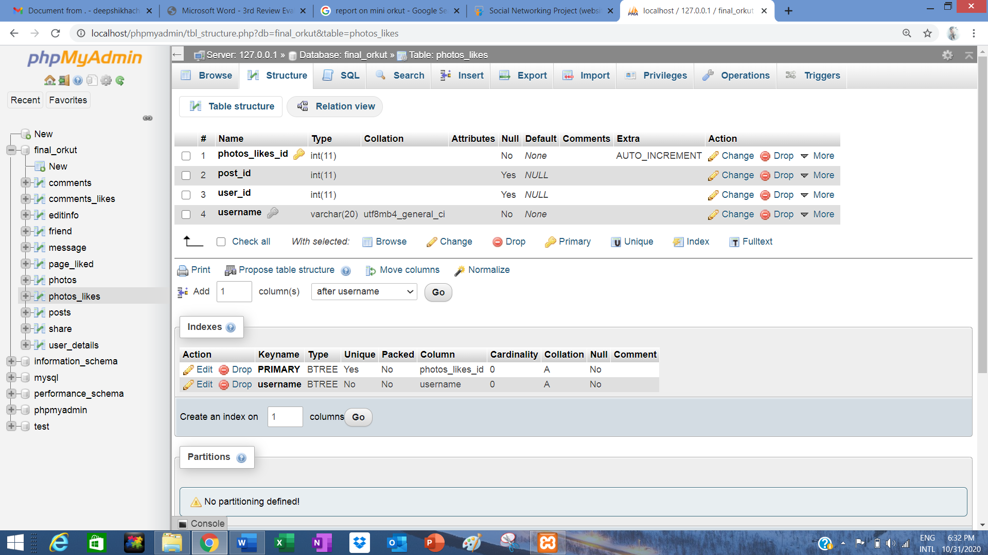

**POSTS**

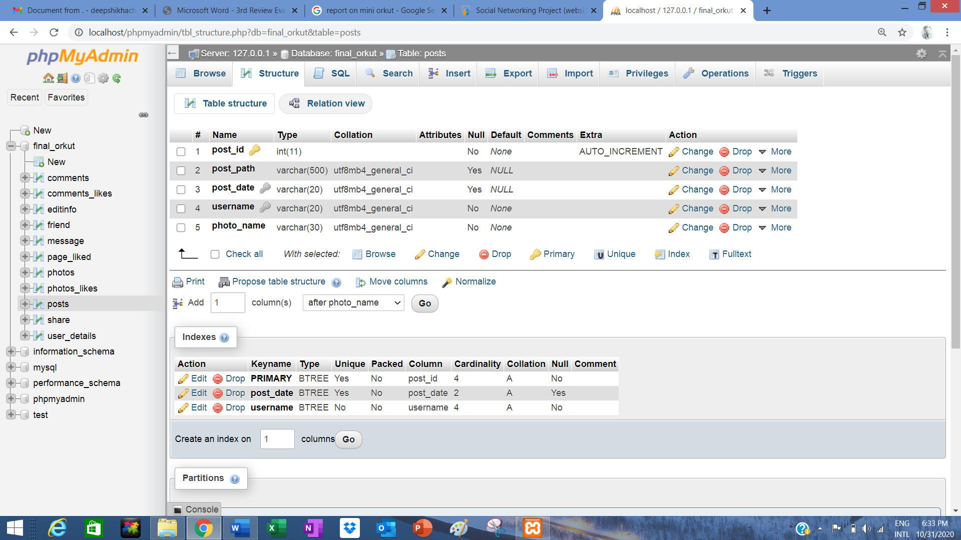

**USER DETAILS**

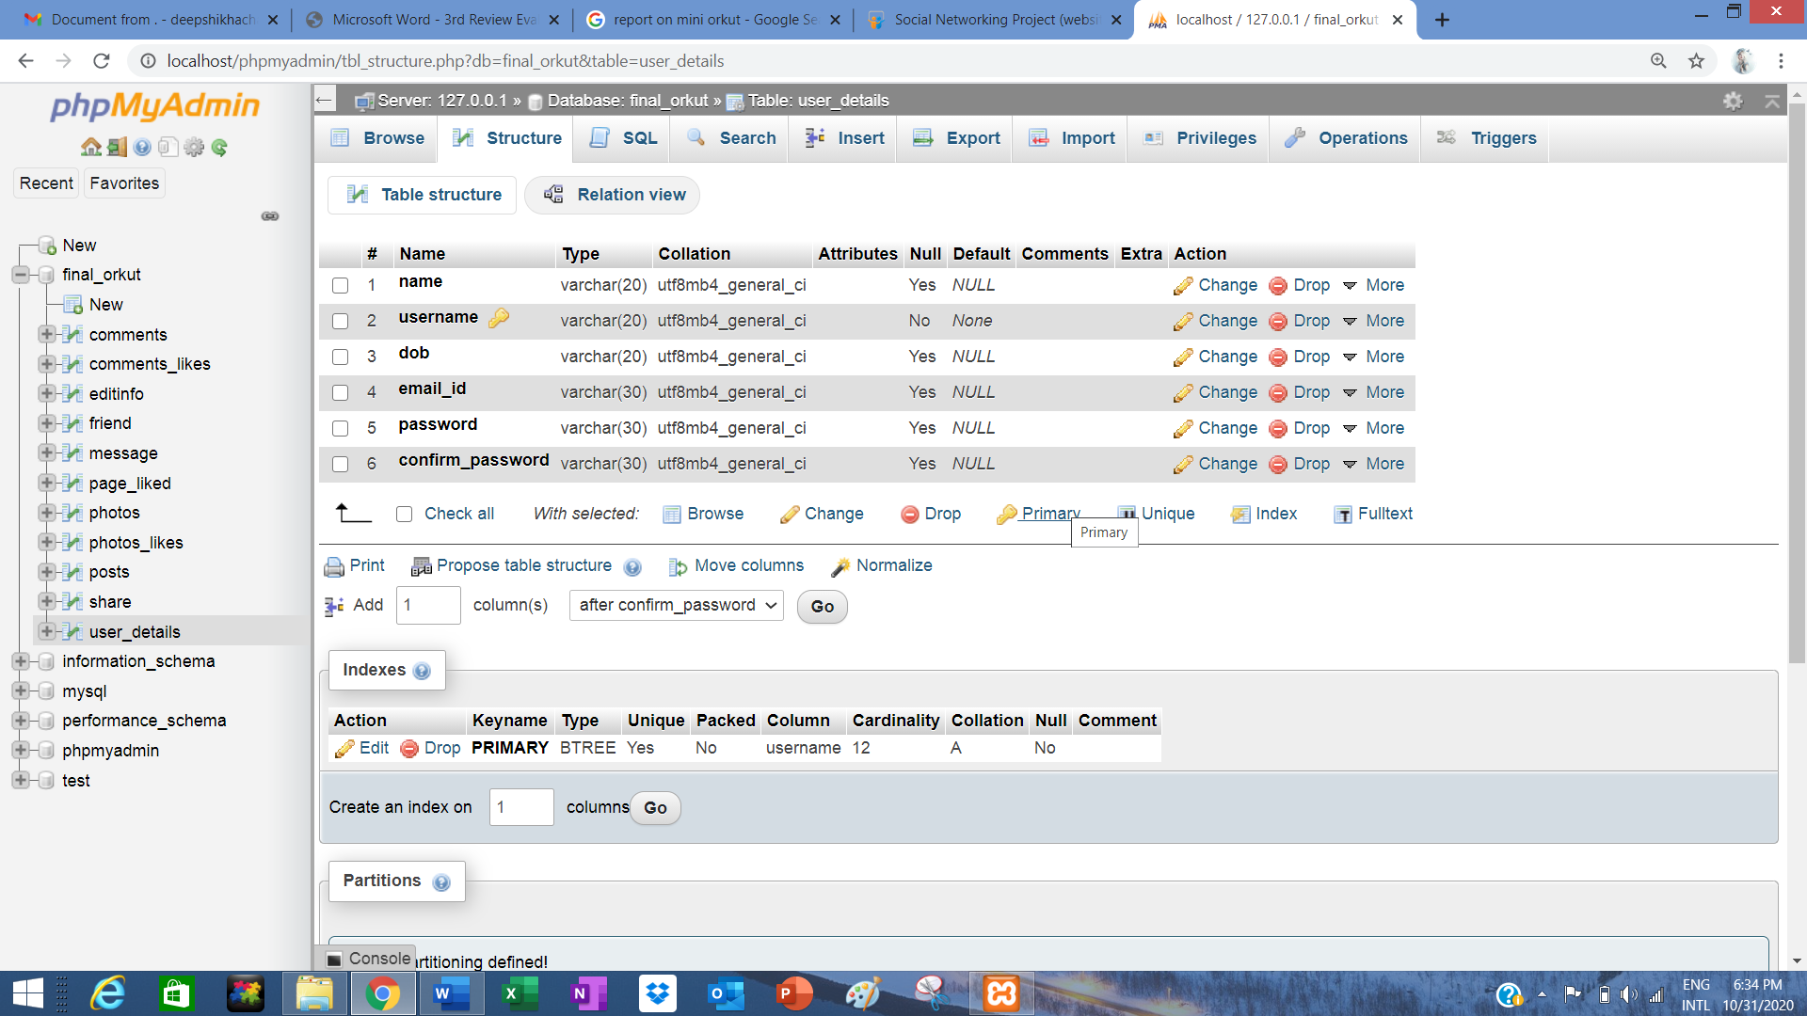

**IMPLEMENTATION DETAILS**

**SOURCE CODE:**

1. **HOME PAGE**

**package miniO;**

**import java.io.*;**

**import java.sql.*;**

**import java.util.logging.Level;**

**import java.util.logging.Logger;**

**import java.awt.Image;**

**import java.awt.event.ActionEvent;**

**import java.awt.event.ActionListener;**

**import java.io.File;**

**import javax.swing.*;**

**import javax.swing.filechooser.FileNameExtensionFilter;**

**public final class HOME extends javax.swing.JFrame {**

**Connection con = null;**

**static String USER_NAME;**

**public HOME(String user_name) {**

**initComponents();**

**con = dbConnection.con();**

**try{**

**USER_NAME = user_name;**

**System.out.println(USER_NAME);**

**PreparedStatement x = con.prepareStatement("select photo_path from photos where username=? ");**

**x.setString(1,USER_NAME);**

**ResultSet y = x.executeQuery();**

**if(y.next()){**

**System.out.println("pic is there");**

**System.out.println(y.getString(1));**

**homeprofile.setIcon(ResizeImage(y.getString(1)));**

**}**

**PreparedStatement z = con.prepareStatement("select post_path from posts where username=? ");**

**z.setString(1,USER_NAME);**

**//z.setString(2,USER_NAME);**

**ResultSet a = z.executeQuery();**

**if(a.next()){**

**post1.setIcon(ResizeImage(a.getString(1)));**

**//post2.setIcon(ResizeImage(a.getString(2)));**

**}**

**PreparedStatement q = con.prepareStatement("select post_path from posts where username=? ");**

**q.setString(1,USER_NAME);**

**ResultSet b = q.executeQuery();**

**if(b.next()){**

**post2.setIcon(ResizeImage(b.getString(1)));**

**}**

**PreparedStatement ps=con.prepareStatement("select * from user_details where username=? ");**

**ps.setString(1,USER_NAME);**

**ResultSet rs = ps.executeQuery();**

**if(rs.next())**

**{**

**name.setText(rs.getString(1));**

**dob.setText(rs.getString(3));**

**emailid.setText(rs.getString(4));**

**}}**

**catch(SQLException e2)**

**{**

**System.out.println(e2);**

**}**

**}**

**public ImageIcon ResizeImage(String ImagePath)**

**{**

**System.out.println("in image icon");**

**ImageIcon MyImage = new ImageIcon(ImagePath);**

**Image img = MyImage.getImage();**

**Image newImg = img.getScaledInstance(homeprofile.getWidth(), homeprofile.getHeight(), Image.SCALE_SMOOTH);**

**// Image newImg1 = img.getScaledInstance(post1.getWidth(), post1.getHeight(), Image.SCALE_SMOOTH);**

**// Image newImg2 = img.getScaledInstance(post2.getWidth(), post2.getHeight(), Image.SCALE_SMOOTH);**

**ImageIcon image = new ImageIcon(newImg);**

**// ImageIcon image1;**

**// image1 = new ImageIcon(newImg1);**

**/* ImageIcon image2;**

**image2 = new ImageIcon(newImg2);*/**

**return (image);**

**//return (image1);**

**}**

**HOME() {**

**throw new UnsupportedOperationException("Not supported yet."); //To change body of generated methods, choose Tools | Templates.**

**}**

**/\*\***

**\* This method is called from within the constructor to initialize the form.**

**\* WARNING: Do NOT modify this code. The content of this method is always**

**\* regenerated by the Form Editor.**

**\*/**

**@SuppressWarnings("unchecked")**

**// <editor-fold defaultstate="collapsed" desc="Generated Code">//GEN-BEGIN:initComponents**

**private void initComponents() {**

**jPanel1 = new javax.swing.JPanel();**

**homeprofile = new javax.swing.JLabel();**

**jPanel2 = new javax.swing.JPanel();**

**jLabel7 = new javax.swing.JLabel();**

**jButton8 = new javax.swing.JButton();**

**jButton9 = new javax.swing.JButton();**

**jButton10 = new javax.swing.JButton();**

**jButton3 = new javax.swing.JButton();**

**jPanel3 = new javax.swing.JPanel();**

**jLabel3 = new javax.swing.JLabel();**

**jLabel4 = new javax.swing.JLabel();**

**jLabel5 = new javax.swing.JLabel();**

**jLabel6 = new javax.swing.JLabel();**

**jLabel12 = new javax.swing.JLabel();**

**jLabel13 = new javax.swing.JLabel();**

**name = new javax.swing.JTextField();**

**dob = new javax.swing.JTextField();**

**emailid = new javax.swing.JTextField();**

**jPanel4 = new javax.swing.JPanel();**

**jLabel8 = new javax.swing.JLabel();**

**status = new javax.swing.JTextField();**

**post1 = new javax.swing.JLabel();**

**post2 = new javax.swing.JLabel();**

**jPanel5 = new javax.swing.JPanel();**

**jButton6 = new javax.swing.JButton();**

**jButton2 = new javax.swing.JButton();**

**jButton1 = new javax.swing.JButton();**

**jButton4 = new javax.swing.JButton();**

**jButton5 = new javax.swing.JButton();**

**jButton7 = new javax.swing.JButton();**

**setDefaultCloseOperation(javax.swing.WindowConstants.EXIT_ON_CLOSE);**

**homeprofile.setIcon(new javax.swing.ImageIcon(getClass().getResource("/miniO/profile.png"))); // NOI18N**

**homeprofile.setBorder(new javax.swing.border.SoftBevelBorder(javax.swing.border.BevelBorder.RAISED));**

**jPanel2.setBorder(new javax.swing.border.SoftBevelBorder(javax.swing.border.BevelBorder.RAISED));**

**jLabel7.setFont(new java.awt.Font("Comic Sans MS", 1, 18)); // NOI18N**

**jLabel7.setText("COMMUNITIES");**

**jButton8.setIcon(new javax.swing.ImageIcon("C:\\Users\\shivam\\Downloads\\shikha(documents)\\miniorkut\\images.png")); // NOI18N**

**jButton9.setIcon(new javax.swing.ImageIcon("C:\\Users\\shivam\\Downloads\\shikha(documents)\\miniorkut\\friends--v4.png")); // NOI18N**

**jButton10.setIcon(new javax.swing.ImageIcon("C:\\Users\\shivam\\Downloads\\shikha(documents)\\miniorkut\\unnamed.png")); // NOI18N**

**jButton3.setIcon(new javax.swing.ImageIcon("C:\\Users\\shivam\\Downloads\\shikha(documents)\\miniorkut\\login-icon-images-22.png")); // NOI18N**

**javax.swing.GroupLayout jPanel2Layout = new javax.swing.GroupLayout(jPanel2);**

**jPanel2.setLayout(jPanel2Layout);**

**jPanel2Layout.setHorizontalGroup(**

**jPanel2Layout.createParallelGroup(javax.swing.GroupLayout.Alignment.LEADING)**

**.addGroup(jPanel2Layout.createSequentialGroup()**

**.addGroup(jPanel2Layout.createParallelGroup(javax.swing.GroupLayout.Alignment.LEADING)**

**.addGroup(jPanel2Layout.createSequentialGroup()**

**.addGap(33, 33, 33)**

**.addComponent(jLabel7, javax.swing.GroupLayout.PREFERRED_SIZE, 204, javax.swing.GroupLayout.PREFERRED_SIZE))**

**.addGroup(jPanel2Layout.createSequentialGroup()**

**.addContainerGap()**

**.addGroup(jPanel2Layout.createParallelGroup(javax.swing.GroupLayout.Alignment.LEADING)**

**.addComponent(jButton3, javax.swing.GroupLayout.PREFERRED_SIZE, 363, javax.swing.GroupLayout.PREFERRED_SIZE)**

**.addComponent(jButton8))**

**.addPreferredGap(javax.swing.LayoutStyle.ComponentPlacement.RELATED)**

**.addGroup(jPanel2Layout.createParallelGroup(javax.swing.GroupLayout.Alignment.LEADING)**

**.addComponent(jButton10, javax.swing.GroupLayout.PREFERRED_SIZE, 532, javax.swing.GroupLayout.PREFERRED_SIZE)**

**.addComponent(jButton9, javax.swing.GroupLayout.PREFERRED_SIZE, 363, javax.swing.GroupLayout.PREFERRED_SIZE))))**

**.addContainerGap(javax.swing.GroupLayout.DEFAULT_SIZE, Short.MAX_VALUE))**

**);**

**jPanel2Layout.setVerticalGroup(**

**jPanel2Layout.createParallelGroup(javax.swing.GroupLayout.Alignment.LEADING)**

**.addGroup(jPanel2Layout.createSequentialGroup()**

**.addContainerGap()**

**.addComponent(jLabel7, javax.swing.GroupLayout.PREFERRED_SIZE, 53, javax.swing.GroupLayout.PREFERRED_SIZE)**

**.addPreferredGap(javax.swing.LayoutStyle.ComponentPlacement.RELATED)**

**.addGroup(jPanel2Layout.createParallelGroup(javax.swing.GroupLayout.Alignment.LEADING)**

**.addGroup(jPanel2Layout.createSequentialGroup()**

**.addComponent(jButton3, javax.swing.GroupLayout.PREFERRED_SIZE, 300, javax.swing.GroupLayout.PREFERRED_SIZE)**

**.addGap(32, 32, 32)**

**.addComponent(jButton8))**

**.addGroup(jPanel2Layout.createSequentialGroup()**

**.addComponent(jButton9, javax.swing.GroupLayout.PREFERRED_SIZE, 190, javax.swing.GroupLayout.PREFERRED_SIZE)**

**.addPreferredGap(javax.swing.LayoutStyle.ComponentPlacement.RELATED)**

**.addComponent(jButton10, javax.swing.GroupLayout.PREFERRED_SIZE, 496, javax.swing.GroupLayout.PREFERRED_SIZE)))**

**.addContainerGap(438, Short.MAX_VALUE))**

**);**

**jPanel3.setBorder(new javax.swing.border.SoftBevelBorder(javax.swing.border.BevelBorder.RAISED));**

**jLabel3.setFont(new java.awt.Font("Comic Sans MS", 3, 14)); // NOI18N**

**jLabel3.setText("NAME");**

**jLabel4.setFont(new java.awt.Font("Comic Sans MS", 3, 14)); // NOI18N**

**jLabel4.setText("DOB");**

**jLabel5.setFont(new java.awt.Font("Comic Sans MS", 3, 14)); // NOI18N**

**jLabel5.setText("EMAIL");**

**jLabel6.setFont(new java.awt.Font("Comic Sans MS", 3, 14)); // NOI18N**

**jLabel6.setText("ABOUT");**

**name.addActionListener(new java.awt.event.ActionListener() {**

**public void actionPerformed(java.awt.event.ActionEvent evt) {**

**nameActionPerformed(evt);**

**}**

**});**

**javax.swing.GroupLayout jPanel3Layout = new javax.swing.GroupLayout(jPanel3);**

**jPanel3.setLayout(jPanel3Layout);**

**jPanel3Layout.setHorizontalGroup(**

**jPanel3Layout.createParallelGroup(javax.swing.GroupLayout.Alignment.LEADING)**

**.addGroup(jPanel3Layout.createSequentialGroup()**

**.addGroup(jPanel3Layout.createParallelGroup(javax.swing.GroupLayout.Alignment.LEADING)**

**.addGroup(jPanel3Layout.createSequentialGroup()**

**.addGap(20, 20, 20)**

**.addComponent(jLabel6))**

**.addGroup(jPanel3Layout.createSequentialGroup()**

**.addContainerGap()**

**.addGroup(jPanel3Layout.createParallelGroup(javax.swing.GroupLayout.Alignment.LEADING)**

**.addComponent(jLabel3, javax.swing.GroupLayout.PREFERRED_SIZE, 76, javax.swing.GroupLayout.PREFERRED_SIZE)**

**.addGroup(jPanel3Layout.createSequentialGroup()**

**.addGroup(jPanel3Layout.createParallelGroup(javax.swing.GroupLayout.Alignment.LEADING)**

**.addComponent(jLabel4, javax.swing.GroupLayout.PREFERRED_SIZE, 57, javax.swing.GroupLayout.PREFERRED_SIZE)**

**.addComponent(jLabel5, javax.swing.GroupLayout.PREFERRED_SIZE, 57, javax.swing.GroupLayout.PREFERRED_SIZE))**

**.addPreferredGap(javax.swing.LayoutStyle.ComponentPlacement.RELATED)**

**.addGroup(jPanel3Layout.createParallelGroup(javax.swing.GroupLayout.Alignment.LEADING)**

**.addComponent(jLabel12)**

**.addComponent(jLabel13))))**

**.addGap(27, 27, 27)**

**.addGroup(jPanel3Layout.createParallelGroup(javax.swing.GroupLayout.Alignment.LEADING, false)**

**.addComponent(emailid, javax.swing.GroupLayout.DEFAULT_SIZE, 132, Short.MAX_VALUE)**

**.addComponent(dob)**

**.addComponent(name))))**

**.addContainerGap(64, Short.MAX_VALUE))**

**);**

**jPanel3Layout.setVerticalGroup(**

**jPanel3Layout.createParallelGroup(javax.swing.GroupLayout.Alignment.LEADING)**

**.addGroup(jPanel3Layout.createSequentialGroup()**

**.addContainerGap()**

**.addGroup(jPanel3Layout.createParallelGroup(javax.swing.GroupLayout.Alignment.TRAILING)**

**.addComponent(jLabel13)**

**.addGroup(jPanel3Layout.createSequentialGroup()**

**.addComponent(jLabel6)**

**.addGap(74, 74, 74)**

**.addGroup(jPanel3Layout.createParallelGroup(javax.swing.GroupLayout.Alignment.BASELINE)**

**.addComponent(jLabel3)**

**.addComponent(name, javax.swing.GroupLayout.PREFERRED_SIZE, javax.swing.GroupLayout.DEFAULT_SIZE, javax.swing.GroupLayout.PREFERRED_SIZE))**

**.addGap(18, 18, 18)**

**.addGroup(jPanel3Layout.createParallelGroup(javax.swing.GroupLayout.Alignment.LEADING)**

**.addGroup(jPanel3Layout.createParallelGroup(javax.swing.GroupLayout.Alignment.BASELINE)**

**.addComponent(jLabel4)**

**.addComponent(dob, javax.swing.GroupLayout.PREFERRED_SIZE, javax.swing.GroupLayout.DEFAULT_SIZE, javax.swing.GroupLayout.PREFERRED_SIZE))**

**.addComponent(jLabel12))**

**.addGap(18, 18, 18)**

**.addGroup(jPanel3Layout.createParallelGroup(javax.swing.GroupLayout.Alignment.BASELINE)**

**.addComponent(jLabel5)**

**.addComponent(emailid, javax.swing.GroupLayout.PREFERRED_SIZE, javax.swing.GroupLayout.DEFAULT_SIZE, javax.swing.GroupLayout.PREFERRED_SIZE))))**

**.addContainerGap(443, Short.MAX_VALUE))**

**);**

**jPanel4.setBorder(new javax.swing.border.SoftBevelBorder(javax.swing.border.BevelBorder.RAISED));**

**jLabel8.setFont(new java.awt.Font("Comic Sans MS", 1, 18)); // NOI18N**

**jLabel8.setText("Status");**

**status.addActionListener(new java.awt.event.ActionListener() {**

**public void actionPerformed(java.awt.event.ActionEvent evt) {**

**statusActionPerformed(evt);**

**}**

**});**

**javax.swing.GroupLayout jPanel4Layout = new javax.swing.GroupLayout(jPanel4);**

**jPanel4.setLayout(jPanel4Layout);**

**jPanel4Layout.setHorizontalGroup(**

**jPanel4Layout.createParallelGroup(javax.swing.GroupLayout.Alignment.LEADING)**

**.addGroup(javax.swing.GroupLayout.Alignment.TRAILING, jPanel4Layout.createSequentialGroup()**

**.addGap(0, 0, Short.MAX_VALUE)**

**.addComponent(post2, javax.swing.GroupLayout.PREFERRED_SIZE, 577, javax.swing.GroupLayout.PREFERRED_SIZE)**

**.addGap(24, 24, 24))**

**.addGroup(jPanel4Layout.createSequentialGroup()**

**.addGroup(jPanel4Layout.createParallelGroup(javax.swing.GroupLayout.Alignment.LEADING)**

**.addGroup(jPanel4Layout.createSequentialGroup()**

**.addContainerGap()**

**.addComponent(jLabel8, javax.swing.GroupLayout.PREFERRED_SIZE, 131, javax.swing.GroupLayout.PREFERRED_SIZE))**

**.addGroup(jPanel4Layout.createSequentialGroup()**

**.addGap(20, 20, 20)**

**.addComponent(status, javax.swing.GroupLayout.PREFERRED_SIZE, 478, javax.swing.GroupLayout.PREFERRED_SIZE))**

**.addGroup(jPanel4Layout.createSequentialGroup()**

**.addGap(28, 28, 28)**

**.addComponent(post1, javax.swing.GroupLayout.PREFERRED_SIZE, 577, javax.swing.GroupLayout.PREFERRED_SIZE)))**

**.addContainerGap(36, Short.MAX_VALUE))**

**);**

**jPanel4Layout.setVerticalGroup(**

**jPanel4Layout.createParallelGroup(javax.swing.GroupLayout.Alignment.LEADING)**

**.addGroup(jPanel4Layout.createSequentialGroup()**

**.addContainerGap()**

**.addComponent(jLabel8, javax.swing.GroupLayout.PREFERRED_SIZE, 26, javax.swing.GroupLayout.PREFERRED_SIZE)**

**.addGap(33, 33, 33)**

**.addComponent(status, javax.swing.GroupLayout.PREFERRED_SIZE, 72, javax.swing.GroupLayout.PREFERRED_SIZE)**

**.addGap(41, 41, 41)**

**.addComponent(post1, javax.swing.GroupLayout.PREFERRED_SIZE, 286, javax.swing.GroupLayout.PREFERRED_SIZE)**

**.addGap(76, 76, 76)**

**.addComponent(post2, javax.swing.GroupLayout.PREFERRED_SIZE, 311, javax.swing.GroupLayout.PREFERRED_SIZE)**

**.addContainerGap(javax.swing.GroupLayout.DEFAULT_SIZE, Short.MAX_VALUE))**

**);**

**jPanel5.setBorder(new javax.swing.border.SoftBevelBorder(javax.swing.border.BevelBorder.RAISED));**

**jButton6.setFont(new java.awt.Font("Comic Sans MS", 1, 18)); // NOI18N**

**jButton6.setText("PROFILE");**

**jButton6.addActionListener(new java.awt.event.ActionListener() {**

**public void actionPerformed(java.awt.event.ActionEvent evt) {**

**jButton6ActionPerformed(evt);**

**}**

**});**

**jButton2.setFont(new java.awt.Font("Comic Sans MS", 1, 18)); // NOI18N**

**jButton2.setText("POSTS");**

**jButton2.addActionListener(new java.awt.event.ActionListener() {**

**public void actionPerformed(java.awt.event.ActionEvent evt) {**

**jButton2ActionPerformed(evt);**

**}**

**});**

**jButton1.setFont(new java.awt.Font("Comic Sans MS", 1, 18)); // NOI18N**

**jButton1.setText("CHAT");**

**jButton1.addActionListener(new java.awt.event.ActionListener() {**

**public void actionPerformed(java.awt.event.ActionEvent evt) {**

**jButton1ActionPerformed(evt);**

**}**

**});**

**jButton4.setFont(new java.awt.Font("Comic Sans MS", 1, 18)); // NOI18N**

**jButton4.setText("FRIENDS");**

**jButton4.addActionListener(new java.awt.event.ActionListener() {**

**public void actionPerformed(java.awt.event.ActionEvent evt) {**

**jButton4ActionPerformed(evt);**

**}**

**});**

**jButton5.setFont(new java.awt.Font("Comic Sans MS", 1, 18)); // NOI18N**

**jButton5.setText("LOGOUT");**

**jButton5.addActionListener(new java.awt.event.ActionListener() {**

**public void actionPerformed(java.awt.event.ActionEvent evt) {**

**jButton5ActionPerformed(evt);**

**}**

**});**

**jButton7.setFont(new java.awt.Font("Comic Sans MS", 1, 18)); // NOI18N**

**jButton7.setText("SUGGESTED FRIENDS");**

**jButton7.addActionListener(new java.awt.event.ActionListener() {**

**public void actionPerformed(java.awt.event.ActionEvent evt) {**

**jButton7ActionPerformed(evt);**

**}**

**});**

**javax.swing.GroupLayout jPanel5Layout = new javax.swing.GroupLayout(jPanel5);**

**jPanel5.setLayout(jPanel5Layout);**

**jPanel5Layout.setHorizontalGroup(**

**jPanel5Layout.createParallelGroup(javax.swing.GroupLayout.Alignment.LEADING)**

**.addGroup(jPanel5Layout.createSequentialGroup()**

**.addGap(355, 355, 355)**

**.addComponent(jButton6, javax.swing.GroupLayout.PREFERRED_SIZE, 123, javax.swing.GroupLayout.PREFERRED_SIZE)**

**.addPreferredGap(javax.swing.LayoutStyle.ComponentPlacement.RELATED)**

**.addComponent(jButton2, javax.swing.GroupLayout.PREFERRED_SIZE, 116, javax.swing.GroupLayout.PREFERRED_SIZE)**

**.addGap(18, 18, 18)**

**.addComponent(jButton1, javax.swing.GroupLayout.PREFERRED_SIZE, 142, javax.swing.GroupLayout.PREFERRED_SIZE)**

**.addGap(18, 18, 18)**

**.addComponent(jButton4, javax.swing.GroupLayout.PREFERRED_SIZE, 130, javax.swing.GroupLayout.PREFERRED_SIZE)**

**.addPreferredGap(javax.swing.LayoutStyle.ComponentPlacement.RELATED)**

**.addComponent(jButton7, javax.swing.GroupLayout.PREFERRED_SIZE, 246, javax.swing.GroupLayout.PREFERRED_SIZE)**

**.addGap(18, 18, 18)**

**.addComponent(jButton5, javax.swing.GroupLayout.PREFERRED_SIZE, 115, javax.swing.GroupLayout.PREFERRED_SIZE)**

**.addContainerGap(javax.swing.GroupLayout.DEFAULT_SIZE, Short.MAX_VALUE))**

**);**

**jPanel5Layout.setVerticalGroup(**

**jPanel5Layout.createParallelGroup(javax.swing.GroupLayout.Alignment.LEADING)**

**.addGroup(jPanel5Layout.createSequentialGroup()**

**.addGap(9, 9, 9)**

**.addGroup(jPanel5Layout.createParallelGroup(javax.swing.GroupLayout.Alignment.BASELINE)**

**.addComponent(jButton6, javax.swing.GroupLayout.PREFERRED_SIZE, 41, javax.swing.GroupLayout.PREFERRED_SIZE)**

**.addComponent(jButton2, javax.swing.GroupLayout.PREFERRED_SIZE, 41, javax.swing.GroupLayout.PREFERRED_SIZE)**

**.addComponent(jButton1, javax.swing.GroupLayout.PREFERRED_SIZE, 41, javax.swing.GroupLayout.PREFERRED_SIZE)**

**.addComponent(jButton4, javax.swing.GroupLayout.PREFERRED_SIZE, 41, javax.swing.GroupLayout.PREFERRED_SIZE)**

**.addComponent(jButton7, javax.swing.GroupLayout.DEFAULT_SIZE, javax.swing.GroupLayout.DEFAULT_SIZE, Short.MAX_VALUE)**

**.addComponent(jButton5, javax.swing.GroupLayout.PREFERRED_SIZE, 41, javax.swing.GroupLayout.PREFERRED_SIZE))**

**.addGap(15, 15, 15))**

**);**

**javax.swing.GroupLayout jPanel1Layout = new javax.swing.GroupLayout(jPanel1);**

**jPanel1.setLayout(jPanel1Layout);**

**jPanel1Layout.setHorizontalGroup(**

**jPanel1Layout.createParallelGroup(javax.swing.GroupLayout.Alignment.TRAILING)**

**.addGroup(jPanel1Layout.createSequentialGroup()**

**.addGroup(jPanel1Layout.createParallelGroup(javax.swing.GroupLayout.Alignment.TRAILING)**

**.addComponent(jPanel5, javax.swing.GroupLayout.DEFAULT_SIZE, javax.swing.GroupLayout.DEFAULT_SIZE, Short.MAX_VALUE)**

**.addGroup(jPanel1Layout.createSequentialGroup()**

**.addContainerGap()**

**.addGroup(jPanel1Layout.createParallelGroup(javax.swing.GroupLayout.Alignment.LEADING)**

**.addComponent(jPanel3, javax.swing.GroupLayout.PREFERRED_SIZE, javax.swing.GroupLayout.DEFAULT_SIZE, javax.swing.GroupLayout.PREFERRED_SIZE)**

**.addComponent(homeprofile, javax.swing.GroupLayout.PREFERRED_SIZE, 340, javax.swing.GroupLayout.PREFERRED_SIZE))**

**.addPreferredGap(javax.swing.LayoutStyle.ComponentPlacement.RELATED, 28, Short.MAX_VALUE)**

**.addComponent(jPanel4, javax.swing.GroupLayout.PREFERRED_SIZE, javax.swing.GroupLayout.DEFAULT_SIZE, javax.swing.GroupLayout.PREFERRED_SIZE)**

**.addGap(18, 18, 18)**

**.addComponent(jPanel2, javax.swing.GroupLayout.PREFERRED_SIZE, javax.swing.GroupLayout.DEFAULT_SIZE, javax.swing.GroupLayout.PREFERRED_SIZE)))**

**.addContainerGap())**

**);**

**jPanel1Layout.setVerticalGroup(**

**jPanel1Layout.createParallelGroup(javax.swing.GroupLayout.Alignment.LEADING)**

**.addGroup(jPanel1Layout.createSequentialGroup()**

**.addComponent(jPanel5, javax.swing.GroupLayout.PREFERRED_SIZE, javax.swing.GroupLayout.DEFAULT_SIZE, javax.swing.GroupLayout.PREFERRED_SIZE)**

**.addPreferredGap(javax.swing.LayoutStyle.ComponentPlacement.RELATED)**

**.addGroup(jPanel1Layout.createParallelGroup(javax.swing.GroupLayout.Alignment.LEADING)**

**.addGroup(jPanel1Layout.createSequentialGroup()**

**.addComponent(homeprofile, javax.swing.GroupLayout.PREFERRED_SIZE, 258, javax.swing.GroupLayout.PREFERRED_SIZE)**

**.addGap(18, 18, 18)**

**.addComponent(jPanel3, javax.swing.GroupLayout.PREFERRED_SIZE, javax.swing.GroupLayout.DEFAULT_SIZE, javax.swing.GroupLayout.PREFERRED_SIZE))**

**.addGroup(jPanel1Layout.createParallelGroup(javax.swing.GroupLayout.Alignment.TRAILING, false)**

**.addComponent(jPanel2, javax.swing.GroupLayout.Alignment.LEADING, javax.swing.GroupLayout.DEFAULT_SIZE, javax.swing.GroupLayout.DEFAULT_SIZE, Short.MAX_VALUE)**

**.addComponent(jPanel4, javax.swing.GroupLayout.Alignment.LEADING, javax.swing.GroupLayout.DEFAULT_SIZE, javax.swing.GroupLayout.DEFAULT_SIZE, Short.MAX_VALUE)))**

**.addContainerGap(javax.swing.GroupLayout.DEFAULT_SIZE, Short.MAX_VALUE))**

**);**

**javax.swing.GroupLayout layout = new javax.swing.GroupLayout(getContentPane());**

**getContentPane().setLayout(layout);**

**layout.setHorizontalGroup(**

**layout.createParallelGroup(javax.swing.GroupLayout.Alignment.LEADING)**

**.addGroup(layout.createSequentialGroup()**

**.addComponent(jPanel1, javax.swing.GroupLayout.PREFERRED_SIZE, javax.swing.GroupLayout.DEFAULT_SIZE, javax.swing.GroupLayout.PREFERRED_SIZE)**

**.addGap(0, 0, Short.MAX_VALUE))**

**);**

**layout.setVerticalGroup(**

**layout.createParallelGroup(javax.swing.GroupLayout.Alignment.LEADING)**

**.addComponent(jPanel1, javax.swing.GroupLayout.PREFERRED_SIZE, 1019, Short.MAX_VALUE)**

**);**

**pack();**

**}// </editor-fold>//GEN-END:initComponents**

**private void jButton5ActionPerformed(java.awt.event.ActionEvent evt) {//GEN-FIRST:event_jButton5ActionPerformed**

**new LOGIN().setVisible(true);**

**this.setVisible(false);// TODO add your handling code here:**

**}//GEN-LAST:event_jButton5ActionPerformed**

**private void jButton1ActionPerformed(java.awt.event.ActionEvent evt) {//GEN-FIRST:event_jButton1ActionPerformed**

**new CHAT(USER_NAME).setVisible(true);**

**this.setVisible(false);// TODO add your handling code here:**

**}//GEN-LAST:event_jButton1ActionPerformed**

**private void jButton6ActionPerformed(java.awt.event.ActionEvent evt) {//GEN-FIRST:event_jButton6ActionPerformed**

**try {**

**new profile(USER_NAME).setVisible(true);**

**this.setVisible(false);// TODO add your handling code here:**

**} catch (SQLException ex) {**

**Logger.getLogger(HOME.class.getName()).log(Level.SEVERE, null, ex);**

**}**

**}//GEN-LAST:event_jButton6ActionPerformed**

**private void jButton4ActionPerformed(java.awt.event.ActionEvent evt) {//GEN-FIRST:event_jButton4ActionPerformed**

**new FRIENDS(USER_NAME).setVisible(true);**

**this.setVisible(false);// TODO add your handling code here:**

**}//GEN-LAST:event_jButton4ActionPerformed**

**private void jButton2ActionPerformed(java.awt.event.ActionEvent evt) {//GEN-FIRST:event_jButton2ActionPerformed**

**new POSTS(USER_NAME).setVisible(true);**

**this.setVisible(false);// TODO add your handling code here:**

**}//GEN-LAST:event_jButton2ActionPerformed**

**private void statusActionPerformed(java.awt.event.ActionEvent evt) {//GEN-FIRST:event_statusActionPerformed**

**String s = status.getText(); // TODO add your handling code here:**

**}//GEN-LAST:event_statusActionPerformed**

**private void jButton7ActionPerformed(java.awt.event.ActionEvent evt) {//GEN-FIRST:event_jButton7ActionPerformed**

**new SUGGESTED_friends(USER_NAME).setVisible(true);**

**this.setVisible(false);// TODO add your handling code here:**

**}//GEN-LAST:event_jButton7ActionPerformed**

**private void nameActionPerformed(java.awt.event.ActionEvent evt) {//GEN-FIRST:event_nameActionPerformed**

**// TODO add your handling code here:**

**}//GEN-LAST:event_nameActionPerformed**

**/\*\***

**\* @param args the command line arguments**

**\*/**

**public static void main(String args[]) {**

**/* Set the Nimbus look and feel */**

**//<editor-fold defaultstate="collapsed" desc=" Look and feel setting code (optional) ">**

**/* If Nimbus (introduced in Java SE 6) is not available, stay with the default look and feel.**

**\* For details see http://download.oracle.com/javase/tutorial/uiswing/lookandfeel/plaf.html**

**\*/**

**try {**

**for (javax.swing.UIManager.LookAndFeelInfo info : javax.swing.UIManager.getInstalledLookAndFeels()) {**

**if ("Nimbus".equals(info.getName())) {**

**javax.swing.UIManager.setLookAndFeel(info.getClassName());**

**break;**

**}**

**}**

**} catch (ClassNotFoundException ex) {**

**java.util.logging.Logger.getLogger(HOME.class.getName()).log(java.util.logging.Level.SEVERE, null, ex);**

**} catch (InstantiationException ex) {**

**java.util.logging.Logger.getLogger(HOME.class.getName()).log(java.util.logging.Level.SEVERE, null, ex);**

**} catch (IllegalAccessException ex) {**

**java.util.logging.Logger.getLogger(HOME.class.getName()).log(java.util.logging.Level.SEVERE, null, ex);**

**} catch (javax.swing.UnsupportedLookAndFeelException ex) {**

**java.util.logging.Logger.getLogger(HOME.class.getName()).log(java.util.logging.Level.SEVERE, null, ex);**

**}**

**//</editor-fold>**

**/* Create and display the form */**

**java.awt.EventQueue.invokeLater(new Runnable() {**

**public void run() {**

**new HOME().setVisible(true);**

**}**

**});**

**}**

**// Variables declaration - do not modify//GEN-BEGIN:variables**

**private javax.swing.JTextField dob;**

**private javax.swing.JTextField emailid;**

**private javax.swing.JLabel homeprofile;**

**private javax.swing.JButton jButton1;**

**private javax.swing.JButton jButton10;**

**private javax.swing.JButton jButton2;**

**private javax.swing.JButton jButton3;**

**private javax.swing.JButton jButton4;**

**private javax.swing.JButton jButton5;**

**private javax.swing.JButton jButton6;**

**private javax.swing.JButton jButton7;**

**private javax.swing.JButton jButton8;**

**private javax.swing.JButton jButton9;**

**private javax.swing.JLabel jLabel12;**

**private javax.swing.JLabel jLabel13;**

**private javax.swing.JLabel jLabel3;**

**private javax.swing.JLabel jLabel4;**

**private javax.swing.JLabel jLabel5;**

**private javax.swing.JLabel jLabel6;**

**private javax.swing.JLabel jLabel7;**

**private javax.swing.JLabel jLabel8;**

**private javax.swing.JPanel jPanel1;**

**private javax.swing.JPanel jPanel2;**

**private javax.swing.JPanel jPanel3;**

**private javax.swing.JPanel jPanel4;**

**private javax.swing.JPanel jPanel5;**

**private javax.swing.JTextField name;**

**private javax.swing.JLabel post1;**

**private javax.swing.JLabel post2;**

**private javax.swing.JTextField status;**

**// End of variables declaration//GEN-END:variables**

**}**

1. **LOGIN :**

**package miniO;**

**import java.sql.*;**

**import java.util.*;**

**public class LOGIN extends javax.swing.JFrame {**

**Connection con = null;**

**/\*\***

**\* Creates new form LOGIN**

**\*/**

**public LOGIN() {**

**initComponents();**

**con = dbConnection.con();**

**}**

**/\*\***

**\* This method is called from within the constructor to initialize the form.**

**\* WARNING: Do NOT modify this code. The content of this method is always**

**\* regenerated by the Form Editor.**

**\*/**

**@SuppressWarnings("unchecked")**

**// <editor-fold defaultstate="collapsed" desc="Generated Code">//GEN-BEGIN:initComponents**

**private void initComponents() {**

**jPanel3 = new javax.swing.JPanel();**

**jPanel2 = new javax.swing.JPanel();**

**jLabel1 = new javax.swing.JLabel();**

**user = new javax.swing.JTextField();**

**jLabel2 = new javax.swing.JLabel();**

**password = new javax.swing.JPasswordField();**

**jButton1 = new javax.swing.JButton();**

**jButton2 = new javax.swing.JButton();**

**forgotpassword = new javax.swing.JLabel();**

**jPanel4 = new javax.swing.JPanel();**

**jLabel7 = new javax.swing.JLabel();**

**jPanel5 = new javax.swing.JPanel();**

**jButton3 = new javax.swing.JButton();**

**jLabel3 = new javax.swing.JLabel();**

**setDefaultCloseOperation(javax.swing.WindowConstants.EXIT_ON_CLOSE);**

**jPanel3.setBackground(new java.awt.Color(0, 0, 0));**

**jPanel2.setBorder(new javax.swing.border.SoftBevelBorder(javax.swing.border.BevelBorder.RAISED));**

**jPanel2.setForeground(new java.awt.Color(51, 102, 255));**

**jLabel1.setFont(new java.awt.Font("Comic Sans MS", 1, 18)); // NOI18N**

**jLabel1.setText("USERNAME");**

**user.addActionListener(new java.awt.event.ActionListener() {**

**public void actionPerformed(java.awt.event.ActionEvent evt) {**

**userActionPerformed(evt);**

**}**

**});**

**jLabel2.setFont(new java.awt.Font("Comic Sans MS", 1, 18)); // NOI18N**

**jLabel2.setText("PASSWORD");**

**jButton1.setFont(new java.awt.Font("Comic Sans MS", 1, 16)); // NOI18N**

**jButton1.setText("LOGIN");**

**jButton1.addActionListener(new java.awt.event.ActionListener() {**

**public void actionPerformed(java.awt.event.ActionEvent evt) {**

**jButton1ActionPerformed(evt);**

**}**

**});**

**jButton2.setFont(new java.awt.Font("Comic Sans MS", 1, 16)); // NOI18N**

**jButton2.setText("RESET");**

**jButton2.addActionListener(new java.awt.event.ActionListener() {**

**public void actionPerformed(java.awt.event.ActionEvent evt) {**

**jButton2ActionPerformed(evt);**

**}**

**});**

**forgotpassword.setFont(new java.awt.Font("Comic Sans MS", 0, 18)); // NOI18N**

**forgotpassword.setForeground(new java.awt.Color(0, 51, 255));**

**forgotpassword.setText("Forgot Password??");**

**jPanel4.setBorder(new javax.swing.border.SoftBevelBorder(javax.swing.border.BevelBorder.RAISED));**

**jLabel7.setFont(new java.awt.Font("Comic Sans MS", 1, 24)); // NOI18N**

**jLabel7.setText(" Login");**

**javax.swing.GroupLayout jPanel4Layout = new javax.swing.GroupLayout(jPanel4);**

**jPanel4.setLayout(jPanel4Layout);**

**jPanel4Layout.setHorizontalGroup(**

**jPanel4Layout.createParallelGroup(javax.swing.GroupLayout.Alignment.LEADING)**

**.addGroup(jPanel4Layout.createSequentialGroup()**

**.addGap(32, 32, 32)**

**.addComponent(jLabel7, javax.swing.GroupLayout.PREFERRED_SIZE, 220, javax.swing.GroupLayout.PREFERRED_SIZE)**

**.addContainerGap(76, Short.MAX_VALUE))**

**);**

**jPanel4Layout.setVerticalGroup(**

**jPanel4Layout.createParallelGroup(javax.swing.GroupLayout.Alignment.LEADING)**

**.addGroup(jPanel4Layout.createSequentialGroup()**

**.addGap(24, 24, 24)**

**.addComponent(jLabel7, javax.swing.GroupLayout.PREFERRED_SIZE, 49, javax.swing.GroupLayout.PREFERRED_SIZE)**

**.addContainerGap(27, Short.MAX_VALUE))**

**);**

**jPanel5.setBorder(new javax.swing.border.SoftBevelBorder(javax.swing.border.BevelBorder.RAISED));**

**jButton3.setFont(new java.awt.Font("Comic Sans MS", 1, 24)); // NOI18N**

**jButton3.setText("Sign Up");**

**jButton3.addActionListener(new java.awt.event.ActionListener() {**

**public void actionPerformed(java.awt.event.ActionEvent evt) {**

**jButton3ActionPerformed(evt);**

**}**

**});**

**javax.swing.GroupLayout jPanel5Layout = new javax.swing.GroupLayout(jPanel5);**

**jPanel5.setLayout(jPanel5Layout);**

**jPanel5Layout.setHorizontalGroup(**

**jPanel5Layout.createParallelGroup(javax.swing.GroupLayout.Alignment.LEADING)**

**.addComponent(jButton3, javax.swing.GroupLayout.Alignment.TRAILING, javax.swing.GroupLayout.DEFAULT_SIZE, 332, Short.MAX_VALUE)**

**);**

**jPanel5Layout.setVerticalGroup(**

**jPanel5Layout.createParallelGroup(javax.swing.GroupLayout.Alignment.LEADING)**

**.addGroup(javax.swing.GroupLayout.Alignment.TRAILING, jPanel5Layout.createSequentialGroup()**

**.addGap(0, 0, Short.MAX_VALUE)**

**.addComponent(jButton3, javax.swing.GroupLayout.PREFERRED_SIZE, 104, javax.swing.GroupLayout.PREFERRED_SIZE))**

**);**

**javax.swing.GroupLayout jPanel2Layout = new javax.swing.GroupLayout(jPanel2);**

**jPanel2.setLayout(jPanel2Layout);**

**jPanel2Layout.setHorizontalGroup(**

**jPanel2Layout.createParallelGroup(javax.swing.GroupLayout.Alignment.LEADING)**

**.addGroup(jPanel2Layout.createSequentialGroup()**

**.addContainerGap()**

**.addComponent(jPanel4, javax.swing.GroupLayout.PREFERRED_SIZE, javax.swing.GroupLayout.DEFAULT_SIZE, javax.swing.GroupLayout.PREFERRED_SIZE)**

**.addPreferredGap(javax.swing.LayoutStyle.ComponentPlacement.RELATED, 21, Short.MAX_VALUE)**

**.addComponent(jPanel5, javax.swing.GroupLayout.PREFERRED_SIZE, javax.swing.GroupLayout.DEFAULT_SIZE, javax.swing.GroupLayout.PREFERRED_SIZE)**

**.addContainerGap())**

**.addGroup(jPanel2Layout.createSequentialGroup()**

**.addGap(22, 22, 22)**

**.addGroup(jPanel2Layout.createParallelGroup(javax.swing.GroupLayout.Alignment.LEADING)**

**.addGroup(jPanel2Layout.createSequentialGroup()**

**.addGroup(jPanel2Layout.createParallelGroup(javax.swing.GroupLayout.Alignment.LEADING)**

**.addComponent(jLabel1, javax.swing.GroupLayout.PREFERRED_SIZE, 106, javax.swing.GroupLayout.PREFERRED_SIZE)**

**.addComponent(user, javax.swing.GroupLayout.PREFERRED_SIZE, 290, javax.swing.GroupLayout.PREFERRED_SIZE))**

**.addGap(0, 0, Short.MAX_VALUE))**

**.addGroup(jPanel2Layout.createSequentialGroup()**

**.addGroup(jPanel2Layout.createParallelGroup(javax.swing.GroupLayout.Alignment.LEADING)**

**.addComponent(jLabel2)**

**.addComponent(password, javax.swing.GroupLayout.PREFERRED_SIZE, 290, javax.swing.GroupLayout.PREFERRED_SIZE))**

**.addContainerGap(javax.swing.GroupLayout.DEFAULT_SIZE, Short.MAX_VALUE))))**

**.addGroup(javax.swing.GroupLayout.Alignment.TRAILING, jPanel2Layout.createSequentialGroup()**

**.addContainerGap(javax.swing.GroupLayout.DEFAULT_SIZE, Short.MAX_VALUE)**

**.addGroup(jPanel2Layout.createParallelGroup(javax.swing.GroupLayout.Alignment.LEADING)**

**.addGroup(javax.swing.GroupLayout.Alignment.TRAILING, jPanel2Layout.createSequentialGroup()**

**.addComponent(jButton1, javax.swing.GroupLayout.PREFERRED_SIZE, 135, javax.swing.GroupLayout.PREFERRED_SIZE)**

**.addGap(63, 63, 63)**

**.addComponent(jButton2, javax.swing.GroupLayout.PREFERRED_SIZE, 129, javax.swing.GroupLayout.PREFERRED_SIZE)**

**.addGap(198, 198, 198))**

**.addGroup(javax.swing.GroupLayout.Alignment.TRAILING, jPanel2Layout.createSequentialGroup()**

**.addComponent(forgotpassword, javax.swing.GroupLayout.PREFERRED_SIZE, 178, javax.swing.GroupLayout.PREFERRED_SIZE)**

**.addGap(248, 248, 248))))**

**);**

**jPanel2Layout.setVerticalGroup(**

**jPanel2Layout.createParallelGroup(javax.swing.GroupLayout.Alignment.LEADING)**

**.addGroup(jPanel2Layout.createSequentialGroup()**

**.addContainerGap()**

**.addGroup(jPanel2Layout.createParallelGroup(javax.swing.GroupLayout.Alignment.TRAILING)**

**.addComponent(jPanel4, javax.swing.GroupLayout.PREFERRED_SIZE, javax.swing.GroupLayout.DEFAULT_SIZE, javax.swing.GroupLayout.PREFERRED_SIZE)**

**.addComponent(jPanel5, javax.swing.GroupLayout.PREFERRED_SIZE, javax.swing.GroupLayout.DEFAULT_SIZE, javax.swing.GroupLayout.PREFERRED_SIZE))**

**.addGap(57, 57, 57)**

**.addComponent(jLabel1, javax.swing.GroupLayout.PREFERRED_SIZE, 42, javax.swing.GroupLayout.PREFERRED_SIZE)**

**.addPreferredGap(javax.swing.LayoutStyle.ComponentPlacement.UNRELATED)**

**.addComponent(user, javax.swing.GroupLayout.PREFERRED_SIZE, 43, javax.swing.GroupLayout.PREFERRED_SIZE)**

**.addGap(35, 35, 35)**

**.addComponent(jLabel2)**

**.addGap(31, 31, 31)**

**.addComponent(password, javax.swing.GroupLayout.PREFERRED_SIZE, 41, javax.swing.GroupLayout.PREFERRED_SIZE)**

**.addPreferredGap(javax.swing.LayoutStyle.ComponentPlacement.UNRELATED)**

**.addComponent(forgotpassword, javax.swing.GroupLayout.PREFERRED_SIZE, 24, javax.swing.GroupLayout.PREFERRED_SIZE)**

**.addPreferredGap(javax.swing.LayoutStyle.ComponentPlacement.RELATED, 52, Short.MAX_VALUE)**

**.addGroup(jPanel2Layout.createParallelGroup(javax.swing.GroupLayout.Alignment.BASELINE)**

**.addComponent(jButton1, javax.swing.GroupLayout.PREFERRED_SIZE, 47, javax.swing.GroupLayout.PREFERRED_SIZE)**

**.addComponent(jButton2, javax.swing.GroupLayout.PREFERRED_SIZE, 51, javax.swing.GroupLayout.PREFERRED_SIZE))**

**.addGap(58, 58, 58))**

**);**

**jLabel3.setIcon(new javax.swing.ImageIcon("C:\\Users\\shivam\\Downloads\\shikha(documents)\\miniorkut\\login_lock.png")); // NOI18N**

**javax.swing.GroupLayout jPanel3Layout = new javax.swing.GroupLayout(jPanel3);**

**jPanel3.setLayout(jPanel3Layout);**

**jPanel3Layout.setHorizontalGroup(**

**jPanel3Layout.createParallelGroup(javax.swing.GroupLayout.Alignment.LEADING)**

**.addGroup(jPanel3Layout.createSequentialGroup()**

**.addGroup(jPanel3Layout.createParallelGroup(javax.swing.GroupLayout.Alignment.LEADING)**

**.addGroup(jPanel3Layout.createSequentialGroup()**

**.addGap(547, 547, 547)**

**.addComponent(jPanel2, javax.swing.GroupLayout.PREFERRED_SIZE, javax.swing.GroupLayout.DEFAULT_SIZE, javax.swing.GroupLayout.PREFERRED_SIZE))**

**.addGroup(jPanel3Layout.createSequentialGroup()**

**.addGap(750, 750, 750)**

**.addComponent(jLabel3, javax.swing.GroupLayout.PREFERRED_SIZE, 307, javax.swing.GroupLayout.PREFERRED_SIZE)))**

**.addContainerGap(1286, Short.MAX_VALUE))**

**);**

**jPanel3Layout.setVerticalGroup(**

**jPanel3Layout.createParallelGroup(javax.swing.GroupLayout.Alignment.LEADING)**

**.addGroup(jPanel3Layout.createSequentialGroup()**

**.addGap(39, 39, 39)**

**.addComponent(jLabel3, javax.swing.GroupLayout.PREFERRED_SIZE, 299, javax.swing.GroupLayout.PREFERRED_SIZE)**

**.addPreferredGap(javax.swing.LayoutStyle.ComponentPlacement.RELATED)**

**.addComponent(jPanel2, javax.swing.GroupLayout.PREFERRED_SIZE, javax.swing.GroupLayout.DEFAULT_SIZE, javax.swing.GroupLayout.PREFERRED_SIZE)**

**.addContainerGap(162, Short.MAX_VALUE))**

**);**

**javax.swing.GroupLayout layout = new javax.swing.GroupLayout(getContentPane());**

**getContentPane().setLayout(layout);**

**layout.setHorizontalGroup(**

**layout.createParallelGroup(javax.swing.GroupLayout.Alignment.LEADING)**

**.addGroup(javax.swing.GroupLayout.Alignment.TRAILING, layout.createSequentialGroup()**

**.addGap(0, 24, Short.MAX_VALUE)**

**.addComponent(jPanel3, javax.swing.GroupLayout.PREFERRED_SIZE, javax.swing.GroupLayout.DEFAULT_SIZE, javax.swing.GroupLayout.PREFERRED_SIZE))**

**);**

**layout.setVerticalGroup(**

**layout.createParallelGroup(javax.swing.GroupLayout.Alignment.LEADING)**

**.addGroup(javax.swing.GroupLayout.Alignment.TRAILING, layout.createSequentialGroup()**

**.addComponent(jPanel3, javax.swing.GroupLayout.PREFERRED_SIZE, javax.swing.GroupLayout.DEFAULT_SIZE, javax.swing.GroupLayout.PREFERRED_SIZE)**

**.addGap(0, 0, Short.MAX_VALUE))**

**);**

**pack();**

**}// </editor-fold>//GEN-END:initComponents**

**private void userActionPerformed(java.awt.event.ActionEvent evt) {//GEN-FIRST:event_userActionPerformed**

**// TODO add your handling code here:**

**}//GEN-LAST:event_userActionPerformed**

**private void jButton1ActionPerformed(java.awt.event.ActionEvent evt) {//GEN-FIRST:event_jButton1ActionPerformed**

**String s1=user.getText(),s2=password.getText();**

**try{**

**PreparedStatement ps=con.prepareStatement("select * from user_details where username=? and password=?");**

**ps.setString(1,s1);**

**ps.setString(2,s2);**

**ResultSet rs=ps.executeQuery();**

**if(rs.next())**

**{**

**javax.swing.JOptionPane.showMessageDialog(null,"Credentials Accepted");**

**new HOME(s1).setVisible(true);**

**this.setVisible(false);**

**}**

**else**

**{**

**javax.swing.JOptionPane.showMessageDialog(null,"Please try again");**

**}**

**}**

**catch(SQLException e2)**

**{**

**System.out.println(e2);**

**}// TODO add your handling code here:**

**}//GEN-LAST:event_jButton1ActionPerformed**

**private void jButton2ActionPerformed(java.awt.event.ActionEvent evt) {//GEN-FIRST:event_jButton2ActionPerformed**

**user.setText(" ");**

**password.setText(" ");**

**// TODO add your handling code here:**

**}//GEN-LAST:event_jButton2ActionPerformed**

**private void jButton3ActionPerformed(java.awt.event.ActionEvent evt) {//GEN-FIRST:event_jButton3ActionPerformed**

**new SIGNUP().setVisible(true);**

**System.out.println("vis false");**

**// jPanel1.exit();**

**this.setVisible(false);**

**// TODO add your handling code here:**

**}//GEN-LAST:event_jButton3ActionPerformed**

**/\*\***

**\* @param args the command line arguments**

**\*/**

**public static void main(String args[]) {**

**/* Set the Nimbus look and feel */**

**//<editor-fold defaultstate="collapsed" desc=" Look and feel setting code (optional) ">**

**/* If Nimbus (introduced in Java SE 6) is not available, stay with the default look and feel.**

**\* For details see http://download.oracle.com/javase/tutorial/uiswing/lookandfeel/plaf.html**

**\*/**

**try {**

**for (javax.swing.UIManager.LookAndFeelInfo info : javax.swing.UIManager.getInstalledLookAndFeels()) {**

**if ("Nimbus".equals(info.getName())) {**

**javax.swing.UIManager.setLookAndFeel(info.getClassName());**

**break;**

**}**

**}**

**} catch (ClassNotFoundException ex) {**

**java.util.logging.Logger.getLogger(LOGIN.class.getName()).log(java.util.logging.Level.SEVERE, null, ex);**

**} catch (InstantiationException ex) {**

**java.util.logging.Logger.getLogger(LOGIN.class.getName()).log(java.util.logging.Level.SEVERE, null, ex);**

**} catch (IllegalAccessException ex) {**

**java.util.logging.Logger.getLogger(LOGIN.class.getName()).log(java.util.logging.Level.SEVERE, null, ex);**

**} catch (javax.swing.UnsupportedLookAndFeelException ex) {**

**java.util.logging.Logger.getLogger(LOGIN.class.getName()).log(java.util.logging.Level.SEVERE, null, ex);**

**}**

**//</editor-fold>**

**/* Create and display the form */**

**java.awt.EventQueue.invokeLater(new Runnable() {**

**public void run() {**

**new LOGIN().setVisible(true);**

**}**

**});**

**}**

**// Variables declaration - do not modify//GEN-BEGIN:variables**

**private javax.swing.JLabel forgotpassword;**

**private javax.swing.JButton jButton1;**

**private javax.swing.JButton jButton2;**

**private javax.swing.JButton jButton3;**

**private javax.swing.JLabel jLabel1;**

**private javax.swing.JLabel jLabel2;**

**private javax.swing.JLabel jLabel3;**

**private javax.swing.JLabel jLabel7;**

**private javax.swing.JPanel jPanel2;**

**private javax.swing.JPanel jPanel3;**

**private javax.swing.JPanel jPanel4;**

**private javax.swing.JPanel jPanel5;**

**private javax.swing.JPasswordField password;**

**private javax.swing.JTextField user;**

**// End of variables declaration//GEN-END:variables**

**}**

1. **SIGNUP**

**package miniO;**

**import java.awt.HeadlessException;**

**import java.sql.*;**

**public class SIGNUP extends javax.swing.JFrame {**

**Connection con = null;**

**/\*\***

**\* Creates new form SIGNUP**

**\*/**

**public SIGNUP() {**

**initComponents();**

**con = dbConnection.con();**

**}**

**public boolean checkInputs()**

**{**

**if(name.getText()==null|| username.getText()==null|| emailid.getText()==null|| password.getText()==null|| confirmpassword.getText()==null)**

**{**

**return false;**

**}**

**else**

**{**

**try{**

**return true;**

**}**

**catch(Exception e)**

**{**

**return false;**

**}**

**}**

**}**

**/\*\***

**\* This method is called from within the constructor to initialize the form.**

**\* WARNING: Do NOT modify this code. The content of this method is always**

**\* regenerated by the Form Editor.**

**\*/**

**@SuppressWarnings("unchecked")**

**// <editor-fold defaultstate="collapsed" desc="Generated Code">//GEN-BEGIN:initComponents**

**private void initComponents() {**

**jPanel1 = new javax.swing.JPanel();**

**jPanel2 = new javax.swing.JPanel();**

**jLabel1 = new javax.swing.JLabel();**

**jLabel2 = new javax.swing.JLabel();**

**jLabel3 = new javax.swing.JLabel();**

**jLabel4 = new javax.swing.JLabel();**

**jLabel5 = new javax.swing.JLabel();**

**jLabel6 = new javax.swing.JLabel();**

**name = new javax.swing.JTextField();**

**username = new javax.swing.JTextField();**

**emailid = new javax.swing.JTextField();**

**password = new javax.swing.JPasswordField();**

**confirmpassword = new javax.swing.JPasswordField();**

**jButton1 = new javax.swing.JButton();**

**jButton2 = new javax.swing.JButton();**

**dob = new javax.swing.JTextField();**

**jLabel7 = new javax.swing.JLabel();**

**jLabel8 = new javax.swing.JLabel();**

**jLabel9 = new javax.swing.JLabel();**

**setDefaultCloseOperation(javax.swing.WindowConstants.EXIT_ON_CLOSE);**

**jPanel1.setBackground(new java.awt.Color(0, 0, 0));**

**jPanel2.setBorder(javax.swing.BorderFactory.createTitledBorder(new javax.swing.border.SoftBevelBorder(javax.swing.border.BevelBorder.RAISED, null, new java.awt.Color(204, 204, 204), null, null), "Sign Up", javax.swing.border.TitledBorder.DEFAULT_JUSTIFICATION, javax.swing.border.TitledBorder.DEFAULT_POSITION, new java.awt.Font("Comic Sans MS", 1, 36))); // NOI18N**

**jLabel1.setFont(new java.awt.Font("Comic Sans MS", 0, 24)); // NOI18N**

**jLabel1.setText("NAME");**

**jLabel2.setFont(new java.awt.Font("Comic Sans MS", 0, 24)); // NOI18N**

**jLabel2.setText("USERNAME");**

**jLabel3.setFont(new java.awt.Font("Comic Sans MS", 0, 24)); // NOI18N**

**jLabel3.setText("EMAIL ID");**

**jLabel4.setFont(new java.awt.Font("Comic Sans MS", 0, 24)); // NOI18N**

**jLabel4.setText("PASSWORD");**

**jLabel5.setFont(new java.awt.Font("Comic Sans MS", 0, 24)); // NOI18N**

**jLabel5.setText("DOB");**

**jLabel6.setFont(new java.awt.Font("Comic Sans MS", 0, 24)); // NOI18N**

**jLabel6.setText("CONFIRM PASSWORD");**

**name.addActionListener(new java.awt.event.ActionListener() {**

**public void actionPerformed(java.awt.event.ActionEvent evt) {**

**nameActionPerformed(evt);**

**}**

**});**

**jButton1.setFont(new java.awt.Font("Comic Sans MS", 1, 24)); // NOI18N**

**jButton1.setText("Sign Up");**

**jButton1.addActionListener(new java.awt.event.ActionListener() {**

**public void actionPerformed(java.awt.event.ActionEvent evt) {**

**jButton1ActionPerformed(evt);**

**}**

**});**

**jButton2.setFont(new java.awt.Font("Comic Sans MS", 1, 24)); // NOI18N**

**jButton2.setText("EXIT");**

**jButton2.addActionListener(new java.awt.event.ActionListener() {**

**public void actionPerformed(java.awt.event.ActionEvent evt) {**

**jButton2ActionPerformed(evt);**

**}**

**});**

**javax.swing.GroupLayout jPanel2Layout = new javax.swing.GroupLayout(jPanel2);**

**jPanel2.setLayout(jPanel2Layout);**

**jPanel2Layout.setHorizontalGroup(**

**jPanel2Layout.createParallelGroup(javax.swing.GroupLayout.Alignment.LEADING)**

**.addGroup(jPanel2Layout.createSequentialGroup()**

**.addGap(91, 91, 91)**

**.addGroup(jPanel2Layout.createParallelGroup(javax.swing.GroupLayout.Alignment.TRAILING)**

**.addGroup(jPanel2Layout.createParallelGroup(javax.swing.GroupLayout.Alignment.LEADING)**

**.addComponent(jLabel1, javax.swing.GroupLayout.PREFERRED_SIZE, 165, javax.swing.GroupLayout.PREFERRED_SIZE)**

**.addComponent(jLabel5, javax.swing.GroupLayout.PREFERRED_SIZE, 61, javax.swing.GroupLayout.PREFERRED_SIZE)**

**.addComponent(jLabel3, javax.swing.GroupLayout.PREFERRED_SIZE, 172, javax.swing.GroupLayout.PREFERRED_SIZE)**

**.addComponent(jLabel4, javax.swing.GroupLayout.PREFERRED_SIZE, 193, javax.swing.GroupLayout.PREFERRED_SIZE)**

**.addComponent(jLabel6))**

**.addGroup(jPanel2Layout.createSequentialGroup()**

**.addComponent(jLabel2, javax.swing.GroupLayout.PREFERRED_SIZE, 173, javax.swing.GroupLayout.PREFERRED_SIZE)**

**.addGap(98, 98, 98)))**

**.addGap(33, 33, 33)**

**.addGroup(jPanel2Layout.createParallelGroup(javax.swing.GroupLayout.Alignment.LEADING, false)**

**.addComponent(name, javax.swing.GroupLayout.DEFAULT_SIZE, 308, Short.MAX_VALUE)**

**.addComponent(username)**

**.addComponent(emailid)**

**.addComponent(password, javax.swing.GroupLayout.Alignment.TRAILING)**

**.addComponent(confirmpassword)**

**.addComponent(dob))**

**.addGap(0, 0, Short.MAX_VALUE))**

**.addGroup(jPanel2Layout.createSequentialGroup()**

**.addGap(267, 267, 267)**

**.addComponent(jButton1, javax.swing.GroupLayout.PREFERRED_SIZE, 144, javax.swing.GroupLayout.PREFERRED_SIZE)**

**.addPreferredGap(javax.swing.LayoutStyle.ComponentPlacement.RELATED, 15, Short.MAX_VALUE)**

**.addComponent(jButton2, javax.swing.GroupLayout.PREFERRED_SIZE, 137, javax.swing.GroupLayout.PREFERRED_SIZE)**

**.addGap(247, 247, 247))**

**);**

**jPanel2Layout.setVerticalGroup(**

**jPanel2Layout.createParallelGroup(javax.swing.GroupLayout.Alignment.LEADING)**

**.addGroup(jPanel2Layout.createSequentialGroup()**

**.addGap(58, 58, 58)**

**.addGroup(jPanel2Layout.createParallelGroup(javax.swing.GroupLayout.Alignment.BASELINE)**

**.addComponent(jLabel1, javax.swing.GroupLayout.PREFERRED_SIZE, 40, javax.swing.GroupLayout.PREFERRED_SIZE)**

**.addComponent(name, javax.swing.GroupLayout.PREFERRED_SIZE, 40, javax.swing.GroupLayout.PREFERRED_SIZE))**

**.addGap(23, 23, 23)**

**.addGroup(jPanel2Layout.createParallelGroup(javax.swing.GroupLayout.Alignment.TRAILING)**

**.addComponent(jLabel2, javax.swing.GroupLayout.PREFERRED_SIZE, 33, javax.swing.GroupLayout.PREFERRED_SIZE)**

**.addComponent(username, javax.swing.GroupLayout.PREFERRED_SIZE, 35, javax.swing.GroupLayout.PREFERRED_SIZE))**

**.addGap(17, 17, 17)**

**.addGroup(jPanel2Layout.createParallelGroup(javax.swing.GroupLayout.Alignment.LEADING)**

**.addGroup(jPanel2Layout.createSequentialGroup()**

**.addComponent(jLabel5)**

**.addGap(0, 16, Short.MAX_VALUE))**

**.addGroup(jPanel2Layout.createSequentialGroup()**

**.addGap(11, 11, 11)**

**.addComponent(dob)))**

**.addGap(18, 18, 18)**

**.addGroup(jPanel2Layout.createParallelGroup(javax.swing.GroupLayout.Alignment.LEADING)**

**.addComponent(emailid, javax.swing.GroupLayout.PREFERRED_SIZE, 34, javax.swing.GroupLayout.PREFERRED_SIZE)**

**.addComponent(jLabel3))**

**.addGap(43, 43, 43)**

**.addGroup(jPanel2Layout.createParallelGroup(javax.swing.GroupLayout.Alignment.BASELINE)**

**.addComponent(password, javax.swing.GroupLayout.PREFERRED_SIZE, 34, javax.swing.GroupLayout.PREFERRED_SIZE)**

**.addComponent(jLabel4))**

**.addGap(42, 42, 42)**

**.addGroup(jPanel2Layout.createParallelGroup(javax.swing.GroupLayout.Alignment.BASELINE)**

**.addComponent(jLabel6)**

**.addComponent(confirmpassword, javax.swing.GroupLayout.PREFERRED_SIZE, 34, javax.swing.GroupLayout.PREFERRED_SIZE))**

**.addGap(76, 76, 76)**

**.addGroup(jPanel2Layout.createParallelGroup(javax.swing.GroupLayout.Alignment.BASELINE)**

**.addComponent(jButton2, javax.swing.GroupLayout.PREFERRED_SIZE, 53, javax.swing.GroupLayout.PREFERRED_SIZE)**

**.addComponent(jButton1, javax.swing.GroupLayout.PREFERRED_SIZE, 53, javax.swing.GroupLayout.PREFERRED_SIZE))**

**.addGap(55, 55, 55))**

**);**

**jLabel7.setFont(new java.awt.Font("Comic Sans MS", 3, 36)); // NOI18N**

**jLabel7.setForeground(new java.awt.Color(255, 255, 255));**

**jLabel8.setText("jLabel8");**

**jLabel9.setIcon(new javax.swing.ImageIcon("C:\\Users\\shivam\\Downloads\\shikha(documents)\\miniorkut\\signup-icon-13.jpg")); // NOI18N**

**jLabel9.setText("jLabel9");**

**javax.swing.GroupLayout jPanel1Layout = new javax.swing.GroupLayout(jPanel1);**

**jPanel1.setLayout(jPanel1Layout);**

**jPanel1Layout.setHorizontalGroup(**

**jPanel1Layout.createParallelGroup(javax.swing.GroupLayout.Alignment.LEADING)**

**.addGroup(jPanel1Layout.createSequentialGroup()**

**.addGap(148, 148, 148)**

**.addComponent(jLabel9, javax.swing.GroupLayout.PREFERRED_SIZE, 268, javax.swing.GroupLayout.PREFERRED_SIZE)**

**.addGroup(jPanel1Layout.createParallelGroup(javax.swing.GroupLayout.Alignment.LEADING)**

**.addGroup(jPanel1Layout.createSequentialGroup()**

**.addPreferredGap(javax.swing.LayoutStyle.ComponentPlacement.RELATED, javax.swing.GroupLayout.DEFAULT_SIZE, Short.MAX_VALUE)**

**.addComponent(jLabel8)**

**.addGap(215, 215, 215))**

**.addGroup(jPanel1Layout.createSequentialGroup()**

**.addGap(315, 315, 315)**

**.addComponent(jPanel2, javax.swing.GroupLayout.PREFERRED_SIZE, javax.swing.GroupLayout.DEFAULT_SIZE, javax.swing.GroupLayout.PREFERRED_SIZE)**

**.addContainerGap(359, Short.MAX_VALUE))))**

**.addGroup(jPanel1Layout.createSequentialGroup()**

**.addGap(95, 95, 95)**

**.addComponent(jLabel7, javax.swing.GroupLayout.PREFERRED_SIZE, 398, javax.swing.GroupLayout.PREFERRED_SIZE)**

**.addGap(0, 0, Short.MAX_VALUE))**

**);**

**jPanel1Layout.setVerticalGroup(**

**jPanel1Layout.createParallelGroup(javax.swing.GroupLayout.Alignment.LEADING)**

**.addGroup(jPanel1Layout.createSequentialGroup()**

**.addGroup(jPanel1Layout.createParallelGroup(javax.swing.GroupLayout.Alignment.LEADING)**

**.addGroup(jPanel1Layout.createSequentialGroup()**

**.addContainerGap()**

**.addComponent(jLabel8)**

**.addGap(146, 146, 146)**

**.addComponent(jPanel2, javax.swing.GroupLayout.PREFERRED_SIZE, javax.swing.GroupLayout.DEFAULT_SIZE, javax.swing.GroupLayout.PREFERRED_SIZE))**

**.addGroup(jPanel1Layout.createSequentialGroup()**

**.addGap(90, 90, 90)**

**.addComponent(jLabel7, javax.swing.GroupLayout.PREFERRED_SIZE, 69, javax.swing.GroupLayout.PREFERRED_SIZE)**

**.addGap(307, 307, 307)**

**.addComponent(jLabel9, javax.swing.GroupLayout.PREFERRED_SIZE, 224, javax.swing.GroupLayout.PREFERRED_SIZE)))**

**.addContainerGap(329, Short.MAX_VALUE))**

**);**

**javax.swing.GroupLayout layout = new javax.swing.GroupLayout(getContentPane());**

**getContentPane().setLayout(layout);**

**layout.setHorizontalGroup(**

**layout.createParallelGroup(javax.swing.GroupLayout.Alignment.LEADING)**

**.addComponent(jPanel1, javax.swing.GroupLayout.DEFAULT_SIZE, javax.swing.GroupLayout.DEFAULT_SIZE, Short.MAX_VALUE)**

**);**

**layout.setVerticalGroup(**

**layout.createParallelGroup(javax.swing.GroupLayout.Alignment.LEADING)**

**.addComponent(jPanel1, javax.swing.GroupLayout.PREFERRED_SIZE, javax.swing.GroupLayout.DEFAULT_SIZE, javax.swing.GroupLayout.PREFERRED_SIZE)**

**);**

**pack();**

**}// </editor-fold>//GEN-END:initComponents**

**private void jButton2ActionPerformed(java.awt.event.ActionEvent evt) {//GEN-FIRST:event_jButton2ActionPerformed**

**new LOGIN().setVisible(true);**

**this.setVisible(false);// TODO add your handling code here:**

**}//GEN-LAST:event_jButton2ActionPerformed**

**private void jButton1ActionPerformed(java.awt.event.ActionEvent evt) {//GEN-FIRST:event_jButton1ActionPerformed**

**String s1 ="";**

**String s2 = name.getText();**

**String s3 = username.getText();**

**String s4 = dob.getText();**

**String s5;**

**s5 = emailid.getText();**

**String s6 = password.getText();**

**String s7 = confirmpassword.getText();**

**try{**

**PreparedStatement ps=con.prepareStatement( "insert into user_details(name, username, dob, email_id,password,confirm_password) values(?,?,?,?,?,?)");**

**ps.setString(1,s2);**

**ps.setString(2,s3);**

**ps.setString(3,s4);**

**ps.setString(4,s5);**

**ps.setString(5,s6);**

**ps.setString(6,s7);**

**int i = ps.executeUpdate();**

**if(i>0)**

**{**

**javax.swing.JOptionPane.showMessageDialog(null,"Now you can login");**

**new LOGIN().setVisible(true);}**

**Statement stmt=con.createStatement();**

**ResultSet rs=stmt.executeQuery("INSERT INTO `editinfo`( `username`) VALUES ('"+s3+"')");**

**javax.swing.JOptionPane.showMessageDialog(null,"Edit info insert");**

**// TODO add your handling code here:**

**}//GEN-LAST:event_jButton1ActionPerformed**

**catch(HeadlessException | SQLException e2){**

**System.out.println(e2);**

**}**

**}**

**private void nameActionPerformed(java.awt.event.ActionEvent evt) {//GEN-FIRST:event_nameActionPerformed**

**// TODO add your handling code here:**

**}//GEN-LAST:event_nameActionPerformed**

**/\*\***

**\* @param args the command line arguments**

**\*/**

**public static void main(String args[]) {**

**/* Set the Nimbus look and feel */**

**//<editor-fold defaultstate="collapsed" desc=" Look and feel setting code (optional) ">**

**/* If Nimbus (introduced in Java SE 6) is not available, stay with the default look and feel.**

**\* For details see http://download.oracle.com/javase/tutorial/uiswing/lookandfeel/plaf.html**

**\*/**

**try {**

**for (javax.swing.UIManager.LookAndFeelInfo info : javax.swing.UIManager.getInstalledLookAndFeels()) {**

**if ("Nimbus".equals(info.getName())) {**

**javax.swing.UIManager.setLookAndFeel(info.getClassName());**

**break;**

**}**

**}**

**} catch (ClassNotFoundException ex) {**

**java.util.logging.Logger.getLogger(SIGNUP.class.getName()).log(java.util.logging.Level.SEVERE, null, ex);**

**} catch (InstantiationException ex) {**

**java.util.logging.Logger.getLogger(SIGNUP.class.getName()).log(java.util.logging.Level.SEVERE, null, ex);**

**} catch (IllegalAccessException ex) {**

**java.util.logging.Logger.getLogger(SIGNUP.class.getName()).log(java.util.logging.Level.SEVERE, null, ex);**

**} catch (javax.swing.UnsupportedLookAndFeelException ex) {**

**java.util.logging.Logger.getLogger(SIGNUP.class.getName()).log(java.util.logging.Level.SEVERE, null, ex);**

**}**

**//</editor-fold>**

**/* Create and display the form */**

**java.awt.EventQueue.invokeLater(new Runnable() {**

**public void run() {**

**new SIGNUP().setVisible(true);**

**new LOGIN().setVisible(false);**

**}**

**});**

**}**

**// Variables declaration - do not modify//GEN-BEGIN:variables**

**private javax.swing.JPasswordField confirmpassword;**

**private javax.swing.JTextField dob;**

**private javax.swing.JTextField emailid;**

**private javax.swing.JButton jButton1;**

**private javax.swing.JButton jButton2;**

**private javax.swing.JLabel jLabel1;**

**private javax.swing.JLabel jLabel2;**

**private javax.swing.JLabel jLabel3;**

**private javax.swing.JLabel jLabel4;**

**private javax.swing.JLabel jLabel5;**

**private javax.swing.JLabel jLabel6;**

**private javax.swing.JLabel jLabel7;**

**private javax.swing.JLabel jLabel8;**

**private javax.swing.JLabel jLabel9;**

**private javax.swing.JPanel jPanel1;**

**private javax.swing.JPanel jPanel2;**

**private javax.swing.JTextField name;**

**private javax.swing.JPasswordField password;**

**private javax.swing.JTextField username;**

**// End of variables declaration//GEN-END:variables**

**}**

1. **FRIENDS**

**package miniO;**

**import java.sql.*;**

**//import java.util.Iterator;**

**//import java.util.ServiceLoader.*;**

**//import java.util.ServiceLoader;**

**import static miniO.SUGGESTED_friends.user_name;**

**public class FRIENDS extends javax.swing.JFrame {**

**Connection con = null;**

**String fa[]={"","","","",""};**

**String cc="";**

**static String user_name;**

**/\*\***

**\* Creates new form FRIENDS**

**\* @param USER**

**\*/**

**public FRIENDS(String USER) {**

**initComponents();**

**con = dbConnection.con();**

**user_name = USER;**

**try{**

**Statement stmt=con.createStatement();**

**Statement stmtt=con.createStatement();**

**Statement stmttt=con.createStatement();**

**ResultSet rs=stmt.executeQuery("select * from friend where (friend_one='"+user_name+"' or friend_two='"+user_name+"') and status=1");**

**int i=0;**

**String friend[]={"","","","","",""};**

**String a;**

**while(rs.next())**

**{**

**if(user_name.equals(rs.getString(2))){**

**a=rs.getString(3);**

**ResultSet ro=stmtt.executeQuery("select * from user_details where username='"+a+"'");**

**while(ro.next()){**

**friend[i]=ro.getString(1);**

**i++;**

**}**

**}**

**else if(user_name.equals(rs.getString(3))){**

**a=rs.getString(2);**

**ResultSet roo=stmtt.executeQuery("select * from user_details where username='"+a+"'");**

**while(roo.next()){**

**friend[i]=roo.getString(1);**

**i++;**

**}**

**}**

**else{**

**System.out.println("Else condition run");**

**}**

**}**

**if(friend[0].equals(cc)){**

**jPanel6.setVisible(false);**

**}**

**else{**

**friend1.setText(friend[0]);**

**}**

**if(friend[1].equals(cc)){**

**jPanel7.setVisible(false);**

**}**

**else{**

**friend2.setText(friend[1]);**

**}**

**if(friend[2].equals(cc)){**

**jPanel8.setVisible(false);**

**}**

**else{**

**friend3.setText(friend[2]);**

**}**

**if(friend[3].equals(cc)){**

**jPanel9.setVisible(false);**

**}**

**else{**

**friend4.setText(friend[3]);**

**}**

**if(friend[4].equals(cc)){**

**jPanel10.setVisible(false);**

**}**

**else{**

**friend5.setText(friend[4]);**

**}**

**ResultSet rss=stmt.executeQuery("select * from friend where friend_two='"+user_name+"' and status=0");**

**String fr[]={"","","","",""};**

**int j=0;**

**int ii=0;**

**String aa;**

**while(rss.next())**

**{**

**// a=rs.getString(2);**

**aa=rss.getString(2);**

**fa[ii]=rss.getString(2);**

**ii++;**

**System.out.println(aa);**

**ResultSet r=stmtt.executeQuery("select * from user_details where username='"+aa+"'");**

**while(r.next()){**

**fr[j]=r.getString(1);**

**// System.out.println(fr[j]);**

**j++;**

**}**

**}**

**if(fr[0].equals(cc)){**

**jPanel12.setVisible(false);**

**}**

**else{**

**fr1.setText(fr[0]);**

**}**

**if(fr[1].equals(cc)){**

**jPanel18.setVisible(false);**

**}**

**else{**

**fr2.setText(fr[1]);**

**}**

**if(fr[2].equals(cc)){**

**jPanel14.setVisible(false);**

**}**

**else{**

**fr3.setText(fr[2]);**

**}**

**if(fr[3].equals(cc)){**

**jPanel13.setVisible(false);**

**}**

**else{**

**fr4.setText(fr[3]);**

**}**

**if(fr[4].equals(cc)){**

**jPanel15.setVisible(false);**

**}**

**else{**

**fr5.setText(fr[4]);**

**}**

**}**

**catch(SQLException e2)**

**{**

**System.out.println(e2);**

**}**

**}**

**private FRIENDS() {**

**throw new UnsupportedOperationException("Not supported yet."); //To change body of generated methods, choose Tools | Templates.**

**}**

**/\*\***

**\* This method is called from within the constructor to initialize the form.**

**\* WARNING: Do NOT modify this code. The content of this method is always**

**\* regenerated by the Form Editor.**

**\*/**

**@SuppressWarnings("unchecked")**

**// <editor-fold defaultstate="collapsed" desc="Generated Code">//GEN-BEGIN:initComponents**

**private void initComponents() {**

**jPanel1 = new javax.swing.JPanel();**

**jPanel2 = new javax.swing.JPanel();**

**jLabel2 = new javax.swing.JLabel();**

**jLabel3 = new javax.swing.JLabel();**

**jPanel3 = new javax.swing.JPanel();**

**jPanel6 = new javax.swing.JPanel();**

**jButton29 = new javax.swing.JButton();**

**friend1 = new javax.swing.JLabel();**

**jPanel7 = new javax.swing.JPanel();**

**jButton30 = new javax.swing.JButton();**

**friend2 = new javax.swing.JLabel();**

**jPanel8 = new javax.swing.JPanel();**

**friend3 = new javax.swing.JLabel();**

**jButton12 = new javax.swing.JButton();**

**jPanel9 = new javax.swing.JPanel();**

**jButton32 = new javax.swing.JButton();**

**friend4 = new javax.swing.JLabel();**

**jPanel10 = new javax.swing.JPanel();**

**jButton33 = new javax.swing.JButton();**

**friend5 = new javax.swing.JLabel();**

**jPanel4 = new javax.swing.JPanel();**

**jPanel12 = new javax.swing.JPanel();**

**jButton1 = new javax.swing.JButton();**

**jButton2 = new javax.swing.JButton();**

**fr1 = new javax.swing.JLabel();**

**jPanel13 = new javax.swing.JPanel();**

**jButton7 = new javax.swing.JButton();**

**jButton8 = new javax.swing.JButton();**

**fr4 = new javax.swing.JLabel();**

**jPanel14 = new javax.swing.JPanel();**

**jButton5 = new javax.swing.JButton();**

**jButton6 = new javax.swing.JButton();**

**fr3 = new javax.swing.JLabel();**

**jPanel15 = new javax.swing.JPanel();**

**jButton9 = new javax.swing.JButton();**

**jButton10 = new javax.swing.JButton();**

**fr5 = new javax.swing.JLabel();**

**jPanel18 = new javax.swing.JPanel();**

**jButton3 = new javax.swing.JButton();**

**jButton4 = new javax.swing.JButton();**

**fr2 = new javax.swing.JLabel();**

**jButton11 = new javax.swing.JButton();**

**setDefaultCloseOperation(javax.swing.WindowConstants.EXIT_ON_CLOSE);**

**jPanel1.setBackground(new java.awt.Color(204, 204, 204));**

**jPanel2.setBackground(new java.awt.Color(204, 204, 204));**

**jPanel2.setBorder(new javax.swing.border.SoftBevelBorder(javax.swing.border.BevelBorder.RAISED));**

**jLabel2.setIcon(new javax.swing.ImageIcon("C:\\Users\\shivam\\Downloads\\shikha(documents)\\miniorkut\\images (3).png")); // NOI18N**

**jLabel3.setIcon(new javax.swing.ImageIcon("C:\\Users\\shivam\\Downloads\\shikha(documents)\\miniorkut\\images.png")); // NOI18N**

**javax.swing.GroupLayout jPanel2Layout = new javax.swing.GroupLayout(jPanel2);**

**jPanel2.setLayout(jPanel2Layout);**

**jPanel2Layout.setHorizontalGroup(**

**jPanel2Layout.createParallelGroup(javax.swing.GroupLayout.Alignment.LEADING)**

**.addGroup(javax.swing.GroupLayout.Alignment.TRAILING, jPanel2Layout.createSequentialGroup()**

**.addGap(185, 185, 185)**

**.addComponent(jLabel3, javax.swing.GroupLayout.PREFERRED_SIZE, 239, javax.swing.GroupLayout.PREFERRED_SIZE)**

**.addPreferredGap(javax.swing.LayoutStyle.ComponentPlacement.RELATED, 746, Short.MAX_VALUE)**

**.addComponent(jLabel2)**

**.addGap(412, 412, 412))**

**);**

**jPanel2Layout.setVerticalGroup(**

**jPanel2Layout.createParallelGroup(javax.swing.GroupLayout.Alignment.LEADING)**

**.addGroup(jPanel2Layout.createSequentialGroup()**

**.addGroup(jPanel2Layout.createParallelGroup(javax.swing.GroupLayout.Alignment.LEADING)**

**.addGroup(jPanel2Layout.createSequentialGroup()**

**.addContainerGap()**

**.addComponent(jLabel2, javax.swing.GroupLayout.PREFERRED_SIZE, 181, javax.swing.GroupLayout.PREFERRED_SIZE))**

**.addGroup(jPanel2Layout.createSequentialGroup()**

**.addGap(30, 30, 30)**

**.addComponent(jLabel3, javax.swing.GroupLayout.PREFERRED_SIZE, 117, javax.swing.GroupLayout.PREFERRED_SIZE)))**

**.addContainerGap(javax.swing.GroupLayout.DEFAULT_SIZE, Short.MAX_VALUE))**

**);**

**jPanel3.setBorder(javax.swing.BorderFactory.createTitledBorder(new javax.swing.border.SoftBevelBorder(javax.swing.border.BevelBorder.RAISED), "Friends List", javax.swing.border.TitledBorder.DEFAULT_JUSTIFICATION, javax.swing.border.TitledBorder.DEFAULT_POSITION, new java.awt.Font("Comic Sans MS", 1, 24))); // NOI18N**

**jPanel6.setBorder(new javax.swing.border.SoftBevelBorder(javax.swing.border.BevelBorder.RAISED));**

**jButton29.setFont(new java.awt.Font("Comic Sans MS", 1, 18)); // NOI18N**

**jButton29.setText("MESSAGE");**

**jButton29.addActionListener(new java.awt.event.ActionListener() {**

**public void actionPerformed(java.awt.event.ActionEvent evt) {**

**jButton29ActionPerformed(evt);**

**}**

**});**

**friend1.setFont(new java.awt.Font("Comic Sans MS", 1, 24)); // NOI18N**

**friend1.setText("FRIEND ");**

**javax.swing.GroupLayout jPanel6Layout = new javax.swing.GroupLayout(jPanel6);**

**jPanel6.setLayout(jPanel6Layout);**

**jPanel6Layout.setHorizontalGroup(**

**jPanel6Layout.createParallelGroup(javax.swing.GroupLayout.Alignment.LEADING)**

**.addGroup(javax.swing.GroupLayout.Alignment.TRAILING, jPanel6Layout.createSequentialGroup()**

**.addGap(38, 38, 38)**

**.addComponent(friend1, javax.swing.GroupLayout.DEFAULT_SIZE, 263, Short.MAX_VALUE)**

**.addGap(18, 18, 18)**

**.addComponent(jButton29)**

**.addGap(22, 22, 22))**

**);**

**jPanel6Layout.setVerticalGroup(**

**jPanel6Layout.createParallelGroup(javax.swing.GroupLayout.Alignment.LEADING)**

**.addGroup(jPanel6Layout.createSequentialGroup()**

**.addGap(36, 36, 36)**

**.addGroup(jPanel6Layout.createParallelGroup(javax.swing.GroupLayout.Alignment.BASELINE)**

**.addComponent(jButton29)**

**.addComponent(friend1, javax.swing.GroupLayout.PREFERRED_SIZE, 37, javax.swing.GroupLayout.PREFERRED_SIZE))**

**.addContainerGap(39, Short.MAX_VALUE))**

**);**

**jPanel7.setBorder(new javax.swing.border.SoftBevelBorder(javax.swing.border.BevelBorder.RAISED));**

**jButton30.setFont(new java.awt.Font("Comic Sans MS", 1, 18)); // NOI18N**

**jButton30.setText("MESSAGE");**

**jButton30.addActionListener(new java.awt.event.ActionListener() {**

**public void actionPerformed(java.awt.event.ActionEvent evt) {**

**jButton30ActionPerformed(evt);**

**}**

**});**

**friend2.setFont(new java.awt.Font("Comic Sans MS", 1, 24)); // NOI18N**

**friend2.setText("FRIEND");**

**javax.swing.GroupLayout jPanel7Layout = new javax.swing.GroupLayout(jPanel7);**

**jPanel7.setLayout(jPanel7Layout);**

**jPanel7Layout.setHorizontalGroup(**

**jPanel7Layout.createParallelGroup(javax.swing.GroupLayout.Alignment.LEADING)**

**.addGroup(javax.swing.GroupLayout.Alignment.TRAILING, jPanel7Layout.createSequentialGroup()**

**.addGap(32, 32, 32)**

**.addComponent(friend2, javax.swing.GroupLayout.DEFAULT_SIZE, javax.swing.GroupLayout.DEFAULT_SIZE, Short.MAX_VALUE)**

**.addPreferredGap(javax.swing.LayoutStyle.ComponentPlacement.UNRELATED)**

**.addComponent(jButton30)**

**.addGap(29, 29, 29))**

**);**

**jPanel7Layout.setVerticalGroup(**

**jPanel7Layout.createParallelGroup(javax.swing.GroupLayout.Alignment.LEADING)**

**.addGroup(jPanel7Layout.createSequentialGroup()**

**.addGap(37, 37, 37)**

**.addGroup(jPanel7Layout.createParallelGroup(javax.swing.GroupLayout.Alignment.BASELINE)**

**.addComponent(jButton30)**

**.addComponent(friend2, javax.swing.GroupLayout.PREFERRED_SIZE, 35, javax.swing.GroupLayout.PREFERRED_SIZE))**

**.addContainerGap(38, Short.MAX_VALUE))**

**);**

**jPanel8.setBorder(new javax.swing.border.SoftBevelBorder(javax.swing.border.BevelBorder.RAISED));**

**friend3.setFont(new java.awt.Font("Comic Sans MS", 1, 24)); // NOI18N**

**friend3.setText("FRIEND");**

**jButton12.setFont(new java.awt.Font("Comic Sans MS", 1, 18)); // NOI18N**

**jButton12.setText("MESSAGE");**

**jButton12.addActionListener(new java.awt.event.ActionListener() {**

**public void actionPerformed(java.awt.event.ActionEvent evt) {**

**jButton12ActionPerformed(evt);**

**}**

**});**

**javax.swing.GroupLayout jPanel8Layout = new javax.swing.GroupLayout(jPanel8);**

**jPanel8.setLayout(jPanel8Layout);**

**jPanel8Layout.setHorizontalGroup(**

**jPanel8Layout.createParallelGroup(javax.swing.GroupLayout.Alignment.LEADING)**

**.addGroup(javax.swing.GroupLayout.Alignment.TRAILING, jPanel8Layout.createSequentialGroup()**

**.addGap(24, 24, 24)**

**.addComponent(friend3, javax.swing.GroupLayout.DEFAULT_SIZE, javax.swing.GroupLayout.DEFAULT_SIZE, Short.MAX_VALUE)**

**.addPreferredGap(javax.swing.LayoutStyle.ComponentPlacement.RELATED)**

**.addComponent(jButton12, javax.swing.GroupLayout.PREFERRED_SIZE, 119, javax.swing.GroupLayout.PREFERRED_SIZE)**

**.addGap(32, 32, 32))**

**);**

**jPanel8Layout.setVerticalGroup(**

**jPanel8Layout.createParallelGroup(javax.swing.GroupLayout.Alignment.LEADING)**

**.addGroup(javax.swing.GroupLayout.Alignment.TRAILING, jPanel8Layout.createSequentialGroup()**

**.addContainerGap(39, Short.MAX_VALUE)**

**.addComponent(friend3, javax.swing.GroupLayout.PREFERRED_SIZE, 26, javax.swing.GroupLayout.PREFERRED_SIZE)**

**.addGap(45, 45, 45))**

**.addGroup(javax.swing.GroupLayout.Alignment.TRAILING, jPanel8Layout.createSequentialGroup()**

**.addContainerGap(javax.swing.GroupLayout.DEFAULT_SIZE, Short.MAX_VALUE)**

**.addComponent(jButton12, javax.swing.GroupLayout.PREFERRED_SIZE, 36, javax.swing.GroupLayout.PREFERRED_SIZE)**

**.addContainerGap(javax.swing.GroupLayout.DEFAULT_SIZE, Short.MAX_VALUE))**

**);**

**jPanel9.setBorder(new javax.swing.border.SoftBevelBorder(javax.swing.border.BevelBorder.RAISED));**

**jButton32.setFont(new java.awt.Font("Comic Sans MS", 1, 18)); // NOI18N**

**jButton32.setText("MESSAGE");**

**jButton32.addActionListener(new java.awt.event.ActionListener() {**

**public void actionPerformed(java.awt.event.ActionEvent evt) {**

**jButton32ActionPerformed(evt);**

**}**

**});**

**friend4.setFont(new java.awt.Font("Comic Sans MS", 1, 24)); // NOI18N**

**friend4.setText("FRIEND");**

**javax.swing.GroupLayout jPanel9Layout = new javax.swing.GroupLayout(jPanel9);**

**jPanel9.setLayout(jPanel9Layout);**

**jPanel9Layout.setHorizontalGroup(**

**jPanel9Layout.createParallelGroup(javax.swing.GroupLayout.Alignment.LEADING)**

**.addGroup(javax.swing.GroupLayout.Alignment.TRAILING, jPanel9Layout.createSequentialGroup()**

**.addGap(33, 33, 33)**

**.addComponent(friend4, javax.swing.GroupLayout.DEFAULT_SIZE, javax.swing.GroupLayout.DEFAULT_SIZE, Short.MAX_VALUE)**

**.addPreferredGap(javax.swing.LayoutStyle.ComponentPlacement.RELATED)**

**.addComponent(jButton32)**

**.addGap(27, 27, 27))**

**);**

**jPanel9Layout.setVerticalGroup(**

**jPanel9Layout.createParallelGroup(javax.swing.GroupLayout.Alignment.LEADING)**

**.addGroup(jPanel9Layout.createSequentialGroup()**

**.addGap(37, 37, 37)**

**.addGroup(jPanel9Layout.createParallelGroup(javax.swing.GroupLayout.Alignment.LEADING, false)**

**.addComponent(jButton32, javax.swing.GroupLayout.DEFAULT_SIZE, javax.swing.GroupLayout.DEFAULT_SIZE, Short.MAX_VALUE)**

**.addComponent(friend4, javax.swing.GroupLayout.DEFAULT_SIZE, javax.swing.GroupLayout.DEFAULT_SIZE, Short.MAX_VALUE))**

**.addContainerGap(38, Short.MAX_VALUE))**

**);**

**jPanel10.setBorder(new javax.swing.border.SoftBevelBorder(javax.swing.border.BevelBorder.RAISED));**

**jButton33.setFont(new java.awt.Font("Comic Sans MS", 1, 18)); // NOI18N**

**jButton33.setText("MESSAGE");**

**jButton33.addActionListener(new java.awt.event.ActionListener() {**

**public void actionPerformed(java.awt.event.ActionEvent evt) {**

**jButton33ActionPerformed(evt);**

**}**

**});**

**friend5.setFont(new java.awt.Font("Comic Sans MS", 1, 24)); // NOI18N**

**friend5.setText("FRIEND");**

**javax.swing.GroupLayout jPanel10Layout = new javax.swing.GroupLayout(jPanel10);**

**jPanel10.setLayout(jPanel10Layout);**

**jPanel10Layout.setHorizontalGroup(**

**jPanel10Layout.createParallelGroup(javax.swing.GroupLayout.Alignment.LEADING)**

**.addGroup(javax.swing.GroupLayout.Alignment.TRAILING, jPanel10Layout.createSequentialGroup()**

**.addGap(33, 33, 33)**

**.addComponent(friend5, javax.swing.GroupLayout.DEFAULT_SIZE, javax.swing.GroupLayout.DEFAULT_SIZE, Short.MAX_VALUE)**

**.addGap(18, 18, 18)**

**.addComponent(jButton33)**

**.addGap(24, 24, 24))**

**);**

**jPanel10Layout.setVerticalGroup(**

**jPanel10Layout.createParallelGroup(javax.swing.GroupLayout.Alignment.LEADING)**

**.addGroup(jPanel10Layout.createSequentialGroup()**

**.addGap(34, 34, 34)**

**.addGroup(jPanel10Layout.createParallelGroup(javax.swing.GroupLayout.Alignment.BASELINE)**

**.addComponent(jButton33)**

**.addComponent(friend5, javax.swing.GroupLayout.PREFERRED_SIZE, 35, javax.swing.GroupLayout.PREFERRED_SIZE))**

**.addContainerGap(41, Short.MAX_VALUE))**

**);**

**javax.swing.GroupLayout jPanel3Layout = new javax.swing.GroupLayout(jPanel3);**

**jPanel3.setLayout(jPanel3Layout);**

**jPanel3Layout.setHorizontalGroup(**

**jPanel3Layout.createParallelGroup(javax.swing.GroupLayout.Alignment.LEADING)**

**.addGroup(jPanel3Layout.createSequentialGroup()**

**.addContainerGap()**

**.addGroup(jPanel3Layout.createParallelGroup(javax.swing.GroupLayout.Alignment.LEADING)**

**.addComponent(jPanel7, javax.swing.GroupLayout.DEFAULT_SIZE, javax.swing.GroupLayout.DEFAULT_SIZE, Short.MAX_VALUE)**

**.addComponent(jPanel8, javax.swing.GroupLayout.DEFAULT_SIZE, javax.swing.GroupLayout.DEFAULT_SIZE, Short.MAX_VALUE)**

**.addComponent(jPanel9, javax.swing.GroupLayout.DEFAULT_SIZE, javax.swing.GroupLayout.DEFAULT_SIZE, Short.MAX_VALUE)**

**.addComponent(jPanel10, javax.swing.GroupLayout.DEFAULT_SIZE, javax.swing.GroupLayout.DEFAULT_SIZE, Short.MAX_VALUE)**

**.addGroup(jPanel3Layout.createSequentialGroup()**

**.addComponent(jPanel6, javax.swing.GroupLayout.PREFERRED_SIZE, javax.swing.GroupLayout.DEFAULT_SIZE, javax.swing.GroupLayout.PREFERRED_SIZE)**

**.addGap(0, 0, Short.MAX_VALUE)))**

**.addContainerGap())**

**);**

**jPanel3Layout.setVerticalGroup(**

**jPanel3Layout.createParallelGroup(javax.swing.GroupLayout.Alignment.LEADING)**

**.addGroup(jPanel3Layout.createSequentialGroup()**

**.addGap(29, 29, 29)**

**.addComponent(jPanel6, javax.swing.GroupLayout.PREFERRED_SIZE, javax.swing.GroupLayout.DEFAULT_SIZE, javax.swing.GroupLayout.PREFERRED_SIZE)**

**.addGap(30, 30, 30)**

**.addComponent(jPanel7, javax.swing.GroupLayout.PREFERRED_SIZE, javax.swing.GroupLayout.DEFAULT_SIZE, javax.swing.GroupLayout.PREFERRED_SIZE)**

**.addGap(18, 18, 18)**

**.addComponent(jPanel8, javax.swing.GroupLayout.PREFERRED_SIZE, javax.swing.GroupLayout.DEFAULT_SIZE, javax.swing.GroupLayout.PREFERRED_SIZE)**

**.addGap(18, 18, 18)**

**.addComponent(jPanel9, javax.swing.GroupLayout.PREFERRED_SIZE, javax.swing.GroupLayout.DEFAULT_SIZE, javax.swing.GroupLayout.PREFERRED_SIZE)**

**.addGap(18, 18, 18)**

**.addComponent(jPanel10, javax.swing.GroupLayout.PREFERRED_SIZE, javax.swing.GroupLayout.DEFAULT_SIZE, javax.swing.GroupLayout.PREFERRED_SIZE)**

**.addContainerGap(34, Short.MAX_VALUE))**

**);**

**jPanel4.setBorder(javax.swing.BorderFactory.createTitledBorder(new javax.swing.border.SoftBevelBorder(javax.swing.border.BevelBorder.RAISED), "Friend Request", javax.swing.border.TitledBorder.DEFAULT_JUSTIFICATION, javax.swing.border.TitledBorder.DEFAULT_POSITION, new java.awt.Font("Comic Sans MS", 1, 24))); // NOI18N**

**jPanel12.setBorder(new javax.swing.border.SoftBevelBorder(javax.swing.border.BevelBorder.RAISED));**

**jButton1.setFont(new java.awt.Font("Comic Sans MS", 1, 18)); // NOI18N**

**jButton1.setText("ACCEPT");**

**jButton1.addActionListener(new java.awt.event.ActionListener() {**

**public void actionPerformed(java.awt.event.ActionEvent evt) {**

**jButton1ActionPerformed(evt);**

**}**

**});**

**jButton2.setFont(new java.awt.Font("Comic Sans MS", 1, 18)); // NOI18N**

**jButton2.setText("DELETE");**

**fr1.setFont(new java.awt.Font("Comic Sans MS", 1, 24)); // NOI18N**

**fr1.setText("FRIEND");**

**javax.swing.GroupLayout jPanel12Layout = new javax.swing.GroupLayout(jPanel12);**

**jPanel12.setLayout(jPanel12Layout);**

**jPanel12Layout.setHorizontalGroup(**

**jPanel12Layout.createParallelGroup(javax.swing.GroupLayout.Alignment.LEADING)**

**.addGroup(javax.swing.GroupLayout.Alignment.TRAILING, jPanel12Layout.createSequentialGroup()**

**.addContainerGap()**

**.addComponent(fr1, javax.swing.GroupLayout.DEFAULT_SIZE, 183, Short.MAX_VALUE)**

**.addGap(51, 51, 51)**

**.addComponent(jButton1)**

**.addGap(18, 18, 18)**

**.addComponent(jButton2)**

**.addGap(34, 34, 34))**

**);**

**jPanel12Layout.setVerticalGroup(**

**jPanel12Layout.createParallelGroup(javax.swing.GroupLayout.Alignment.LEADING)**

**.addGroup(jPanel12Layout.createSequentialGroup()**

**.addGap(44, 44, 44)**

**.addGroup(jPanel12Layout.createParallelGroup(javax.swing.GroupLayout.Alignment.BASELINE)**

**.addComponent(jButton1)**

**.addComponent(jButton2)**

**.addComponent(fr1, javax.swing.GroupLayout.PREFERRED_SIZE, 37, javax.swing.GroupLayout.PREFERRED_SIZE))**

**.addContainerGap(38, Short.MAX_VALUE))**

**);**

**jPanel13.setBorder(new javax.swing.border.SoftBevelBorder(javax.swing.border.BevelBorder.RAISED));**

**jButton7.setFont(new java.awt.Font("Comic Sans MS", 1, 18)); // NOI18N**

**jButton7.setText("ACCEPT");**

**jButton7.addActionListener(new java.awt.event.ActionListener() {**

**public void actionPerformed(java.awt.event.ActionEvent evt) {**

**jButton7ActionPerformed(evt);**

**}**

**});**

**jButton8.setFont(new java.awt.Font("Comic Sans MS", 1, 18)); // NOI18N**

**jButton8.setText("DELETE");**

**fr4.setFont(new java.awt.Font("Comic Sans MS", 1, 24)); // NOI18N**

**fr4.setText("FRIEND");**

**javax.swing.GroupLayout jPanel13Layout = new javax.swing.GroupLayout(jPanel13);**

**jPanel13.setLayout(jPanel13Layout);**

**jPanel13Layout.setHorizontalGroup(**

**jPanel13Layout.createParallelGroup(javax.swing.GroupLayout.Alignment.LEADING)**

**.addGroup(javax.swing.GroupLayout.Alignment.TRAILING, jPanel13Layout.createSequentialGroup()**

**.addContainerGap()**

**.addComponent(fr4, javax.swing.GroupLayout.DEFAULT_SIZE, javax.swing.GroupLayout.DEFAULT_SIZE, Short.MAX_VALUE)**

**.addGap(18, 18, 18)**

**.addComponent(jButton7)**

**.addGap(18, 18, 18)**

**.addComponent(jButton8)**

**.addGap(26, 26, 26))**

**);**

**jPanel13Layout.setVerticalGroup(**

**jPanel13Layout.createParallelGroup(javax.swing.GroupLayout.Alignment.LEADING)**

**.addGroup(javax.swing.GroupLayout.Alignment.TRAILING, jPanel13Layout.createSequentialGroup()**

**.addContainerGap(45, Short.MAX_VALUE)**

**.addGroup(jPanel13Layout.createParallelGroup(javax.swing.GroupLayout.Alignment.BASELINE)**

**.addComponent(jButton7)**

**.addComponent(jButton8)**

**.addComponent(fr4, javax.swing.GroupLayout.PREFERRED_SIZE, 35, javax.swing.GroupLayout.PREFERRED_SIZE))**

**.addGap(36, 36, 36))**

**);**

**jPanel14.setBorder(new javax.swing.border.SoftBevelBorder(javax.swing.border.BevelBorder.RAISED));**

**jButton5.setFont(new java.awt.Font("Comic Sans MS", 1, 18)); // NOI18N**

**jButton5.setText("ACCEPT");**

**jButton5.addActionListener(new java.awt.event.ActionListener() {**

**public void actionPerformed(java.awt.event.ActionEvent evt) {**

**jButton5ActionPerformed(evt);**

**}**

**});**

**jButton6.setFont(new java.awt.Font("Comic Sans MS", 1, 18)); // NOI18N**

**jButton6.setText("DELETE");**

**fr3.setFont(new java.awt.Font("Comic Sans MS", 1, 24)); // NOI18N**

**fr3.setText("FRIEND");**

**javax.swing.GroupLayout jPanel14Layout = new javax.swing.GroupLayout(jPanel14);**

**jPanel14.setLayout(jPanel14Layout);**

**jPanel14Layout.setHorizontalGroup(**

**jPanel14Layout.createParallelGroup(javax.swing.GroupLayout.Alignment.LEADING)**

**.addGroup(javax.swing.GroupLayout.Alignment.TRAILING, jPanel14Layout.createSequentialGroup()**

**.addContainerGap()**

**.addComponent(fr3, javax.swing.GroupLayout.DEFAULT_SIZE, javax.swing.GroupLayout.DEFAULT_SIZE, Short.MAX_VALUE)**

**.addPreferredGap(javax.swing.LayoutStyle.ComponentPlacement.RELATED)**

**.addComponent(jButton5)**

**.addGap(18, 18, 18)**

**.addComponent(jButton6)**

**.addGap(29, 29, 29))**

**);**

**jPanel14Layout.setVerticalGroup(**

**jPanel14Layout.createParallelGroup(javax.swing.GroupLayout.Alignment.LEADING)**

**.addGroup(jPanel14Layout.createSequentialGroup()**

**.addGroup(jPanel14Layout.createParallelGroup(javax.swing.GroupLayout.Alignment.LEADING)**

**.addGroup(jPanel14Layout.createSequentialGroup()**

**.addGap(38, 38, 38)**

**.addGroup(jPanel14Layout.createParallelGroup(javax.swing.GroupLayout.Alignment.BASELINE)**

**.addComponent(jButton5)**

**.addComponent(jButton6)))**

**.addGroup(jPanel14Layout.createSequentialGroup()**

**.addGap(39, 39, 39)**

**.addComponent(fr3, javax.swing.GroupLayout.PREFERRED_SIZE, 25, javax.swing.GroupLayout.PREFERRED_SIZE)))**

**.addContainerGap(37, Short.MAX_VALUE))**

**);**

**jPanel15.setBorder(new javax.swing.border.SoftBevelBorder(javax.swing.border.BevelBorder.RAISED));**

**jButton9.setFont(new java.awt.Font("Comic Sans MS", 1, 18)); // NOI18N**

**jButton9.setText("ACCEPT");**

**jButton9.addActionListener(new java.awt.event.ActionListener() {**

**public void actionPerformed(java.awt.event.ActionEvent evt) {**

**jButton9ActionPerformed(evt);**

**}**

**});**

**jButton10.setFont(new java.awt.Font("Comic Sans MS", 1, 18)); // NOI18N**

**jButton10.setText("DELETE");**

**fr5.setFont(new java.awt.Font("Comic Sans MS", 1, 24)); // NOI18N**

**fr5.setText("FRIEND");**

**javax.swing.GroupLayout jPanel15Layout = new javax.swing.GroupLayout(jPanel15);**

**jPanel15.setLayout(jPanel15Layout);**

**jPanel15Layout.setHorizontalGroup(**

**jPanel15Layout.createParallelGroup(javax.swing.GroupLayout.Alignment.LEADING)**

**.addGroup(javax.swing.GroupLayout.Alignment.TRAILING, jPanel15Layout.createSequentialGroup()**

**.addContainerGap()**

**.addComponent(fr5, javax.swing.GroupLayout.DEFAULT_SIZE, 237, Short.MAX_VALUE)**

**.addPreferredGap(javax.swing.LayoutStyle.ComponentPlacement.UNRELATED)**

**.addComponent(jButton9)**

**.addGap(18, 18, 18)**

**.addComponent(jButton10)**

**.addGap(27, 27, 27))**

**);**

**jPanel15Layout.setVerticalGroup(**

**jPanel15Layout.createParallelGroup(javax.swing.GroupLayout.Alignment.LEADING)**

**.addGroup(jPanel15Layout.createSequentialGroup()**

**.addGap(38, 38, 38)**

**.addGroup(jPanel15Layout.createParallelGroup(javax.swing.GroupLayout.Alignment.BASELINE)**

**.addComponent(jButton9)**

**.addComponent(jButton10)**

**.addComponent(fr5, javax.swing.GroupLayout.PREFERRED_SIZE, 35, javax.swing.GroupLayout.PREFERRED_SIZE))**

**.addContainerGap(37, Short.MAX_VALUE))**

**);**

**jPanel18.setBorder(new javax.swing.border.SoftBevelBorder(javax.swing.border.BevelBorder.RAISED));**

**jButton3.setFont(new java.awt.Font("Comic Sans MS", 1, 18)); // NOI18N**

**jButton3.setText("ACCEPT");**

**jButton3.addActionListener(new java.awt.event.ActionListener() {**

**public void actionPerformed(java.awt.event.ActionEvent evt) {**

**jButton3ActionPerformed(evt);**

**}**

**});**

**jButton4.setFont(new java.awt.Font("Comic Sans MS", 1, 18)); // NOI18N**

**jButton4.setText("DELETE");**

**fr2.setFont(new java.awt.Font("Comic Sans MS", 1, 24)); // NOI18N**

**fr2.setText("FRIEND");**

**javax.swing.GroupLayout jPanel18Layout = new javax.swing.GroupLayout(jPanel18);**

**jPanel18.setLayout(jPanel18Layout);**

**jPanel18Layout.setHorizontalGroup(**

**jPanel18Layout.createParallelGroup(javax.swing.GroupLayout.Alignment.LEADING)**

**.addGroup(javax.swing.GroupLayout.Alignment.TRAILING, jPanel18Layout.createSequentialGroup()**

**.addContainerGap()**

**.addComponent(fr2, javax.swing.GroupLayout.DEFAULT_SIZE, javax.swing.GroupLayout.DEFAULT_SIZE, Short.MAX_VALUE)**

**.addPreferredGap(javax.swing.LayoutStyle.ComponentPlacement.UNRELATED)**

**.addComponent(jButton3)**

**.addPreferredGap(javax.swing.LayoutStyle.ComponentPlacement.UNRELATED)**

**.addComponent(jButton4)**

**.addGap(31, 31, 31))**

**);**

**jPanel18Layout.setVerticalGroup(**

**jPanel18Layout.createParallelGroup(javax.swing.GroupLayout.Alignment.LEADING)**

**.addGroup(jPanel18Layout.createSequentialGroup()**

**.addGap(36, 36, 36)**

**.addGroup(jPanel18Layout.createParallelGroup(javax.swing.GroupLayout.Alignment.BASELINE)**

**.addComponent(jButton3)**

**.addComponent(jButton4)**

**.addComponent(fr2, javax.swing.GroupLayout.PREFERRED_SIZE, 35, javax.swing.GroupLayout.PREFERRED_SIZE))**

**.addContainerGap(39, Short.MAX_VALUE))**

**);**

**javax.swing.GroupLayout jPanel4Layout = new javax.swing.GroupLayout(jPanel4);**

**jPanel4.setLayout(jPanel4Layout);**

**jPanel4Layout.setHorizontalGroup(**

**jPanel4Layout.createParallelGroup(javax.swing.GroupLayout.Alignment.LEADING)**

**.addGroup(jPanel4Layout.createSequentialGroup()**

**.addContainerGap()**

**.addGroup(jPanel4Layout.createParallelGroup(javax.swing.GroupLayout.Alignment.LEADING)**

**.addGroup(jPanel4Layout.createParallelGroup(javax.swing.GroupLayout.Alignment.LEADING, false)**

**.addComponent(jPanel12, javax.swing.GroupLayout.DEFAULT_SIZE, javax.swing.GroupLayout.DEFAULT_SIZE, Short.MAX_VALUE)**

**.addComponent(jPanel18, javax.swing.GroupLayout.DEFAULT_SIZE, javax.swing.GroupLayout.DEFAULT_SIZE, Short.MAX_VALUE)**

**.addComponent(jPanel14, javax.swing.GroupLayout.DEFAULT_SIZE, javax.swing.GroupLayout.DEFAULT_SIZE, Short.MAX_VALUE)**

**.addComponent(jPanel13, javax.swing.GroupLayout.DEFAULT_SIZE, javax.swing.GroupLayout.DEFAULT_SIZE, Short.MAX_VALUE))**

**.addComponent(jPanel15, javax.swing.GroupLayout.PREFERRED_SIZE, javax.swing.GroupLayout.DEFAULT_SIZE, javax.swing.GroupLayout.PREFERRED_SIZE))**

**.addContainerGap(26, Short.MAX_VALUE))**

**);**

**jPanel4Layout.setVerticalGroup(**

**jPanel4Layout.createParallelGroup(javax.swing.GroupLayout.Alignment.LEADING)**

**.addGroup(jPanel4Layout.createSequentialGroup()**

**.addContainerGap()**

**.addComponent(jPanel12, javax.swing.GroupLayout.PREFERRED_SIZE, javax.swing.GroupLayout.DEFAULT_SIZE, javax.swing.GroupLayout.PREFERRED_SIZE)**

**.addGap(38, 38, 38)**

**.addComponent(jPanel18, javax.swing.GroupLayout.PREFERRED_SIZE, javax.swing.GroupLayout.DEFAULT_SIZE, javax.swing.GroupLayout.PREFERRED_SIZE)**

**.addGap(18, 18, 18)**

**.addComponent(jPanel14, javax.swing.GroupLayout.PREFERRED_SIZE, javax.swing.GroupLayout.DEFAULT_SIZE, javax.swing.GroupLayout.PREFERRED_SIZE)**

**.addGap(18, 18, 18)**

**.addComponent(jPanel13, javax.swing.GroupLayout.PREFERRED_SIZE, javax.swing.GroupLayout.DEFAULT_SIZE, javax.swing.GroupLayout.PREFERRED_SIZE)**

**.addGap(18, 18, 18)**

**.addComponent(jPanel15, javax.swing.GroupLayout.PREFERRED_SIZE, javax.swing.GroupLayout.DEFAULT_SIZE, javax.swing.GroupLayout.PREFERRED_SIZE)**

**.addContainerGap(javax.swing.GroupLayout.DEFAULT_SIZE, Short.MAX_VALUE))**

**);**

**jButton11.setText("BACK");**

**jButton11.addActionListener(new java.awt.event.ActionListener() {**

**public void actionPerformed(java.awt.event.ActionEvent evt) {**

**jButton11ActionPerformed(evt);**

**}**

**});**

**javax.swing.GroupLayout jPanel1Layout = new javax.swing.GroupLayout(jPanel1);**

**jPanel1.setLayout(jPanel1Layout);**

**jPanel1Layout.setHorizontalGroup(**

**jPanel1Layout.createParallelGroup(javax.swing.GroupLayout.Alignment.LEADING)**

**.addGroup(jPanel1Layout.createSequentialGroup()**

**.addContainerGap(javax.swing.GroupLayout.DEFAULT_SIZE, Short.MAX_VALUE)**

**.addComponent(jPanel3, javax.swing.GroupLayout.PREFERRED_SIZE, javax.swing.GroupLayout.DEFAULT_SIZE, javax.swing.GroupLayout.PREFERRED_SIZE)**

**.addGap(386, 386, 386)**

**.addComponent(jPanel4, javax.swing.GroupLayout.PREFERRED_SIZE, javax.swing.GroupLayout.DEFAULT_SIZE, javax.swing.GroupLayout.PREFERRED_SIZE)**

**.addGap(312, 312, 312))**

**.addGroup(jPanel1Layout.createSequentialGroup()**

**.addComponent(jPanel2, javax.swing.GroupLayout.PREFERRED_SIZE, javax.swing.GroupLayout.DEFAULT_SIZE, javax.swing.GroupLayout.PREFERRED_SIZE)**

**.addPreferredGap(javax.swing.LayoutStyle.ComponentPlacement.RELATED)**

**.addComponent(jButton11)**

**.addContainerGap(81, Short.MAX_VALUE))**

**);**

**jPanel1Layout.setVerticalGroup(**

**jPanel1Layout.createParallelGroup(javax.swing.GroupLayout.Alignment.LEADING)**

**.addGroup(jPanel1Layout.createSequentialGroup()**

**.addGroup(jPanel1Layout.createParallelGroup(javax.swing.GroupLayout.Alignment.LEADING)**

**.addGroup(jPanel1Layout.createSequentialGroup()**

**.addContainerGap()**

**.addComponent(jPanel2, javax.swing.GroupLayout.PREFERRED_SIZE, 200, javax.swing.GroupLayout.PREFERRED_SIZE))**

**.addGroup(jPanel1Layout.createSequentialGroup()**

**.addGap(57, 57, 57)**

**.addComponent(jButton11)))**

**.addGap(42, 42, 42)**

**.addGroup(jPanel1Layout.createParallelGroup(javax.swing.GroupLayout.Alignment.LEADING)**

**.addComponent(jPanel3, javax.swing.GroupLayout.PREFERRED_SIZE, javax.swing.GroupLayout.DEFAULT_SIZE, javax.swing.GroupLayout.PREFERRED_SIZE)**

**.addComponent(jPanel4, javax.swing.GroupLayout.PREFERRED_SIZE, javax.swing.GroupLayout.DEFAULT_SIZE, javax.swing.GroupLayout.PREFERRED_SIZE))**

**.addContainerGap(54, Short.MAX_VALUE))**

**);**

**javax.swing.GroupLayout layout = new javax.swing.GroupLayout(getContentPane());**

**getContentPane().setLayout(layout);**

**layout.setHorizontalGroup(**

**layout.createParallelGroup(javax.swing.GroupLayout.Alignment.LEADING)**

**.addGroup(layout.createSequentialGroup()**

**.addContainerGap()**

**.addComponent(jPanel1, javax.swing.GroupLayout.PREFERRED_SIZE, javax.swing.GroupLayout.DEFAULT_SIZE, javax.swing.GroupLayout.PREFERRED_SIZE)**

**.addContainerGap(javax.swing.GroupLayout.DEFAULT_SIZE, Short.MAX_VALUE))**

**);**

**layout.setVerticalGroup(**

**layout.createParallelGroup(javax.swing.GroupLayout.Alignment.LEADING)**

**.addComponent(jPanel1, javax.swing.GroupLayout.DEFAULT_SIZE, javax.swing.GroupLayout.DEFAULT_SIZE, Short.MAX_VALUE)**

**);**

**pack();**

**}// </editor-fold>//GEN-END:initComponents**

**private void jButton7ActionPerformed(java.awt.event.ActionEvent evt) {//GEN-FIRST:event_jButton7ActionPerformed**

**javax.swing.JOptionPane.showMessageDialog(null,"Now you are friends"); // TODO add your handling code here:**

**}//GEN-LAST:event_jButton7ActionPerformed**

**private void jButton29ActionPerformed(java.awt.event.ActionEvent evt) {//GEN-FIRST:event_jButton29ActionPerformed**

**new CHAT(user_name).setVisible(true); // TODO add your handling code here:**

**}//GEN-LAST:event_jButton29ActionPerformed**

**private void jButton30ActionPerformed(java.awt.event.ActionEvent evt) {//GEN-FIRST:event_jButton30ActionPerformed**

**new CHAT(user_name).setVisible(true); // TODO add your handling code here:**

**}//GEN-LAST:event_jButton30ActionPerformed**

**private void jButton32ActionPerformed(java.awt.event.ActionEvent evt) {//GEN-FIRST:event_jButton32ActionPerformed**

**new CHAT(user_name).setVisible(true); // TODO add your handling code here:**

**}//GEN-LAST:event_jButton32ActionPerformed**

**private void jButton33ActionPerformed(java.awt.event.ActionEvent evt) {//GEN-FIRST:event_jButton33ActionPerformed**

**new CHAT(user_name).setVisible(true); // TODO add your handling code here:**

**}//GEN-LAST:event_jButton33ActionPerformed**

**private void jButton1ActionPerformed(java.awt.event.ActionEvent evt) {//GEN-FIRST:event_jButton1ActionPerformed**

**//javax.swing.JOptionPane.showMessageDialog(null,"Now you are friends");**

**try{**

**javax.swing.JOptionPane.showMessageDialog(null,"Now you are friends");**

**Statement stmt_u=con.createStatement();**

**stmt_u.executeUpdate("UPDATE `friend` SET `status`=1 WHERE `friend_one`='"+fa[0]+"' and `friend_two`='"+user_name+"'");**

**Statement stmt_e=con.createStatement();**

**Statement stmt_ee=con.createStatement();**

**ResultSet rss=stmt_e.executeQuery("select * from friend where friend_two='"+user_name+"' and status=0");**

**String fr[]={"","","","",""};**

**int j=0;**

**int ii=0;**

**String aa;**

**while(rss.next())**

**{**

**// a=rs.getString(2);**

**aa=rss.getString(2);**

**fa[ii]=rss.getString(2);**

**ii++;**

**System.out.println(aa);**

**ResultSet r=stmt_ee.executeQuery("select * from user_details where username='"+aa+"'");**

**while(r.next()){**

**fr[j]=r.getString(1);**

**// System.out.println(fr[j]);**

**j++;**

**}**

**}**

**if(fr[0].equals(cc)){**

**jPanel12.setVisible(false);**

**}**

**else{**

**fr1.setText(fr[0]);**

**}**

**if(fr[1].equals(cc)){**

**jPanel18.setVisible(false);**

**}**

**else{**

**fr2.setText(fr[1]);**

**}**

**if(fr[2].equals(cc)){**

**jPanel14.setVisible(false);**

**}**

**else{**

**fr3.setText(fr[2]);**

**}**

**if(fr[3].equals(cc)){**

**jPanel13.setVisible(false);**

**}**

**else{**

**fr4.setText(fr[3]);**

**}**

**if(fr[4].equals(cc)){**

**jPanel15.setVisible(false);**

**}**

**else{**

**fr5.setText(fr[4]);**

**}**

**}catch(SQLException e3)**

**{**

**System.out.println(e3);**

**}**

**//ServiceLoader<FRIENDS> serviceLoader =**

**// ServiceLoader.load(FRIENDS.class);**

**//jPanel1.reload();**

**// TODO add your handling code here:**

**}//GEN-LAST:event_jButton1ActionPerformed**

**private void jButton9ActionPerformed(java.awt.event.ActionEvent evt) {//GEN-FIRST:event_jButton9ActionPerformed**

**javax.swing.JOptionPane.showMessageDialog(null,"Now you are friends"); // TODO add your handling code here:**

**}//GEN-LAST:event_jButton9ActionPerformed**

**private void jButton5ActionPerformed(java.awt.event.ActionEvent evt) {//GEN-FIRST:event_jButton5ActionPerformed**

**javax.swing.JOptionPane.showMessageDialog(null,"Now you are friends"); // TODO add your handling code here:**

**}//GEN-LAST:event_jButton5ActionPerformed**

**private void jButton3ActionPerformed(java.awt.event.ActionEvent evt) {//GEN-FIRST:event_jButton3ActionPerformed**

**javax.swing.JOptionPane.showMessageDialog(null,"Now you are friends"); // TODO add your handling code here:**

**}//GEN-LAST:event_jButton3ActionPerformed**

**private void jButton11ActionPerformed(java.awt.event.ActionEvent evt) {//GEN-FIRST:event_jButton11ActionPerformed**

**new HOME(user_name).setVisible(true);**

**this.setVisible(false); // TODO add your handling code here:**

**}//GEN-LAST:event_jButton11ActionPerformed**

**private void jButton12ActionPerformed(java.awt.event.ActionEvent evt) {//GEN-FIRST:event_jButton12ActionPerformed**

**new CHAT(user_name).setVisible(true);**

**// TODO add your handling code here:**

**}//GEN-LAST:event_jButton12ActionPerformed**

**/\*\***

**\* @param args the command line arguments**

**\*/**

**public static void main(String args[]) {**

**/* Set the Nimbus look and feel */**

**//<editor-fold defaultstate="collapsed" desc=" Look and feel setting code (optional) ">**

**/* If Nimbus (introduced in Java SE 6) is not available, stay with the default look and feel.**

**\* For details see http://download.oracle.com/javase/tutorial/uiswing/lookandfeel/plaf.html**

**\*/**

**try {**

**for (javax.swing.UIManager.LookAndFeelInfo info : javax.swing.UIManager.getInstalledLookAndFeels()) {**

**if ("Nimbus".equals(info.getName())) {**

**javax.swing.UIManager.setLookAndFeel(info.getClassName());**

**break;**

**}**

**}**

**} catch (ClassNotFoundException ex) {**

**java.util.logging.Logger.getLogger(FRIENDS.class.getName()).log(java.util.logging.Level.SEVERE, null, ex);**

**} catch (InstantiationException ex) {**

**java.util.logging.Logger.getLogger(FRIENDS.class.getName()).log(java.util.logging.Level.SEVERE, null, ex);**

**} catch (IllegalAccessException ex) {**

**java.util.logging.Logger.getLogger(FRIENDS.class.getName()).log(java.util.logging.Level.SEVERE, null, ex);**

**} catch (javax.swing.UnsupportedLookAndFeelException ex) {**

**java.util.logging.Logger.getLogger(FRIENDS.class.getName()).log(java.util.logging.Level.SEVERE, null, ex);**

**}**

**//</editor-fold>**

**/* Create and display the form */**

**java.awt.EventQueue.invokeLater(new Runnable() {**

**public void run() {**

**new FRIENDS().setVisible(true);**

**}**

**});**

**}**

**// Variables declaration - do not modify//GEN-BEGIN:variables**

**private javax.swing.JLabel fr1;**

**private javax.swing.JLabel fr2;**

**private javax.swing.JLabel fr3;**

**private javax.swing.JLabel fr4;**

**private javax.swing.JLabel fr5;**

**private javax.swing.JLabel friend1;**

**private javax.swing.JLabel friend2;**

**private javax.swing.JLabel friend3;**

**private javax.swing.JLabel friend4;**

**private javax.swing.JLabel friend5;**

**private javax.swing.JButton jButton1;**

**private javax.swing.JButton jButton10;**

**private javax.swing.JButton jButton11;**

**private javax.swing.JButton jButton12;**

**private javax.swing.JButton jButton2;**

**private javax.swing.JButton jButton29;**

**private javax.swing.JButton jButton3;**

**private javax.swing.JButton jButton30;**

**private javax.swing.JButton jButton32;**

**private javax.swing.JButton jButton33;**

**private javax.swing.JButton jButton4;**

**private javax.swing.JButton jButton5;**

**private javax.swing.JButton jButton6;**

**private javax.swing.JButton jButton7;**

**private javax.swing.JButton jButton8;**

**private javax.swing.JButton jButton9;**

**private javax.swing.JLabel jLabel2;**

**private javax.swing.JLabel jLabel3;**

**private javax.swing.JPanel jPanel1;**

**private javax.swing.JPanel jPanel10;**

**private javax.swing.JPanel jPanel12;**

**private javax.swing.JPanel jPanel13;**

**private javax.swing.JPanel jPanel14;**

**private javax.swing.JPanel jPanel15;**

**private javax.swing.JPanel jPanel18;**

**private javax.swing.JPanel jPanel2;**

**private javax.swing.JPanel jPanel3;**

**private javax.swing.JPanel jPanel4;**

**private javax.swing.JPanel jPanel6;**

**private javax.swing.JPanel jPanel7;**

**private javax.swing.JPanel jPanel8;**

**private javax.swing.JPanel jPanel9;**

**// End of variables declaration//GEN-END:variables**

**}**

1. **EDIT INFO**

**package miniO;**

**//import home.java;**

**import java.awt.HeadlessException;**

**import java.sql.*;**

**import java.util.logging.Level;**

**import java.util.logging.Logger;**

**import static miniO.CHAT.user_name;**

**public class EDITINFO extends javax.swing.JFrame {**

**Connection con = null;**

**static String user;**

**private String gender;**

**/\*\***

**\* Creates new form EDITINFO**

**\* @param USER_NAME**

**\*/**

**public EDITINFO(String NAME) {**

**initComponents();**

**con = dbConnection.con();**

**user=NAME;**

**}**

**EDITINFO() {**

**throw new UnsupportedOperationException("Not supported yet."); //To change body of generated methods, choose Tools | Templates.**

**}**

**@SuppressWarnings("unchecked")**

**// <editor-fold defaultstate="collapsed" desc="Generated Code">//GEN-BEGIN:initComponents**

**private void initComponents() {**

**jPanel1 = new javax.swing.JPanel();**

**jPanel2 = new javax.swing.JPanel();**

**jButton3 = new javax.swing.JButton();**

**jPanel3 = new javax.swing.JPanel();**

**jLabel1 = new javax.swing.JLabel();**

**jLabel2 = new javax.swing.JLabel();**

**jLabel3 = new javax.swing.JLabel();**

**jLabel4 = new javax.swing.JLabel();**

**jLabel5 = new javax.swing.JLabel();**

**jLabel6 = new javax.swing.JLabel();**

**jLabel7 = new javax.swing.JLabel();**

**jLabel8 = new javax.swing.JLabel();**

**name = new javax.swing.JTextField();**

**language = new javax.swing.JTextField();**

**school = new javax.swing.JTextField();**

**mobileno = new javax.swing.JTextField();**

**about = new javax.swing.JTextField();**

**location = new javax.swing.JTextField();**

**jLabel9 = new javax.swing.JLabel();**

**interests = new javax.swing.JTextField();**

**jLabel10 = new javax.swing.JLabel();**

**status = new javax.swing.JTextField();**

**jButton2 = new javax.swing.JButton();**

**MALE = new javax.swing.JRadioButton();**

**FEMALE = new javax.swing.JRadioButton();**

**dob = new javax.swing.JTextField();**

**setDefaultCloseOperation(javax.swing.WindowConstants.EXIT_ON_CLOSE);**

**jPanel2.setBackground(new java.awt.Color(204, 204, 204));**

**jPanel2.setBorder(new javax.swing.border.SoftBevelBorder(javax.swing.border.BevelBorder.RAISED));**

**jButton3.setText("BACK");**

**jButton3.addActionListener(new java.awt.event.ActionListener() {**

**public void actionPerformed(java.awt.event.ActionEvent evt) {**

**jButton3ActionPerformed(evt);**

**}**

**});**

**javax.swing.GroupLayout jPanel2Layout = new javax.swing.GroupLayout(jPanel2);**

**jPanel2.setLayout(jPanel2Layout);**

**jPanel2Layout.setHorizontalGroup(**

**jPanel2Layout.createParallelGroup(javax.swing.GroupLayout.Alignment.LEADING)**

**.addGroup(javax.swing.GroupLayout.Alignment.TRAILING, jPanel2Layout.createSequentialGroup()**

**.addContainerGap(javax.swing.GroupLayout.DEFAULT_SIZE, Short.MAX_VALUE)**

**.addComponent(jButton3, javax.swing.GroupLayout.PREFERRED_SIZE, 102, javax.swing.GroupLayout.PREFERRED_SIZE)**

**.addGap(40, 40, 40))**

**);**

**jPanel2Layout.setVerticalGroup(**

**jPanel2Layout.createParallelGroup(javax.swing.GroupLayout.Alignment.LEADING)**

**.addGroup(jPanel2Layout.createSequentialGroup()**

**.addGap(24, 24, 24)**

**.addComponent(jButton3, javax.swing.GroupLayout.PREFERRED_SIZE, 41, javax.swing.GroupLayout.PREFERRED_SIZE)**

**.addContainerGap(35, Short.MAX_VALUE))**

**);**

**jPanel3.setBackground(new java.awt.Color(204, 204, 204));**

**jPanel3.setBorder(new javax.swing.border.SoftBevelBorder(javax.swing.border.BevelBorder.RAISED));**

**jLabel1.setFont(new java.awt.Font("Comic Sans MS", 0, 18)); // NOI18N**

**jLabel1.setText("NAME");**

**jLabel2.setFont(new java.awt.Font("Comic Sans MS", 0, 18)); // NOI18N**

**jLabel2.setText("DOB");**

**jLabel3.setFont(new java.awt.Font("Comic Sans MS", 0, 18)); // NOI18N**

**jLabel3.setText("LANGUAGE");**

**jLabel4.setFont(new java.awt.Font("Comic Sans MS", 0, 18)); // NOI18N**

**jLabel4.setText("SCHOOL/COLLEGE");**

**jLabel5.setFont(new java.awt.Font("Comic Sans MS", 0, 18)); // NOI18N**

**jLabel5.setText("MOBILE NO");**

**jLabel6.setFont(new java.awt.Font("Comic Sans MS", 0, 18)); // NOI18N**

**jLabel6.setText("GENDER");**

**jLabel7.setFont(new java.awt.Font("Comic Sans MS", 0, 18)); // NOI18N**

**jLabel7.setText("ABOUT");**

**jLabel8.setFont(new java.awt.Font("Comic Sans MS", 0, 18)); // NOI18N**

**jLabel8.setText("LOCATION");**

**mobileno.addActionListener(new java.awt.event.ActionListener() {**

**public void actionPerformed(java.awt.event.ActionEvent evt) {**

**mobilenoActionPerformed(evt);**

**}**

**});**

**jLabel9.setFont(new java.awt.Font("Comic Sans MS", 0, 18)); // NOI18N**

**jLabel9.setText("INTERESTS");**

**jLabel10.setFont(new java.awt.Font("Comic Sans MS", 0, 18)); // NOI18N**

**jLabel10.setText("STATUS");**

**jButton2.setText("SUBMIT");**

**jButton2.addActionListener(new java.awt.event.ActionListener() {**

**public void actionPerformed(java.awt.event.ActionEvent evt) {**

**jButton2ActionPerformed(evt);**

**}**

**});**

**MALE.setText("MALE");**

**FEMALE.setText("FEMALE");**

**javax.swing.GroupLayout jPanel3Layout = new javax.swing.GroupLayout(jPanel3);**

**jPanel3.setLayout(jPanel3Layout);**

**jPanel3Layout.setHorizontalGroup(**

**jPanel3Layout.createParallelGroup(javax.swing.GroupLayout.Alignment.LEADING)**

**.addGroup(javax.swing.GroupLayout.Alignment.TRAILING, jPanel3Layout.createSequentialGroup()**

**.addGroup(jPanel3Layout.createParallelGroup(javax.swing.GroupLayout.Alignment.TRAILING)**

**.addGroup(jPanel3Layout.createSequentialGroup()**

**.addGroup(jPanel3Layout.createParallelGroup(javax.swing.GroupLayout.Alignment.LEADING)**

**.addGroup(jPanel3Layout.createSequentialGroup()**

**.addGap(59, 59, 59)**

**.addGroup(jPanel3Layout.createParallelGroup(javax.swing.GroupLayout.Alignment.LEADING)**

**.addComponent(jLabel1, javax.swing.GroupLayout.PREFERRED_SIZE, 189, javax.swing.GroupLayout.PREFERRED_SIZE)**

**.addComponent(jLabel2, javax.swing.GroupLayout.PREFERRED_SIZE, 164, javax.swing.GroupLayout.PREFERRED_SIZE)**

**.addComponent(jLabel6, javax.swing.GroupLayout.PREFERRED_SIZE, 112, javax.swing.GroupLayout.PREFERRED_SIZE)**

**.addComponent(jLabel7, javax.swing.GroupLayout.PREFERRED_SIZE, 104, javax.swing.GroupLayout.PREFERRED_SIZE)**

**.addComponent(jLabel8, javax.swing.GroupLayout.PREFERRED_SIZE, 126, javax.swing.GroupLayout.PREFERRED_SIZE))**

**.addPreferredGap(javax.swing.LayoutStyle.ComponentPlacement.RELATED))**

**.addGroup(javax.swing.GroupLayout.Alignment.TRAILING, jPanel3Layout.createSequentialGroup()**

**.addContainerGap()**

**.addComponent(jLabel3, javax.swing.GroupLayout.PREFERRED_SIZE, 164, javax.swing.GroupLayout.PREFERRED_SIZE)**

**.addGap(41, 41, 41)))**

**.addGroup(jPanel3Layout.createParallelGroup(javax.swing.GroupLayout.Alignment.LEADING)**

**.addComponent(location)**

**.addComponent(about)**

**.addGroup(jPanel3Layout.createSequentialGroup()**

**.addGroup(jPanel3Layout.createParallelGroup(javax.swing.GroupLayout.Alignment.LEADING)**

**.addGroup(jPanel3Layout.createSequentialGroup()**

**.addComponent(MALE)**

**.addGap(45, 45, 45)**

**.addComponent(FEMALE))**

**.addGroup(jPanel3Layout.createParallelGroup(javax.swing.GroupLayout.Alignment.TRAILING, false)**

**.addComponent(language, javax.swing.GroupLayout.Alignment.LEADING, javax.swing.GroupLayout.DEFAULT_SIZE, 397, Short.MAX_VALUE)**

**.addComponent(dob, javax.swing.GroupLayout.Alignment.LEADING)**

**.addComponent(name, javax.swing.GroupLayout.Alignment.LEADING)))**

**.addGap(0, 145, Short.MAX_VALUE))))**

**.addGroup(javax.swing.GroupLayout.Alignment.LEADING, jPanel3Layout.createSequentialGroup()**

**.addGap(40, 40, 40)**

**.addGroup(jPanel3Layout.createParallelGroup(javax.swing.GroupLayout.Alignment.TRAILING)**

**.addGroup(jPanel3Layout.createSequentialGroup()**

**.addComponent(jLabel5, javax.swing.GroupLayout.PREFERRED_SIZE, 112, javax.swing.GroupLayout.PREFERRED_SIZE)**

**.addGap(91, 91, 91)**

**.addComponent(mobileno, javax.swing.GroupLayout.PREFERRED_SIZE, 397, javax.swing.GroupLayout.PREFERRED_SIZE))**

**.addGroup(jPanel3Layout.createSequentialGroup()**

**.addComponent(jLabel4)**

**.addGap(49, 49, 49)**

**.addComponent(school, javax.swing.GroupLayout.PREFERRED_SIZE, 397, javax.swing.GroupLayout.PREFERRED_SIZE)))))**

**.addGap(88, 88, 88)**

**.addGroup(jPanel3Layout.createParallelGroup(javax.swing.GroupLayout.Alignment.LEADING)**

**.addGroup(jPanel3Layout.createSequentialGroup()**

**.addGap(121, 121, 121)**

**.addGroup(jPanel3Layout.createParallelGroup(javax.swing.GroupLayout.Alignment.LEADING)**

**.addComponent(jLabel9, javax.swing.GroupLayout.PREFERRED_SIZE, 120, javax.swing.GroupLayout.PREFERRED_SIZE)**

**.addComponent(jLabel10, javax.swing.GroupLayout.PREFERRED_SIZE, 173, javax.swing.GroupLayout.PREFERRED_SIZE))**

**.addGap(20, 20, 20)**

**.addGroup(jPanel3Layout.createParallelGroup(javax.swing.GroupLayout.Alignment.LEADING, false)**

**.addComponent(status, javax.swing.GroupLayout.DEFAULT_SIZE, 331, Short.MAX_VALUE)**

**.addComponent(interests)))**

**.addGroup(jPanel3Layout.createSequentialGroup()**

**.addGap(403, 403, 403)**

**.addComponent(jButton2, javax.swing.GroupLayout.PREFERRED_SIZE, 131, javax.swing.GroupLayout.PREFERRED_SIZE)))**

**.addGap(37, 37, 37))**

**);**

**jPanel3Layout.setVerticalGroup(**

**jPanel3Layout.createParallelGroup(javax.swing.GroupLayout.Alignment.LEADING)**

**.addGroup(jPanel3Layout.createSequentialGroup()**

**.addGap(50, 50, 50)**

**.addGroup(jPanel3Layout.createParallelGroup(javax.swing.GroupLayout.Alignment.TRAILING)**

**.addComponent(jLabel1, javax.swing.GroupLayout.PREFERRED_SIZE, 31, javax.swing.GroupLayout.PREFERRED_SIZE)**

**.addComponent(name, javax.swing.GroupLayout.PREFERRED_SIZE, 31, javax.swing.GroupLayout.PREFERRED_SIZE)**

**.addGroup(jPanel3Layout.createSequentialGroup()**

**.addGroup(jPanel3Layout.createParallelGroup(javax.swing.GroupLayout.Alignment.TRAILING)**

**.addComponent(interests, javax.swing.GroupLayout.PREFERRED_SIZE, 31, javax.swing.GroupLayout.PREFERRED_SIZE)**

**.addComponent(jLabel9, javax.swing.GroupLayout.PREFERRED_SIZE, 31, javax.swing.GroupLayout.PREFERRED_SIZE))**

**.addGap(9, 9, 9)))**

**.addGroup(jPanel3Layout.createParallelGroup(javax.swing.GroupLayout.Alignment.LEADING)**

**.addGroup(jPanel3Layout.createSequentialGroup()**

**.addGroup(jPanel3Layout.createParallelGroup(javax.swing.GroupLayout.Alignment.LEADING)**

**.addGroup(jPanel3Layout.createSequentialGroup()**

**.addGap(32, 32, 32)**

**.addGroup(jPanel3Layout.createParallelGroup(javax.swing.GroupLayout.Alignment.BASELINE)**

**.addComponent(jLabel2, javax.swing.GroupLayout.PREFERRED_SIZE, 25, javax.swing.GroupLayout.PREFERRED_SIZE)**

**.addComponent(jLabel10, javax.swing.GroupLayout.PREFERRED_SIZE, 35, javax.swing.GroupLayout.PREFERRED_SIZE)**

**.addComponent(dob, javax.swing.GroupLayout.PREFERRED_SIZE, 35, javax.swing.GroupLayout.PREFERRED_SIZE)))**

**.addGroup(javax.swing.GroupLayout.Alignment.TRAILING, jPanel3Layout.createSequentialGroup()**

**.addPreferredGap(javax.swing.LayoutStyle.ComponentPlacement.RELATED)**

**.addComponent(status, javax.swing.GroupLayout.PREFERRED_SIZE, 37, javax.swing.GroupLayout.PREFERRED_SIZE)))**

**.addPreferredGap(javax.swing.LayoutStyle.ComponentPlacement.RELATED, javax.swing.GroupLayout.DEFAULT_SIZE, Short.MAX_VALUE)**

**.addComponent(jButton2, javax.swing.GroupLayout.PREFERRED_SIZE, 41, javax.swing.GroupLayout.PREFERRED_SIZE)**

**.addGap(46, 46, 46))**

**.addGroup(jPanel3Layout.createSequentialGroup()**

**.addGap(119, 119, 119)**

**.addGroup(jPanel3Layout.createParallelGroup(javax.swing.GroupLayout.Alignment.BASELINE)**

**.addComponent(jLabel3, javax.swing.GroupLayout.PREFERRED_SIZE, 24, javax.swing.GroupLayout.PREFERRED_SIZE)**

**.addComponent(language, javax.swing.GroupLayout.PREFERRED_SIZE, 41, javax.swing.GroupLayout.PREFERRED_SIZE))**

**.addGap(41, 41, 41)**

**.addGroup(jPanel3Layout.createParallelGroup(javax.swing.GroupLayout.Alignment.BASELINE)**

**.addComponent(jLabel4, javax.swing.GroupLayout.PREFERRED_SIZE, 26, javax.swing.GroupLayout.PREFERRED_SIZE)**

**.addComponent(school, javax.swing.GroupLayout.PREFERRED_SIZE, 37, javax.swing.GroupLayout.PREFERRED_SIZE))**

**.addGap(40, 40, 40)**

**.addGroup(jPanel3Layout.createParallelGroup(javax.swing.GroupLayout.Alignment.BASELINE)**

**.addComponent(jLabel5, javax.swing.GroupLayout.PREFERRED_SIZE, 29, javax.swing.GroupLayout.PREFERRED_SIZE)**

**.addComponent(mobileno, javax.swing.GroupLayout.PREFERRED_SIZE, 36, javax.swing.GroupLayout.PREFERRED_SIZE))**

**.addGap(61, 61, 61)**

**.addGroup(jPanel3Layout.createParallelGroup(javax.swing.GroupLayout.Alignment.LEADING)**

**.addComponent(jLabel6, javax.swing.GroupLayout.PREFERRED_SIZE, 28, javax.swing.GroupLayout.PREFERRED_SIZE)**

**.addGroup(jPanel3Layout.createParallelGroup(javax.swing.GroupLayout.Alignment.BASELINE)**

**.addComponent(MALE)**

**.addComponent(FEMALE)))**

**.addGroup(jPanel3Layout.createParallelGroup(javax.swing.GroupLayout.Alignment.LEADING)**

**.addGroup(jPanel3Layout.createSequentialGroup()**

**.addGap(37, 37, 37)**

**.addComponent(jLabel7, javax.swing.GroupLayout.PREFERRED_SIZE, 37, javax.swing.GroupLayout.PREFERRED_SIZE))**

**.addGroup(javax.swing.GroupLayout.Alignment.TRAILING, jPanel3Layout.createSequentialGroup()**

**.addGap(40, 40, 40)**

**.addComponent(about, javax.swing.GroupLayout.PREFERRED_SIZE, 34, javax.swing.GroupLayout.PREFERRED_SIZE)))**

**.addGap(38, 38, 38)**

**.addGroup(jPanel3Layout.createParallelGroup(javax.swing.GroupLayout.Alignment.BASELINE)**

**.addComponent(jLabel8, javax.swing.GroupLayout.PREFERRED_SIZE, 31, javax.swing.GroupLayout.PREFERRED_SIZE)**

**.addComponent(location, javax.swing.GroupLayout.PREFERRED_SIZE, 40, javax.swing.GroupLayout.PREFERRED_SIZE))**

**.addContainerGap(137, Short.MAX_VALUE))))**

**);**

**javax.swing.GroupLayout jPanel1Layout = new javax.swing.GroupLayout(jPanel1);**

**jPanel1.setLayout(jPanel1Layout);**

**jPanel1Layout.setHorizontalGroup(**

**jPanel1Layout.createParallelGroup(javax.swing.GroupLayout.Alignment.LEADING)**

**.addComponent(jPanel2, javax.swing.GroupLayout.DEFAULT_SIZE, javax.swing.GroupLayout.DEFAULT_SIZE, Short.MAX_VALUE)**

**.addGroup(jPanel1Layout.createSequentialGroup()**

**.addComponent(jPanel3, javax.swing.GroupLayout.DEFAULT_SIZE, javax.swing.GroupLayout.DEFAULT_SIZE, Short.MAX_VALUE)**

**.addContainerGap())**

**);**

**jPanel1Layout.setVerticalGroup(**

**jPanel1Layout.createParallelGroup(javax.swing.GroupLayout.Alignment.LEADING)**

**.addGroup(jPanel1Layout.createSequentialGroup()**

**.addComponent(jPanel2, javax.swing.GroupLayout.PREFERRED_SIZE, javax.swing.GroupLayout.DEFAULT_SIZE, javax.swing.GroupLayout.PREFERRED_SIZE)**

**.addGap(18, 18, 18)**

**.addComponent(jPanel3, javax.swing.GroupLayout.DEFAULT_SIZE, javax.swing.GroupLayout.DEFAULT_SIZE, Short.MAX_VALUE)**

**.addContainerGap())**

**);**

**javax.swing.GroupLayout layout = new javax.swing.GroupLayout(getContentPane());**

**getContentPane().setLayout(layout);**

**layout.setHorizontalGroup(**

**layout.createParallelGroup(javax.swing.GroupLayout.Alignment.LEADING)**

**.addComponent(jPanel1, javax.swing.GroupLayout.DEFAULT_SIZE, javax.swing.GroupLayout.DEFAULT_SIZE, Short.MAX_VALUE)**

**);**

**layout.setVerticalGroup(**

**layout.createParallelGroup(javax.swing.GroupLayout.Alignment.LEADING)**

**.addComponent(jPanel1, javax.swing.GroupLayout.DEFAULT_SIZE, javax.swing.GroupLayout.DEFAULT_SIZE, Short.MAX_VALUE)**

**);**

**pack();**

**}// </editor-fold>//GEN-END:initComponents**

**private void jButton2ActionPerformed(java.awt.event.ActionEvent evt) {//GEN-FIRST:event_jButton2ActionPerformed**

**String s1 = name.getText();**

**String s2 = dob.getText();**

**String s3 = language.getText();**

**String s4 = school.getText();**

**String s5 = mobileno.getText();**

**if(MALE.isSelected())**

**gender = "MALE";**

**else if(FEMALE.isSelected())**

**gender = "FEMALE";**

**String s6 =gender;**

**String s7 = about.getText();**

**String s8 = location.getText();**

**String s9 = interests.getText();**

**String s10 = status.getText();**

**try{**

**PreparedStatement pss=con.prepareStatement( "insert into editinfo (name,dob,language,school,mobile_no,gender,about,location,interests,status,username) values(?,?,?,?,?,?,?,?,?,?,?)");**

**pss.setString(1,s1);**

**pss.setString(2,s2);**

**pss.setString(3,s3);**

**pss.setString(4,s4);**

**pss.setString(5,s5);**

**pss.setString(6,s6);**

**pss.setString(7,s7);**

**pss.setString(8,s8);**

**pss.setString(9,s9);**

**pss.setString(10,s10);**

**pss.setString(11,user);**

**int i = pss.executeUpdate();**

**if(i>0)**

**{**

**javax.swing.JOptionPane.showMessageDialog(null,"profile updated");**

**}**

**PreparedStatement ps=con.prepareStatement( "update editinfo set name=?,dob=?,language=?,school=?,mobile_no=?,gender=?,about=?,location=?,interests=?,status=? where username=?");**

**ps.setString(1,s1);**

**ps.setString(2,s2);**

**ps.setString(3,s3);**

**ps.setString(4,s4);**

**ps.setString(5,s5);**

**ps.setString(6,s6);**

**ps.setString(7,s7);**

**ps.setString(8,s8);**

**ps.setString(9,s9);**

**ps.setString(10,s10);**

**ps.setString(11,user);**

**int j = ps.executeUpdate();**

**if(j>0)**

**{**

**javax.swing.JOptionPane.showMessageDialog(null,"profile updated");**

**new profile(user).setVisible(true);**

**this.setVisible(false);**

**} // TODO add your handling code here:**

**}**

**catch(HeadlessException | SQLException e2){**

**System.out.println(e2);**

**}// TODO add your handling code here:**

**}//GEN-LAST:event_jButton2ActionPerformed**

**private void mobilenoActionPerformed(java.awt.event.ActionEvent evt) {//GEN-FIRST:event_mobilenoActionPerformed**

**// TODO add your handling code here:**

**}//GEN-LAST:event_mobilenoActionPerformed**

**private void jButton3ActionPerformed(java.awt.event.ActionEvent evt) {//GEN-FIRST:event_jButton3ActionPerformed**

**new HOME(user_name).setVisible(true);**

**this.setVisible(false); // TODO add your handling code here:**

**}//GEN-LAST:event_jButton3ActionPerformed**

**/\*\***

**\* @param args the command line arguments**

**\*/**

**public static void main(String args[]) {**

**/* Set the Nimbus look and feel */**

**//<editor-fold defaultstate="collapsed" desc=" Look and feel setting code (optional) ">**

**/* If Nimbus (introduced in Java SE 6) is not available, stay with the default look and feel.**

**\* For details see http://download.oracle.com/javase/tutorial/uiswing/lookandfeel/plaf.html**

**\*/**

**try {**

**for (javax.swing.UIManager.LookAndFeelInfo info : javax.swing.UIManager.getInstalledLookAndFeels()) {**

**if ("Nimbus".equals(info.getName())) {**

**javax.swing.UIManager.setLookAndFeel(info.getClassName());**

**break;**

**}**

**}**

**} catch (ClassNotFoundException ex) {**

**java.util.logging.Logger.getLogger(EDITINFO.class.getName()).log(java.util.logging.Level.SEVERE, null, ex);**

**} catch (InstantiationException ex) {**

**java.util.logging.Logger.getLogger(EDITINFO.class.getName()).log(java.util.logging.Level.SEVERE, null, ex);**

**} catch (IllegalAccessException ex) {**

**java.util.logging.Logger.getLogger(EDITINFO.class.getName()).log(java.util.logging.Level.SEVERE, null, ex);**

**} catch (javax.swing.UnsupportedLookAndFeelException ex) {**

**java.util.logging.Logger.getLogger(EDITINFO.class.getName()).log(java.util.logging.Level.SEVERE, null, ex);**

**}**

**//</editor-fold>**

**/* Create and display the form */**

**java.awt.EventQueue.invokeLater(new Runnable() {**

**public void run() {**

**try{**

**new EDITINFO("abc").setVisible(true);**

**}**

**catch(Exception e){System.out.println(e);}}**

**});**

**}**

**// Variables declaration - do not modify//GEN-BEGIN:variables**

**private javax.swing.JRadioButton FEMALE;**

**private javax.swing.JRadioButton MALE;**

**private javax.swing.JTextField about;**

**private javax.swing.JTextField dob;**

**private javax.swing.JTextField interests;**

**private javax.swing.JButton jButton2;**

**private javax.swing.JButton jButton3;**

**private javax.swing.JLabel jLabel1;**

**private javax.swing.JLabel jLabel10;**

**private javax.swing.JLabel jLabel2;**

**private javax.swing.JLabel jLabel3;**

**private javax.swing.JLabel jLabel4;**

**private javax.swing.JLabel jLabel5;**

**private javax.swing.JLabel jLabel6;**

**private javax.swing.JLabel jLabel7;**

**private javax.swing.JLabel jLabel8;**

**private javax.swing.JLabel jLabel9;**

**private javax.swing.JPanel jPanel1;**

**private javax.swing.JPanel jPanel2;**

**private javax.swing.JPanel jPanel3;**

**private javax.swing.JTextField language;**

**private javax.swing.JTextField location;**

**private javax.swing.JTextField mobileno;**

**private javax.swing.JTextField name;**

**private javax.swing.JTextField school;**

**private javax.swing.JTextField status;**

**// End of variables declaration//GEN-END:variables**

**private static class gender {**

**private static String getText() {**

**throw new UnsupportedOperationException("Not supported yet."); //To change body of generated methods, choose Tools | Templates.**

**}**

**public gender() {**

**}**

**}**

**}**

1. **CHAT**

**package miniO;**

**import java.awt.BorderLayout;**

**import java.awt.Component;**

**import javax.swing.JComponent;**

**import java.sql.*;**

**import java.net.*;**

**import java.io.*;**

**import javax.swing.Box;**

**import javax.swing.JPanel;**

**import javax.swing.Timer;**

**public class CHAT extends javax.swing.JFrame {**

**Connection con = null;**

**static String user_name;**

**static Socket s;**

**static DataInputStream din;**

**static DataOutputStream dout;**

**Boolean typing;**

**String friend[]=new String[8];**

**String user_t[]=new String[8];**

**int cf;**

**/\*\***

**\* Creates new form CHAT**

**\* @param user**

**\*/**

**public CHAT(String user) {**

**initComponents();**

**con = dbConnection.con();**

**user_name = user;**

**try{**

**Statement stmt=con.createStatement();**

**ResultSet rs=stmt.executeQuery("select * from user_details limit 8");**

**int i=0;**

**while(rs.next())**

**{ System.out.println("User name= "+user_name+":: user name= "+rs.getString(2)+":: User= "+rs.getString(1));**

**String abc=rs.getString(2);**

**System.out.println(user_name.getClass().getName());**

**System.out.println(rs.getString(2).getClass().getName());**

**if(abc.equals(user_name) ){**

**System.out.println("match found");**

**}**

**else{**

**friend[i]=rs.getString(1);**

**user_t[i]=rs.getString(2);**

**i++;**

**}**

**}**

**friend1.setText(friend[0]);**

**friend2.setText(friend[1]);**

**friend3.setText(friend[2]);**

**friend4.setText(friend[3]);**

**friend5.setText(friend[4]);**

**friend6.setText(friend[5]);**

**friend7.setText(friend[6]);**

**//friend8.setText(friend[7]);**

**/* s = new Socket("127.0.0.1", 6001);**

**din = new DataInputStream(s.getInputStream());**

**dout = new DataOutputStream(s.getOutputStream());**

**String msginput = "";**

**while(true){**

**area.setLayout(new BorderLayout());**

**msginput = din.readUTF();**

**JPanel p2 = formatLabel(msginput);**

**JPanel left = new JPanel(new BorderLayout());**

**left.add(p2, BorderLayout.LINE_START);**

**Component vertical = null;**

**vertical.add(left);**

**vertical.add(Box.createVerticalStrut(15));**

**area.add(vertical, BorderLayout.PAGE_START);**

**//f1.validate();**

**}*/**

**}**

**catch(Exception e2)**

**{**

**System.out.println(e2);**

**}**

**}**

**@SuppressWarnings("unchecked")**

**// <editor-fold defaultstate="collapsed" desc="Generated Code">//GEN-BEGIN:initComponents**

**private void initComponents() {**

**jPanel1 = new javax.swing.JPanel();**

**jPanel2 = new javax.swing.JPanel();**

**jButton2 = new javax.swing.JButton();**

**jPanel3 = new javax.swing.JPanel();**

**TextField = new javax.swing.JTextField();**

**SEND = new javax.swing.JButton();**

**jScrollPane1 = new javax.swing.JScrollPane();**

**area = new javax.swing.JTextArea();**

**jPanel4 = new javax.swing.JPanel();**

**jPanel5 = new javax.swing.JPanel();**

**jButton1 = new javax.swing.JButton();**

**friend1 = new javax.swing.JLabel();**

**jPanel6 = new javax.swing.JPanel();**

**jButton3 = new javax.swing.JButton();**

**jLabel1 = new javax.swing.JLabel();**

**friend2 = new javax.swing.JLabel();**

**jPanel7 = new javax.swing.JPanel();**

**jButton4 = new javax.swing.JButton();**

**friend3 = new javax.swing.JLabel();**

**jPanel8 = new javax.swing.JPanel();**

**jButton5 = new javax.swing.JButton();**

**friend4 = new javax.swing.JLabel();**

**jPanel9 = new javax.swing.JPanel();**

**jButton6 = new javax.swing.JButton();**

**friend5 = new javax.swing.JLabel();**

**jPanel10 = new javax.swing.JPanel();**

**jButton7 = new javax.swing.JButton();**

**friend6 = new javax.swing.JLabel();**

**jPanel11 = new javax.swing.JPanel();**

**jButton8 = new javax.swing.JButton();**

**friend7 = new javax.swing.JLabel();**

**name = new javax.swing.JLabel();**

**jButton9 = new javax.swing.JButton();**

**jButton10 = new javax.swing.JButton();**

**setDefaultCloseOperation(javax.swing.WindowConstants.EXIT_ON_CLOSE);**

**jPanel2.setBorder(new javax.swing.border.SoftBevelBorder(javax.swing.border.BevelBorder.RAISED));**

**jButton2.setFont(new java.awt.Font("Comic Sans MS", 1, 18)); // NOI18N**

**jButton2.setText("BACK");**

**jButton2.addActionListener(new java.awt.event.ActionListener() {**

**public void actionPerformed(java.awt.event.ActionEvent evt) {**

**jButton2ActionPerformed(evt);**

**}**

**});**

**javax.swing.GroupLayout jPanel2Layout = new javax.swing.GroupLayout(jPanel2);**

**jPanel2.setLayout(jPanel2Layout);**

**jPanel2Layout.setHorizontalGroup(**

**jPanel2Layout.createParallelGroup(javax.swing.GroupLayout.Alignment.LEADING)**

**.addGroup(javax.swing.GroupLayout.Alignment.TRAILING, jPanel2Layout.createSequentialGroup()**

**.addContainerGap(javax.swing.GroupLayout.DEFAULT_SIZE, Short.MAX_VALUE)**

**.addComponent(jButton2, javax.swing.GroupLayout.PREFERRED_SIZE, 126, javax.swing.GroupLayout.PREFERRED_SIZE)**

**.addGap(119, 119, 119))**

**);**

**jPanel2Layout.setVerticalGroup(**

**jPanel2Layout.createParallelGroup(javax.swing.GroupLayout.Alignment.LEADING)**

**.addGroup(jPanel2Layout.createSequentialGroup()**

**.addContainerGap()**

**.addComponent(jButton2, javax.swing.GroupLayout.PREFERRED_SIZE, 46, javax.swing.GroupLayout.PREFERRED_SIZE)**

**.addContainerGap(javax.swing.GroupLayout.DEFAULT_SIZE, Short.MAX_VALUE))**

**);**

**jPanel3.setBorder(new javax.swing.border.SoftBevelBorder(javax.swing.border.BevelBorder.RAISED));**

**TextField.setFont(new java.awt.Font("Comic Sans MS", 2, 18)); // NOI18N**

**SEND.setFont(new java.awt.Font("Comic Sans MS", 1, 18)); // NOI18N**

**SEND.setText("SEND");**

**SEND.addActionListener(new java.awt.event.ActionListener() {**

**public void actionPerformed(java.awt.event.ActionEvent evt) {**

**SENDActionPerformed(evt);**

**}**

**});**

**area.setColumns(20);**

**area.setFont(new java.awt.Font("Comic Sans MS", 2, 18)); // NOI18N**

**area.setRows(5);**

**jScrollPane1.setViewportView(area);**

**jPanel4.setBorder(new javax.swing.border.SoftBevelBorder(javax.swing.border.BevelBorder.RAISED));**

**jPanel5.setBorder(new javax.swing.border.SoftBevelBorder(javax.swing.border.BevelBorder.RAISED));**

**jButton1.setFont(new java.awt.Font("Comic Sans MS", 1, 14)); // NOI18N**

**jButton1.setText("CHAT");**

**jButton1.addActionListener(new java.awt.event.ActionListener() {**

**public void actionPerformed(java.awt.event.ActionEvent evt) {**

**jButton1ActionPerformed(evt);**

**}**

**});**

**friend1.setFont(new java.awt.Font("Comic Sans MS", 1, 18)); // NOI18N**

**friend1.setText("FRIEND");**

**javax.swing.GroupLayout jPanel5Layout = new javax.swing.GroupLayout(jPanel5);**

**jPanel5.setLayout(jPanel5Layout);**

**jPanel5Layout.setHorizontalGroup(**

**jPanel5Layout.createParallelGroup(javax.swing.GroupLayout.Alignment.LEADING)**

**.addGroup(javax.swing.GroupLayout.Alignment.TRAILING, jPanel5Layout.createSequentialGroup()**

**.addContainerGap()**

**.addComponent(friend1, javax.swing.GroupLayout.DEFAULT_SIZE, javax.swing.GroupLayout.DEFAULT_SIZE, Short.MAX_VALUE)**

**.addGap(18, 18, 18)**

**.addComponent(jButton1)**

**.addGap(23, 23, 23))**

**);**

**jPanel5Layout.setVerticalGroup(**

**jPanel5Layout.createParallelGroup(javax.swing.GroupLayout.Alignment.LEADING)**

**.addGroup(javax.swing.GroupLayout.Alignment.TRAILING, jPanel5Layout.createSequentialGroup()**

**.addContainerGap(39, Short.MAX_VALUE)**

**.addGroup(jPanel5Layout.createParallelGroup(javax.swing.GroupLayout.Alignment.BASELINE)**

**.addComponent(jButton1)**

**.addComponent(friend1, javax.swing.GroupLayout.PREFERRED_SIZE, 29, javax.swing.GroupLayout.PREFERRED_SIZE))**

**.addGap(36, 36, 36))**

**);**

**jPanel6.setBorder(new javax.swing.border.SoftBevelBorder(javax.swing.border.BevelBorder.RAISED));**

**jButton3.setFont(new java.awt.Font("Comic Sans MS", 1, 14)); // NOI18N**

**jButton3.setText("CHAT");**

**jButton3.addActionListener(new java.awt.event.ActionListener() {**

**public void actionPerformed(java.awt.event.ActionEvent evt) {**

**jButton3ActionPerformed(evt);**

**}**

**});**

**friend2.setFont(new java.awt.Font("Comic Sans MS", 1, 18)); // NOI18N**

**friend2.setText("FRIEND");**

**javax.swing.GroupLayout jPanel6Layout = new javax.swing.GroupLayout(jPanel6);**

**jPanel6.setLayout(jPanel6Layout);**

**jPanel6Layout.setHorizontalGroup(**

**jPanel6Layout.createParallelGroup(javax.swing.GroupLayout.Alignment.LEADING)**

**.addGroup(javax.swing.GroupLayout.Alignment.TRAILING, jPanel6Layout.createSequentialGroup()**

**.addContainerGap()**

**.addGroup(jPanel6Layout.createParallelGroup(javax.swing.GroupLayout.Alignment.LEADING)**

**.addGroup(jPanel6Layout.createSequentialGroup()**

**.addComponent(jLabel1, javax.swing.GroupLayout.PREFERRED_SIZE, 113, javax.swing.GroupLayout.PREFERRED_SIZE)**

**.addGap(0, 0, Short.MAX_VALUE))**

**.addGroup(jPanel6Layout.createSequentialGroup()**

**.addGap(10, 10, 10)**

**.addComponent(friend2, javax.swing.GroupLayout.DEFAULT_SIZE, javax.swing.GroupLayout.DEFAULT_SIZE, Short.MAX_VALUE)))**

**.addPreferredGap(javax.swing.LayoutStyle.ComponentPlacement.RELATED)**

**.addComponent(jButton3)**

**.addGap(22, 22, 22))**

**);**

**jPanel6Layout.setVerticalGroup(**

**jPanel6Layout.createParallelGroup(javax.swing.GroupLayout.Alignment.LEADING)**

**.addGroup(jPanel6Layout.createSequentialGroup()**

**.addGap(35, 35, 35)**

**.addGroup(jPanel6Layout.createParallelGroup(javax.swing.GroupLayout.Alignment.BASELINE)**

**.addComponent(jButton3)**

**.addComponent(jLabel1)**

**.addComponent(friend2))**

**.addContainerGap(40, Short.MAX_VALUE))**

**);**

**jPanel7.setBorder(new javax.swing.border.SoftBevelBorder(javax.swing.border.BevelBorder.RAISED));**

**jButton4.setFont(new java.awt.Font("Comic Sans MS", 1, 14)); // NOI18N**

**jButton4.setText("CHAT");**

**jButton4.addActionListener(new java.awt.event.ActionListener() {**

**public void actionPerformed(java.awt.event.ActionEvent evt) {**

**jButton4ActionPerformed(evt);**

**}**

**});**

**friend3.setFont(new java.awt.Font("Comic Sans MS", 1, 18)); // NOI18N**

**friend3.setText("FRIEND");**

**javax.swing.GroupLayout jPanel7Layout = new javax.swing.GroupLayout(jPanel7);**

**jPanel7.setLayout(jPanel7Layout);**

**jPanel7Layout.setHorizontalGroup(**

**jPanel7Layout.createParallelGroup(javax.swing.GroupLayout.Alignment.LEADING)**

**.addGroup(javax.swing.GroupLayout.Alignment.TRAILING, jPanel7Layout.createSequentialGroup()**

**.addContainerGap()**

**.addComponent(friend3, javax.swing.GroupLayout.DEFAULT_SIZE, javax.swing.GroupLayout.DEFAULT_SIZE, Short.MAX_VALUE)**

**.addPreferredGap(javax.swing.LayoutStyle.ComponentPlacement.UNRELATED)**

**.addComponent(jButton4)**

**.addGap(20, 20, 20))**

**);**

**jPanel7Layout.setVerticalGroup(**

**jPanel7Layout.createParallelGroup(javax.swing.GroupLayout.Alignment.LEADING)**

**.addGroup(javax.swing.GroupLayout.Alignment.TRAILING, jPanel7Layout.createSequentialGroup()**

**.addContainerGap(39, Short.MAX_VALUE)**

**.addGroup(jPanel7Layout.createParallelGroup(javax.swing.GroupLayout.Alignment.BASELINE)**

**.addComponent(jButton4)**

**.addComponent(friend3))**

**.addGap(36, 36, 36))**

**);**

**jPanel8.setBorder(new javax.swing.border.SoftBevelBorder(javax.swing.border.BevelBorder.RAISED));**

**jButton5.setFont(new java.awt.Font("Comic Sans MS", 1, 14)); // NOI18N**

**jButton5.setText("CHAT");**

**jButton5.addActionListener(new java.awt.event.ActionListener() {**

**public void actionPerformed(java.awt.event.ActionEvent evt) {**

**jButton5ActionPerformed(evt);**

**}**

**});**

**friend4.setFont(new java.awt.Font("Comic Sans MS", 1, 18)); // NOI18N**

**friend4.setText("FRIEND");**

**javax.swing.GroupLayout jPanel8Layout = new javax.swing.GroupLayout(jPanel8);**

**jPanel8.setLayout(jPanel8Layout);**

**jPanel8Layout.setHorizontalGroup(**

**jPanel8Layout.createParallelGroup(javax.swing.GroupLayout.Alignment.LEADING)**

**.addGroup(javax.swing.GroupLayout.Alignment.TRAILING, jPanel8Layout.createSequentialGroup()**

**.addContainerGap()**

**.addComponent(friend4, javax.swing.GroupLayout.DEFAULT_SIZE, javax.swing.GroupLayout.DEFAULT_SIZE, Short.MAX_VALUE)**

**.addGap(18, 18, 18)**

**.addComponent(jButton5)**

**.addContainerGap())**

**);**

**jPanel8Layout.setVerticalGroup(**

**jPanel8Layout.createParallelGroup(javax.swing.GroupLayout.Alignment.LEADING)**

**.addGroup(javax.swing.GroupLayout.Alignment.TRAILING, jPanel8Layout.createSequentialGroup()**

**.addContainerGap(39, Short.MAX_VALUE)**

**.addGroup(jPanel8Layout.createParallelGroup(javax.swing.GroupLayout.Alignment.BASELINE)**

**.addComponent(jButton5)**

**.addComponent(friend4))**

**.addGap(36, 36, 36))**

**);**

**jPanel9.setBorder(new javax.swing.border.SoftBevelBorder(javax.swing.border.BevelBorder.RAISED));**

**jButton6.setFont(new java.awt.Font("Comic Sans MS", 1, 14)); // NOI18N**

**jButton6.setText("CHAT");**

**jButton6.addActionListener(new java.awt.event.ActionListener() {**

**public void actionPerformed(java.awt.event.ActionEvent evt) {**

**jButton6ActionPerformed(evt);**

**}**

**});**

**friend5.setFont(new java.awt.Font("Comic Sans MS", 1, 18)); // NOI18N**

**friend5.setText("FRIEND");**

**javax.swing.GroupLayout jPanel9Layout = new javax.swing.GroupLayout(jPanel9);**

**jPanel9.setLayout(jPanel9Layout);**

**jPanel9Layout.setHorizontalGroup(**

**jPanel9Layout.createParallelGroup(javax.swing.GroupLayout.Alignment.LEADING)**

**.addGroup(javax.swing.GroupLayout.Alignment.TRAILING, jPanel9Layout.createSequentialGroup()**

**.addContainerGap()**

**.addComponent(friend5, javax.swing.GroupLayout.DEFAULT_SIZE, javax.swing.GroupLayout.DEFAULT_SIZE, Short.MAX_VALUE)**

**.addPreferredGap(javax.swing.LayoutStyle.ComponentPlacement.UNRELATED)**

**.addComponent(jButton6)**

**.addContainerGap())**

**);**

**jPanel9Layout.setVerticalGroup(**

**jPanel9Layout.createParallelGroup(javax.swing.GroupLayout.Alignment.LEADING)**

**.addGroup(jPanel9Layout.createSequentialGroup()**

**.addGap(38, 38, 38)**

**.addGroup(jPanel9Layout.createParallelGroup(javax.swing.GroupLayout.Alignment.BASELINE)**

**.addComponent(jButton6)**

**.addComponent(friend5))**

**.addContainerGap(37, Short.MAX_VALUE))**

**);**

**jPanel10.setBorder(new javax.swing.border.SoftBevelBorder(javax.swing.border.BevelBorder.RAISED));**

**jButton7.setFont(new java.awt.Font("Comic Sans MS", 1, 14)); // NOI18N**

**jButton7.setText("CHAT");**

**jButton7.addActionListener(new java.awt.event.ActionListener() {**

**public void actionPerformed(java.awt.event.ActionEvent evt) {**

**jButton7ActionPerformed(evt);**

**}**

**});**

**friend6.setFont(new java.awt.Font("Comic Sans MS", 1, 18)); // NOI18N**

**friend6.setText("FRIEND");**

**javax.swing.GroupLayout jPanel10Layout = new javax.swing.GroupLayout(jPanel10);**

**jPanel10.setLayout(jPanel10Layout);**

**jPanel10Layout.setHorizontalGroup(**

**jPanel10Layout.createParallelGroup(javax.swing.GroupLayout.Alignment.LEADING)**

**.addGroup(javax.swing.GroupLayout.Alignment.TRAILING, jPanel10Layout.createSequentialGroup()**

**.addContainerGap()**

**.addComponent(friend6, javax.swing.GroupLayout.PREFERRED_SIZE, 163, javax.swing.GroupLayout.PREFERRED_SIZE)**

**.addPreferredGap(javax.swing.LayoutStyle.ComponentPlacement.RELATED, 27, Short.MAX_VALUE)**

**.addComponent(jButton7)**

**.addContainerGap())**

**);**

**jPanel10Layout.setVerticalGroup(**

**jPanel10Layout.createParallelGroup(javax.swing.GroupLayout.Alignment.LEADING)**

**.addGroup(jPanel10Layout.createSequentialGroup()**

**.addGap(26, 26, 26)**

**.addGroup(jPanel10Layout.createParallelGroup(javax.swing.GroupLayout.Alignment.TRAILING)**

**.addComponent(friend6)**

**.addComponent(jButton7))**

**.addContainerGap(49, Short.MAX_VALUE))**

**);**

**jPanel11.setBorder(new javax.swing.border.SoftBevelBorder(javax.swing.border.BevelBorder.RAISED));**

**jButton8.setFont(new java.awt.Font("Comic Sans MS", 1, 14)); // NOI18N**

**jButton8.setText("CHAT");**

**jButton8.addActionListener(new java.awt.event.ActionListener() {**

**public void actionPerformed(java.awt.event.ActionEvent evt) {**

**jButton8ActionPerformed(evt);**

**}**

**});**

**friend7.setFont(new java.awt.Font("Comic Sans MS", 1, 18)); // NOI18N**

**friend7.setText("FRIEND");**

**javax.swing.GroupLayout jPanel11Layout = new javax.swing.GroupLayout(jPanel11);**

**jPanel11.setLayout(jPanel11Layout);**

**jPanel11Layout.setHorizontalGroup(**

**jPanel11Layout.createParallelGroup(javax.swing.GroupLayout.Alignment.LEADING)**

**.addGroup(javax.swing.GroupLayout.Alignment.TRAILING, jPanel11Layout.createSequentialGroup()**

**.addContainerGap()**

**.addComponent(friend7, javax.swing.GroupLayout.DEFAULT_SIZE, javax.swing.GroupLayout.DEFAULT_SIZE, Short.MAX_VALUE)**

**.addGap(18, 18, 18)**

**.addComponent(jButton8)**

**.addContainerGap())**

**);**

**jPanel11Layout.setVerticalGroup(**

**jPanel11Layout.createParallelGroup(javax.swing.GroupLayout.Alignment.LEADING)**

**.addGroup(jPanel11Layout.createSequentialGroup()**

**.addGap(31, 31, 31)**

**.addGroup(jPanel11Layout.createParallelGroup(javax.swing.GroupLayout.Alignment.BASELINE)**

**.addComponent(jButton8)**

**.addComponent(friend7))**

**.addContainerGap(44, Short.MAX_VALUE))**

**);**

**javax.swing.GroupLayout jPanel4Layout = new javax.swing.GroupLayout(jPanel4);**

**jPanel4.setLayout(jPanel4Layout);**

**jPanel4Layout.setHorizontalGroup(**

**jPanel4Layout.createParallelGroup(javax.swing.GroupLayout.Alignment.LEADING)**

**.addGroup(jPanel4Layout.createSequentialGroup()**

**.addContainerGap()**

**.addGroup(jPanel4Layout.createParallelGroup(javax.swing.GroupLayout.Alignment.LEADING)**

**.addComponent(jPanel5, javax.swing.GroupLayout.DEFAULT_SIZE, javax.swing.GroupLayout.DEFAULT_SIZE, Short.MAX_VALUE)**

**.addComponent(jPanel6, javax.swing.GroupLayout.DEFAULT_SIZE, javax.swing.GroupLayout.DEFAULT_SIZE, Short.MAX_VALUE)**

**.addComponent(jPanel7, javax.swing.GroupLayout.DEFAULT_SIZE, javax.swing.GroupLayout.DEFAULT_SIZE, Short.MAX_VALUE)**

**.addComponent(jPanel8, javax.swing.GroupLayout.DEFAULT_SIZE, javax.swing.GroupLayout.DEFAULT_SIZE, Short.MAX_VALUE)**

**.addComponent(jPanel9, javax.swing.GroupLayout.DEFAULT_SIZE, javax.swing.GroupLayout.DEFAULT_SIZE, Short.MAX_VALUE)**

**.addComponent(jPanel10, javax.swing.GroupLayout.DEFAULT_SIZE, javax.swing.GroupLayout.DEFAULT_SIZE, Short.MAX_VALUE)**

**.addComponent(jPanel11, javax.swing.GroupLayout.DEFAULT_SIZE, javax.swing.GroupLayout.DEFAULT_SIZE, Short.MAX_VALUE))**

**.addContainerGap())**

**);**

**jPanel4Layout.setVerticalGroup(**

**jPanel4Layout.createParallelGroup(javax.swing.GroupLayout.Alignment.LEADING)**

**.addGroup(jPanel4Layout.createSequentialGroup()**

**.addContainerGap()**

**.addComponent(jPanel5, javax.swing.GroupLayout.PREFERRED_SIZE, javax.swing.GroupLayout.DEFAULT_SIZE, javax.swing.GroupLayout.PREFERRED_SIZE)**

**.addGap(27, 27, 27)**

**.addComponent(jPanel6, javax.swing.GroupLayout.PREFERRED_SIZE, javax.swing.GroupLayout.DEFAULT_SIZE, javax.swing.GroupLayout.PREFERRED_SIZE)**

**.addGap(18, 18, 18)**

**.addComponent(jPanel7, javax.swing.GroupLayout.PREFERRED_SIZE, javax.swing.GroupLayout.DEFAULT_SIZE, javax.swing.GroupLayout.PREFERRED_SIZE)**

**.addGap(18, 18, 18)**

**.addComponent(jPanel8, javax.swing.GroupLayout.PREFERRED_SIZE, javax.swing.GroupLayout.DEFAULT_SIZE, javax.swing.GroupLayout.PREFERRED_SIZE)**

**.addGap(33, 33, 33)**

**.addComponent(jPanel9, javax.swing.GroupLayout.PREFERRED_SIZE, javax.swing.GroupLayout.DEFAULT_SIZE, javax.swing.GroupLayout.PREFERRED_SIZE)**

**.addGap(18, 18, 18)**

**.addComponent(jPanel10, javax.swing.GroupLayout.PREFERRED_SIZE, javax.swing.GroupLayout.DEFAULT_SIZE, javax.swing.GroupLayout.PREFERRED_SIZE)**

**.addPreferredGap(javax.swing.LayoutStyle.ComponentPlacement.UNRELATED)**

**.addComponent(jPanel11, javax.swing.GroupLayout.PREFERRED_SIZE, javax.swing.GroupLayout.DEFAULT_SIZE, javax.swing.GroupLayout.PREFERRED_SIZE)**

**.addContainerGap(javax.swing.GroupLayout.DEFAULT_SIZE, Short.MAX_VALUE))**

**);**

**name.setFont(new java.awt.Font("Tahoma", 1, 24)); // NOI18N**

**jButton9.setFont(new java.awt.Font("Comic Sans MS", 1, 18)); // NOI18N**

**jButton9.setText("REFRESH");**

**jButton10.setFont(new java.awt.Font("Comic Sans MS", 1, 18)); // NOI18N**

**jButton10.setText("CLEAR CHAT");**

**jButton10.addActionListener(new java.awt.event.ActionListener() {**

**public void actionPerformed(java.awt.event.ActionEvent evt) {**

**jButton10ActionPerformed(evt);**

**}**

**});**

**javax.swing.GroupLayout jPanel3Layout = new javax.swing.GroupLayout(jPanel3);**

**jPanel3.setLayout(jPanel3Layout);**

**jPanel3Layout.setHorizontalGroup(**

**jPanel3Layout.createParallelGroup(javax.swing.GroupLayout.Alignment.LEADING)**

**.addGroup(jPanel3Layout.createSequentialGroup()**

**.addContainerGap()**

**.addComponent(jPanel4, javax.swing.GroupLayout.PREFERRED_SIZE, javax.swing.GroupLayout.DEFAULT_SIZE, javax.swing.GroupLayout.PREFERRED_SIZE)**

**.addPreferredGap(javax.swing.LayoutStyle.ComponentPlacement.RELATED, 109, Short.MAX_VALUE)**

**.addGroup(jPanel3Layout.createParallelGroup(javax.swing.GroupLayout.Alignment.LEADING, false)**

**.addGroup(jPanel3Layout.createSequentialGroup()**

**.addComponent(TextField, javax.swing.GroupLayout.PREFERRED_SIZE, 781, javax.swing.GroupLayout.PREFERRED_SIZE)**

**.addGap(18, 18, 18)**

**.addComponent(SEND, javax.swing.GroupLayout.PREFERRED_SIZE, 119, javax.swing.GroupLayout.PREFERRED_SIZE))**

**.addComponent(jScrollPane1)**

**.addGroup(jPanel3Layout.createSequentialGroup()**

**.addComponent(name, javax.swing.GroupLayout.PREFERRED_SIZE, 564, javax.swing.GroupLayout.PREFERRED_SIZE)**

**.addGap(59, 59, 59)**

**.addComponent(jButton9)**

**.addGap(31, 31, 31)**

**.addComponent(jButton10, javax.swing.GroupLayout.DEFAULT_SIZE, javax.swing.GroupLayout.DEFAULT_SIZE, Short.MAX_VALUE)))**

**.addContainerGap(583, Short.MAX_VALUE))**

**);**

**jPanel3Layout.setVerticalGroup(**

**jPanel3Layout.createParallelGroup(javax.swing.GroupLayout.Alignment.LEADING)**

**.addGroup(jPanel3Layout.createSequentialGroup()**

**.addGroup(jPanel3Layout.createParallelGroup(javax.swing.GroupLayout.Alignment.LEADING)**

**.addGroup(jPanel3Layout.createSequentialGroup()**

**.addGroup(jPanel3Layout.createParallelGroup(javax.swing.GroupLayout.Alignment.LEADING)**

**.addGroup(jPanel3Layout.createSequentialGroup()**

**.addGap(43, 43, 43)**

**.addComponent(name, javax.swing.GroupLayout.PREFERRED_SIZE, 58, javax.swing.GroupLayout.PREFERRED_SIZE))**

**.addGroup(jPanel3Layout.createSequentialGroup()**

**.addGap(55, 55, 55)**

**.addGroup(jPanel3Layout.createParallelGroup(javax.swing.GroupLayout.Alignment.LEADING, false)**

**.addComponent(jButton9, javax.swing.GroupLayout.DEFAULT_SIZE, 56, Short.MAX_VALUE)**

**.addComponent(jButton10, javax.swing.GroupLayout.DEFAULT_SIZE, javax.swing.GroupLayout.DEFAULT_SIZE, Short.MAX_VALUE))))**

**.addGap(34, 34, 34)**

**.addComponent(jScrollPane1, javax.swing.GroupLayout.PREFERRED_SIZE, 589, javax.swing.GroupLayout.PREFERRED_SIZE)**

**.addGap(60, 60, 60)**

**.addGroup(jPanel3Layout.createParallelGroup(javax.swing.GroupLayout.Alignment.BASELINE)**

**.addComponent(TextField, javax.swing.GroupLayout.PREFERRED_SIZE, 72, javax.swing.GroupLayout.PREFERRED_SIZE)**

**.addComponent(SEND, javax.swing.GroupLayout.PREFERRED_SIZE, 72, javax.swing.GroupLayout.PREFERRED_SIZE)))**

**.addGroup(jPanel3Layout.createSequentialGroup()**

**.addContainerGap()**

**.addComponent(jPanel4, javax.swing.GroupLayout.PREFERRED_SIZE, javax.swing.GroupLayout.DEFAULT_SIZE, javax.swing.GroupLayout.PREFERRED_SIZE)))**

**.addContainerGap(23, Short.MAX_VALUE))**

**);**

**javax.swing.GroupLayout jPanel1Layout = new javax.swing.GroupLayout(jPanel1);**

**jPanel1.setLayout(jPanel1Layout);**

**jPanel1Layout.setHorizontalGroup(**

**jPanel1Layout.createParallelGroup(javax.swing.GroupLayout.Alignment.LEADING)**

**.addGroup(jPanel1Layout.createSequentialGroup()**

**.addContainerGap()**

**.addGroup(jPanel1Layout.createParallelGroup(javax.swing.GroupLayout.Alignment.TRAILING, false)**

**.addComponent(jPanel2, javax.swing.GroupLayout.DEFAULT_SIZE, javax.swing.GroupLayout.DEFAULT_SIZE, Short.MAX_VALUE)**

**.addComponent(jPanel3, javax.swing.GroupLayout.DEFAULT_SIZE, javax.swing.GroupLayout.DEFAULT_SIZE, Short.MAX_VALUE))**

**.addGap(0, 20, Short.MAX_VALUE))**

**);**

**jPanel1Layout.setVerticalGroup(**

**jPanel1Layout.createParallelGroup(javax.swing.GroupLayout.Alignment.LEADING)**

**.addGroup(jPanel1Layout.createSequentialGroup()**

**.addContainerGap()**

**.addComponent(jPanel2, javax.swing.GroupLayout.PREFERRED_SIZE, 76, javax.swing.GroupLayout.PREFERRED_SIZE)**

**.addPreferredGap(javax.swing.LayoutStyle.ComponentPlacement.UNRELATED)**

**.addComponent(jPanel3, javax.swing.GroupLayout.DEFAULT_SIZE, javax.swing.GroupLayout.DEFAULT_SIZE, Short.MAX_VALUE)**

**.addContainerGap())**

**);**

**javax.swing.GroupLayout layout = new javax.swing.GroupLayout(getContentPane());**

**getContentPane().setLayout(layout);**

**layout.setHorizontalGroup(**

**layout.createParallelGroup(javax.swing.GroupLayout.Alignment.LEADING)**

**.addGroup(layout.createSequentialGroup()**

**.addContainerGap()**

**.addComponent(jPanel1, javax.swing.GroupLayout.PREFERRED_SIZE, javax.swing.GroupLayout.DEFAULT_SIZE, javax.swing.GroupLayout.PREFERRED_SIZE)**

**.addContainerGap(javax.swing.GroupLayout.DEFAULT_SIZE, Short.MAX_VALUE))**

**);**

**layout.setVerticalGroup(**

**layout.createParallelGroup(javax.swing.GroupLayout.Alignment.LEADING)**

**.addGroup(javax.swing.GroupLayout.Alignment.TRAILING, layout.createSequentialGroup()**

**.addComponent(jPanel1, javax.swing.GroupLayout.PREFERRED_SIZE, javax.swing.GroupLayout.DEFAULT_SIZE, javax.swing.GroupLayout.PREFERRED_SIZE)**

**.addGap(0, 0, Short.MAX_VALUE))**

**);**

**pack();**

**}// </editor-fold>//GEN-END:initComponents**

**private void jButton2ActionPerformed(java.awt.event.ActionEvent evt) {//GEN-FIRST:event_jButton2ActionPerformed**

**new HOME(user_name).setVisible(true);**

**this.setVisible(false); // TODO add your handling code here:**

**}//GEN-LAST:event_jButton2ActionPerformed**

**private void jButton1ActionPerformed(java.awt.event.ActionEvent evt) {//GEN-FIRST:event_jButton1ActionPerformed**

**cf=0;**

**name.setText(friend[0]);**

**String mas="";**

**String t="";**

**try{**

**Statement stmt_c=con.createStatement();**

**System.out.println("Error 1");**

**ResultSet rss=stmt_c.executeQuery("Select * from message where (f_1='"+user_name+"' and f_2='"+user_t[cf]+"') or (f_1='"+user_t[cf]+"' and f_2='"+user_name+"');" );**

**System.out.println("Error 2");**

**while(rss.next())**

**{ System.out.println(user_name+" :: "+rss.getString(2));**

**String s=rss.getString(4);**

**//**

**// for(int ii=0;ii<=s.length();ii+=40){**

**// if(s.length()>=40){**

**// t+=s.substring(ii,(ii+40))+"\n";**

**//**

**// }**

**// else{**

**// t+=s.substring(ii)+"\n";**

**//**

**// }**

**// // System.out.println(t);**

**// }**

**System.out.println(t);**

**if(user_name.equals(rss.getString(2))){**

**mas=mas+rss.getString(4)+"\n";**

**System.out.println("Error 3");**

**// System.out.println(mas);**

**}**

**else{**

**mas=mas+"\t\t\t\t"+rss.getString(4)+"\n";**

**}**

**}**

**area.setText(mas);**

**}**

**catch(Exception ea){**

**System.out.println("user name:"+user_t[cf]+" current user:"+user_name);**

**System.out.println("Error in pawan");**

**}**

**// TODO add your handling code here:**

**}//GEN-LAST:event_jButton1ActionPerformed**

**private void SENDActionPerformed(java.awt.event.ActionEvent evt) {//GEN-FIRST:event_SENDActionPerformed**

**try{ Statement stmt_i=con.createStatement();**

**System.out.println("Error 1");**

**stmt_i.executeUpdate("INSERT INTO `message`( `f_1`, `f_2`, `message`) VALUES ('"+user_name+"','"+user_t[cf]+"','"+TextField.getText()+"')");**

**TextField.setText("");**

**String mas = "";**

**Statement stmt_c=con.createStatement();**

**System.out.println("Error 1");**

**ResultSet rss=stmt_c.executeQuery("Select * from message where (f_1='"+user_name+"' and f_2='"+user_t[cf]+"') or (f_1='"+user_t[cf]+"' and f_2='"+user_name+"');" );**

**System.out.println("Error 2");**

**while(rss.next())**

**{ System.out.println(user_name+" :: "+rss.getString(2));**

**if(user_name.equals(rss.getString(2))){**

**mas=mas+rss.getString(4)+"\n";**

**System.out.println("Error 3");**

**}**

**else{**

**mas=mas+"\t\t\t\t\t\t\t"+rss.getString(4)+"\n";**

**}**

**}**

**area.setText(mas);**

**}**

**catch(Exception e)**

**{**

**System.out.println(e);**

**}// TODO add your handling code here:**

**}//GEN-LAST:event_SENDActionPerformed**

**private void jButton3ActionPerformed(java.awt.event.ActionEvent evt) {//GEN-FIRST:event_jButton3ActionPerformed**

**cf=1;**

**name.setText(friend[1]);**

**String mas="";**

**String t="";**

**try{**

**Statement stmt_c=con.createStatement();**

**System.out.println("Error 1");**

**ResultSet rss=stmt_c.executeQuery("Select * from message where (f_1='"+user_name+"' and f_2='"+user_t[cf]+"') or (f_1='"+user_t[cf]+"' and f_2='"+user_name+"');" );**

**System.out.println("Error 2");**

**while(rss.next())**

**{ System.out.println(user_name+" :: "+rss.getString(2));**

**String s=rss.getString(4);**

**System.out.println(t);**

**if(user_name.equals(rss.getString(2))){**

**mas=mas+rss.getString(4)+"\n";**

**System.out.println("Error 3");**

**// System.out.println(mas);**

**}**

**else{**

**mas=mas+"\t\t\t\t"+rss.getString(4)+"\n";**

**}**

**}**

**area.setText(mas);**

**}**

**catch(Exception ea){**

**System.out.println("user name:"+user_t[cf]+" current user:"+user_name);**

**System.out.println("Error in pawan");**

**} // TODO add your handling code here:**

**}//GEN-LAST:event_jButton3ActionPerformed**

**private void jButton4ActionPerformed(java.awt.event.ActionEvent evt) {//GEN-FIRST:event_jButton4ActionPerformed**

**cf=2;**

**name.setText(friend[2]);**

**String mas="";**

**String t="";**

**try{**

**Statement stmt_c=con.createStatement();**

**System.out.println("Error 1");**

**ResultSet rss=stmt_c.executeQuery("Select * from message where (f_1='"+user_name+"' and f_2='"+user_t[cf]+"') or (f_1='"+user_t[cf]+"' and f_2='"+user_name+"');" );**

**System.out.println("Error 2");**

**while(rss.next())**

**{ System.out.println(user_name+" :: "+rss.getString(2));**

**String s=rss.getString(4);**

**System.out.println(t);**

**if(user_name.equals(rss.getString(2))){**

**mas=mas+rss.getString(4)+"\n";**

**System.out.println("Error 3");**

**// System.out.println(mas);**

**}**

**else{**

**mas=mas+"\t\t\t\t"+rss.getString(4)+"\n";**

**}**

**}**

**area.setText(mas);**

**}**

**catch(Exception ea){**

**System.out.println("user name:"+user_t[cf]+" current user:"+user_name);**

**System.out.println("Error in pawan");**

**} // TODO add your handling code here:**

**// TODO add your handling code here:**

**}//GEN-LAST:event_jButton4ActionPerformed**

**private void jButton5ActionPerformed(java.awt.event.ActionEvent evt) {//GEN-FIRST:event_jButton5ActionPerformed**

**cf=3;**

**name.setText(friend[3]);**

**String mas="";**

**String t="";**

**try{**

**Statement stmt_c=con.createStatement();**

**System.out.println("Error 1");**

**ResultSet rss=stmt_c.executeQuery("Select * from message where (f_1='"+user_name+"' and f_2='"+user_t[cf]+"') or (f_1='"+user_t[cf]+"' and f_2='"+user_name+"');" );**

**System.out.println("Error 2");**

**while(rss.next())**

**{ System.out.println(user_name+" :: "+rss.getString(2));**

**String s=rss.getString(4);**

**System.out.println(t);**

**if(user_name.equals(rss.getString(2))){**

**mas=mas+rss.getString(4)+"\n";**

**System.out.println("Error 3");**

**// System.out.println(mas);**

**}**

**else{**

**mas=mas+"\t\t\t\t"+rss.getString(4)+"\n";**

**}**

**}**

**area.setText(mas);**

**}**

**catch(Exception ea){**

**System.out.println("user name:"+user_t[cf]+" current user:"+user_name);**

**System.out.println("Error in pawan");**

**} // TODO add your handling code here:**

**// TODO add your handling code here:**

**}//GEN-LAST:event_jButton5ActionPerformed**

**private void jButton6ActionPerformed(java.awt.event.ActionEvent evt) {//GEN-FIRST:event_jButton6ActionPerformed**

**cf=4;**

**name.setText(friend[4]);**

**String mas="";**

**String t="";**

**try{**

**Statement stmt_c=con.createStatement();**

**System.out.println("Error 1");**

**ResultSet rss=stmt_c.executeQuery("Select * from message where (f_1='"+user_name+"' and f_2='"+user_t[cf]+"') or (f_1='"+user_t[cf]+"' and f_2='"+user_name+"');" );**

**System.out.println("Error 2");**

**while(rss.next())**

**{ System.out.println(user_name+" :: "+rss.getString(2));**

**String s=rss.getString(4);**

**System.out.println(t);**

**if(user_name.equals(rss.getString(2))){**

**mas=mas+rss.getString(4)+"\n";**

**System.out.println("Error 3");**

**// System.out.println(mas);**

**}**

**else{**

**mas=mas+"\t\t\t\t"+rss.getString(4)+"\n";**

**}**

**}**

**area.setText(mas);**

**}**

**catch(Exception ea){**

**System.out.println("user name:"+user_t[cf]+" current user:"+user_name);**

**System.out.println("Error in pawan");**

**} // TODO add your handling code here:**

**// TODO add your handling code here:**

**}//GEN-LAST:event_jButton6ActionPerformed**

**private void jButton7ActionPerformed(java.awt.event.ActionEvent evt) {//GEN-FIRST:event_jButton7ActionPerformed**

**cf=5;**

**name.setText(friend[5]);**

**String mas="";**

**String t="";**

**try{**

**Statement stmt_c=con.createStatement();**

**System.out.println("Error 1");**

**ResultSet rss=stmt_c.executeQuery("Select * from message where (f_1='"+user_name+"' and f_2='"+user_t[cf]+"') or (f_1='"+user_t[cf]+"' and f_2='"+user_name+"');" );**

**System.out.println("Error 2");**

**while(rss.next())**

**{ System.out.println(user_name+" :: "+rss.getString(2));**

**String s=rss.getString(4);**

**System.out.println(t);**

**if(user_name.equals(rss.getString(2))){**

**mas=mas+rss.getString(4)+"\n";**

**System.out.println("Error 3");**

**// System.out.println(mas);**

**}**

**else{**

**mas=mas+"\t\t\t\t"+rss.getString(4)+"\n";**

**}**

**}**

**area.setText(mas);**

**}**

**catch(Exception ea){**

**System.out.println("user name:"+user_t[cf]+" current user:"+user_name);**

**System.out.println("Error in pawan");**

**} // TODO add your handling code here:**

**// TODO add your handling code here:**

**}//GEN-LAST:event_jButton7ActionPerformed**

**private void jButton8ActionPerformed(java.awt.event.ActionEvent evt) {//GEN-FIRST:event_jButton8ActionPerformed**

**cf=6;**

**name.setText(friend[6]);**

**String mas="";**

**String t="";**

**try{**

**Statement stmt_c=con.createStatement();**

**System.out.println("Error 1");**

**ResultSet rss=stmt_c.executeQuery("Select * from message where (f_1='"+user_name+"' and f_2='"+user_t[cf]+"') or (f_1='"+user_t[cf]+"' and f_2='"+user_name+"');" );**

**System.out.println("Error 2");**

**while(rss.next())**

**{ System.out.println(user_name+" :: "+rss.getString(2));**

**String s=rss.getString(4);**

**System.out.println(t);**

**if(user_name.equals(rss.getString(2))){**

**mas=mas+rss.getString(4)+"\n";**

**System.out.println("Error 3");**

**// System.out.println(mas);**

**}**

**else{**

**mas=mas+"\t\t\t\t"+rss.getString(4)+"\n";**

**}**

**}**

**area.setText(mas);**

**}**

**catch(Exception ea){**

**System.out.println("user name:"+user_t[cf]+" current user:"+user_name);**

**System.out.println("Error in pawan");**

**} // TODO add your handling code here:**

**// TODO add your handling code here:**

**}//GEN-LAST:event_jButton8ActionPerformed**

**private void jButton10ActionPerformed(java.awt.event.ActionEvent evt) {//GEN-FIRST:event_jButton10ActionPerformed**

**area.setText("");**

**Statement stmt_clear=con.createStatement();**

**System.out.println("Error 1");**

**stmt_clear.executeUpdate("DELETE FROM message' WHERE (f_1='"+user_name+"' and f_2='"+user_t[cf]+"') or (f_1='"+user_t[cf]+"' and f_2='"+user_name+"')");**

**// TODO add your handling code here:**

**}//GEN-LAST:event_jButton10ActionPerformed**

**/\*\***

**\* @param args the command line arguments**

**\*/**

**public static void main(String args[]) {**

**/* Set the Nimbus look and feel */**

**//<editor-fold defaultstate="collapsed" desc=" Look and feel setting code (optional) ">**

**/* If Nimbus (introduced in Java SE 6) is not available, stay with the default look and feel.**

**\* For details see http://download.oracle.com/javase/tutorial/uiswing/lookandfeel/plaf.html**

**\*/**

**try {**

**for (javax.swing.UIManager.LookAndFeelInfo info : javax.swing.UIManager.getInstalledLookAndFeels()) {**

**if ("Nimbus".equals(info.getName())) {**

**javax.swing.UIManager.setLookAndFeel(info.getClassName());**

**break;**

**}**

**}**

**} catch (ClassNotFoundException ex) {**

**java.util.logging.Logger.getLogger(CHAT.class.getName()).log(java.util.logging.Level.SEVERE, null, ex);**

**} catch (InstantiationException ex) {**

**java.util.logging.Logger.getLogger(CHAT.class.getName()).log(java.util.logging.Level.SEVERE, null, ex);**

**} catch (IllegalAccessException ex) {**

**java.util.logging.Logger.getLogger(CHAT.class.getName()).log(java.util.logging.Level.SEVERE, null, ex);**

**} catch (javax.swing.UnsupportedLookAndFeelException ex) {**

**java.util.logging.Logger.getLogger(CHAT.class.getName()).log(java.util.logging.Level.SEVERE, null, ex);**

**}**

**//</editor-fold>**

**/* Create and display the form */**

**java.awt.EventQueue.invokeLater(() -> {**

**new CHAT(user_name).setVisible(true);**

**});**

**}**

**// Variables declaration - do not modify//GEN-BEGIN:variables**

**private javax.swing.JButton SEND;**

**private javax.swing.JTextField TextField;**

**private javax.swing.JTextArea area;**

**private javax.swing.JLabel friend1;**

**private javax.swing.JLabel friend2;**

**private javax.swing.JLabel friend3;**

**private javax.swing.JLabel friend4;**

**private javax.swing.JLabel friend5;**

**private javax.swing.JLabel friend6;**

**private javax.swing.JLabel friend7;**

**private javax.swing.JButton jButton1;**

**private javax.swing.JButton jButton10;**

**private javax.swing.JButton jButton2;**

**private javax.swing.JButton jButton3;**

**private javax.swing.JButton jButton4;**

**private javax.swing.JButton jButton5;**

**private javax.swing.JButton jButton6;**

**private javax.swing.JButton jButton7;**

**private javax.swing.JButton jButton8;**

**private javax.swing.JButton jButton9;**

**private javax.swing.JLabel jLabel1;**

**private javax.swing.JPanel jPanel1;**

**private javax.swing.JPanel jPanel10;**

**private javax.swing.JPanel jPanel11;**

**private javax.swing.JPanel jPanel2;**

**private javax.swing.JPanel jPanel3;**

**private javax.swing.JPanel jPanel4;**

**private javax.swing.JPanel jPanel5;**

**private javax.swing.JPanel jPanel6;**

**private javax.swing.JPanel jPanel7;**

**private javax.swing.JPanel jPanel8;**

**private javax.swing.JPanel jPanel9;**

**private javax.swing.JScrollPane jScrollPane1;**

**private javax.swing.JLabel name;**

**// End of variables declaration//GEN-END:variables**

**private JPanel formatLabel(String msginput) {**

**throw new UnsupportedOperationException("Not supported yet."); //To change body of generated methods, choose Tools | Templates.**

**}**

**}**

**DATABASE CONNECTION**

**package miniO;**

**import java.awt.HeadlessException;**

**import java.sql.*;**

**import javax.swing.JOptionPane;**

**public class dbConnection {**

**public static Connection con(){**

**Connection con =null;**

**try{**

**Class.forName("com.mysql.jdbc.Driver");**

**con = DriverManager.getConnection("jdbc:mysql://localhost:3306/final_orkut","root","");**

**//JOptionPane.showMessageDialog(null,"connected");**

**}**

**catch(HeadlessException | ClassNotFoundException | SQLException e)**

**{**

**JOptionPane.showMessageDialog(null,e);**

**}**

**return con;**

**}**

**}**

**OutPuts and Discussions**

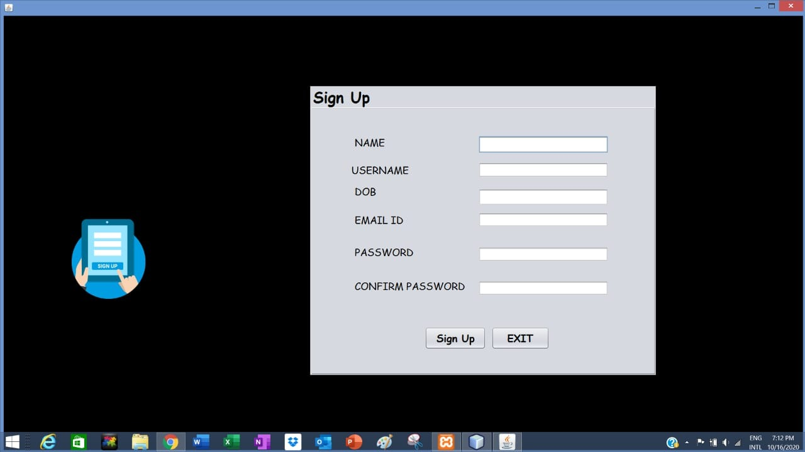

**This page allows you to sign up for the first time and enter your details if you are not an existing user.**

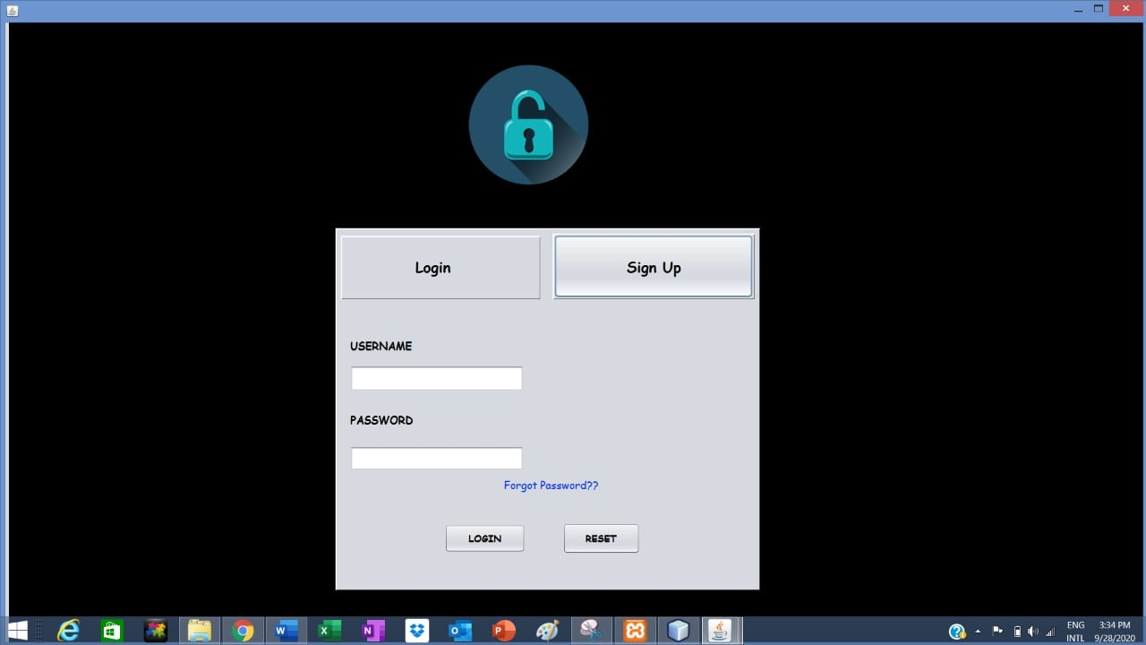

**This is the index page (first page) through which we can log in and signup.**

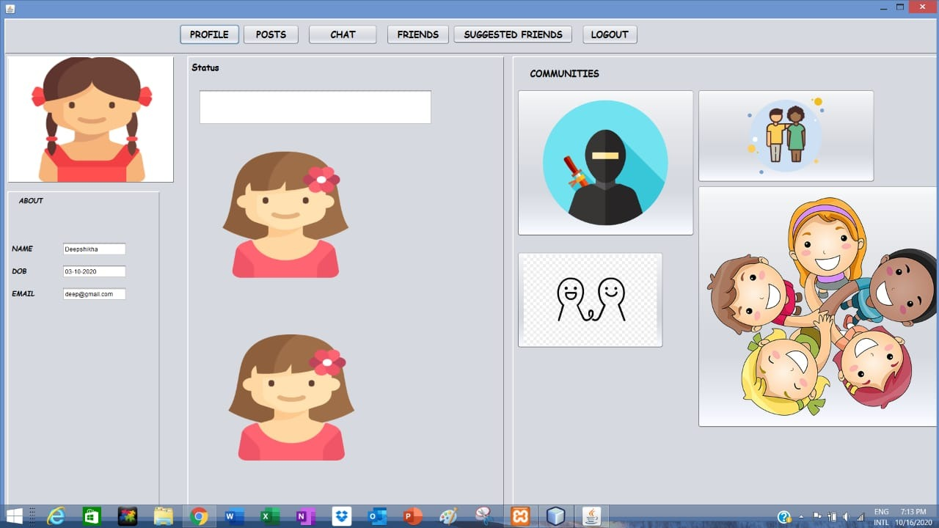

**Profile section where we can see your details.**

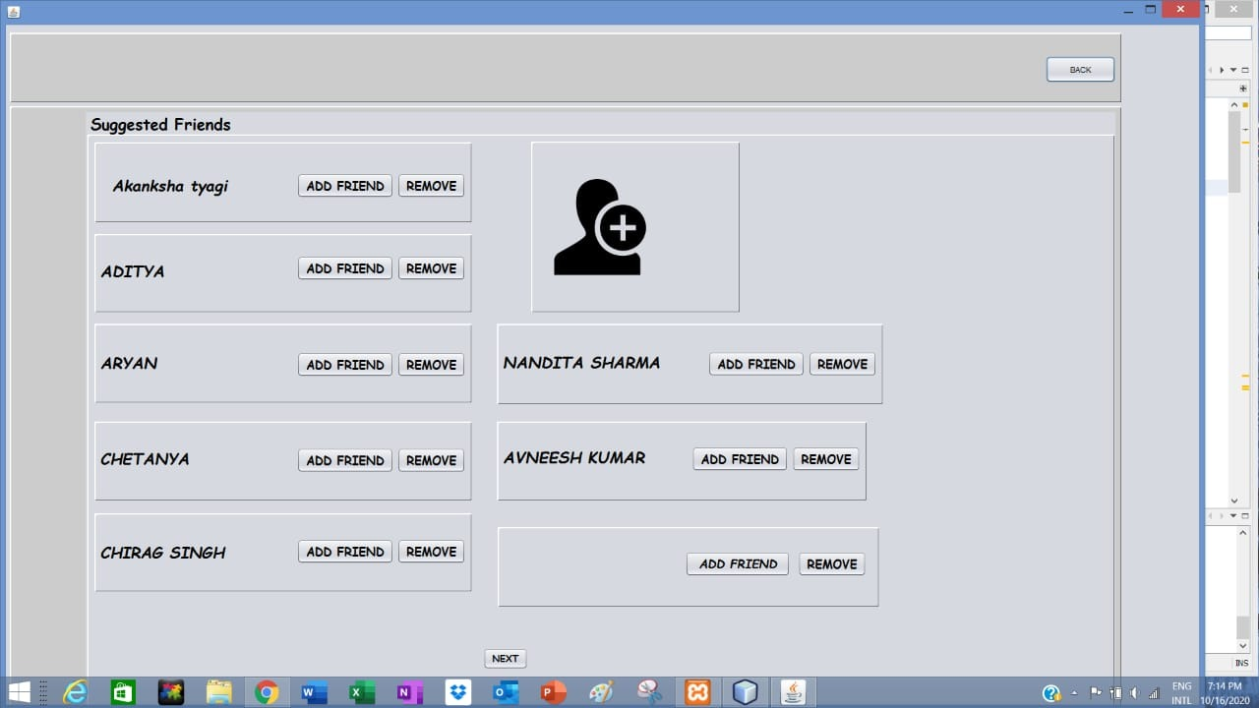

**This section suggests the list of friends**

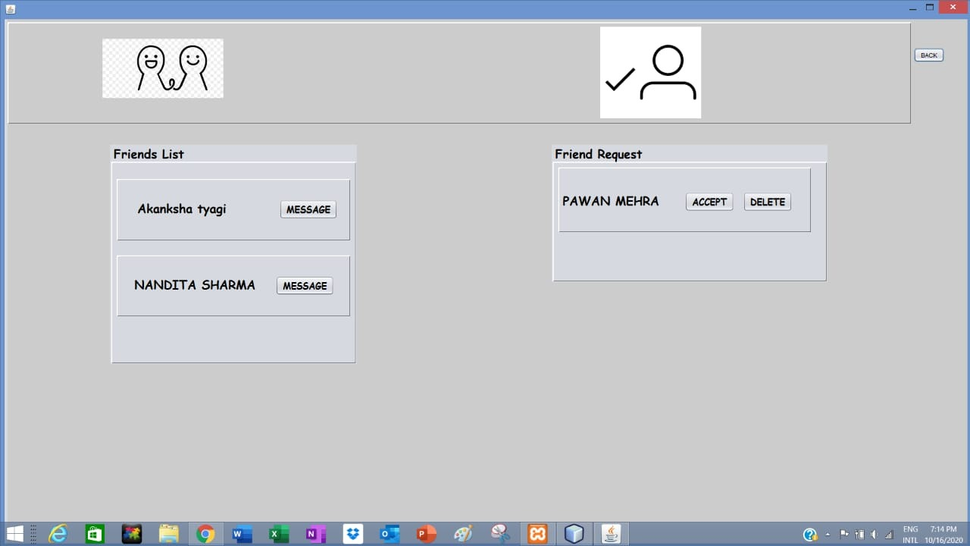

**Here you can see your friends list and your friend request. according to which you can message any individual and can also accept any friend req.**

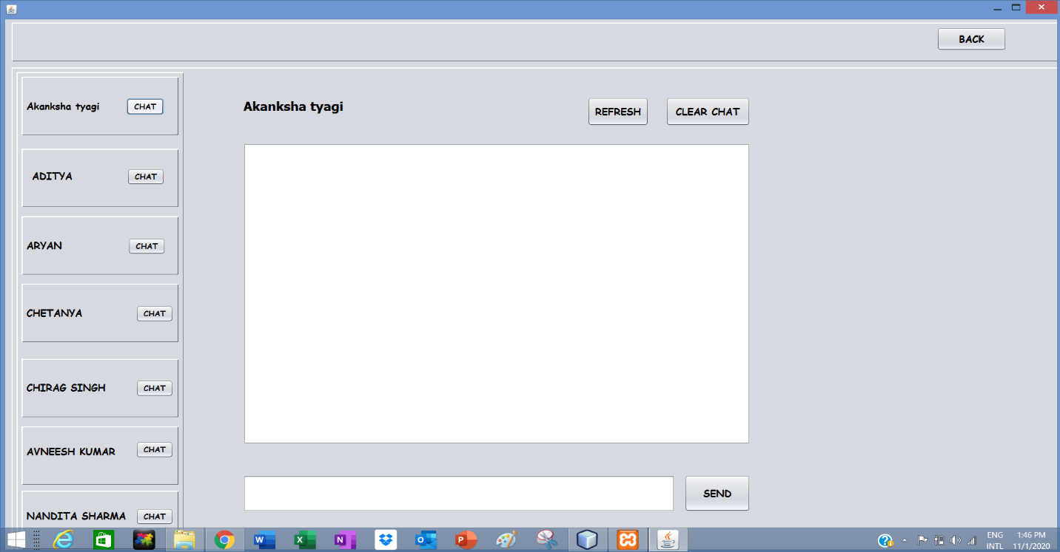

**This section is for a chat where you can send message to a friend.**

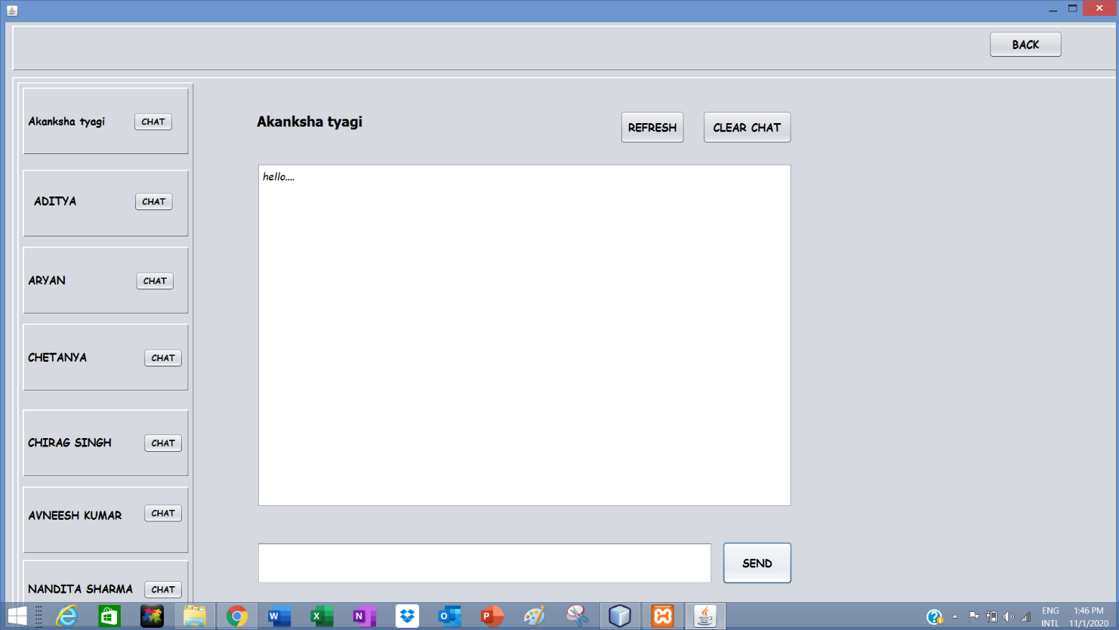

**Select friends and then start a chat.**

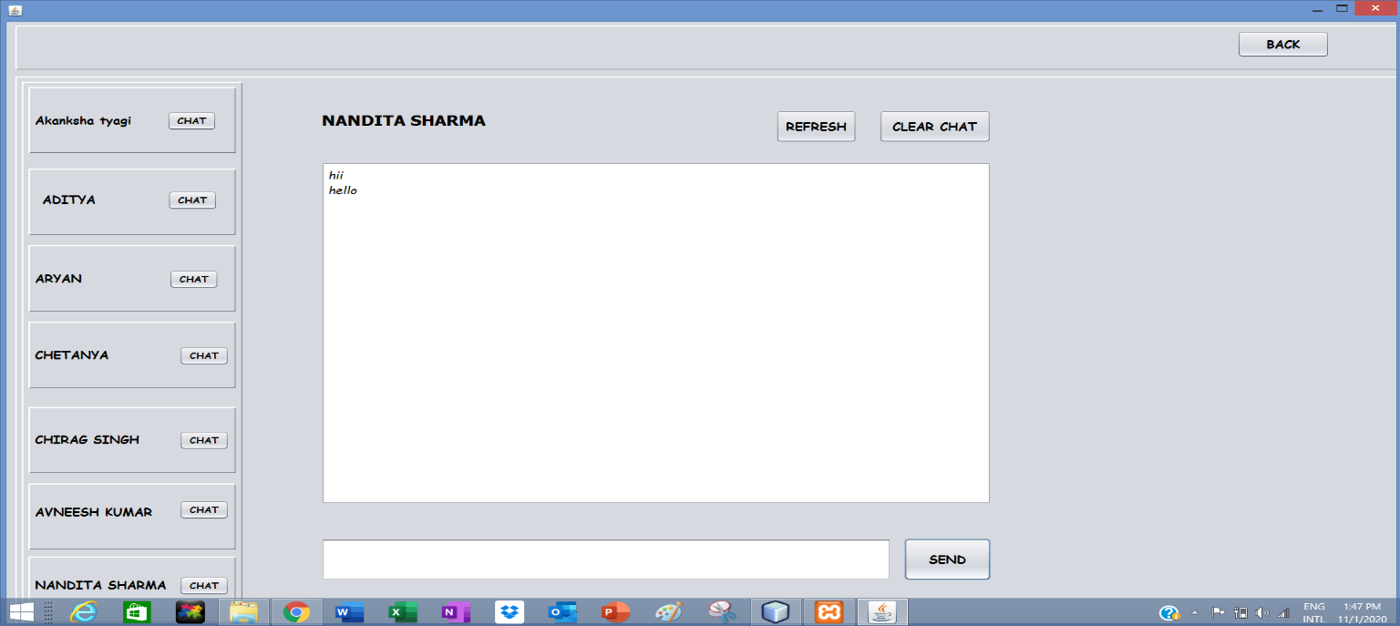

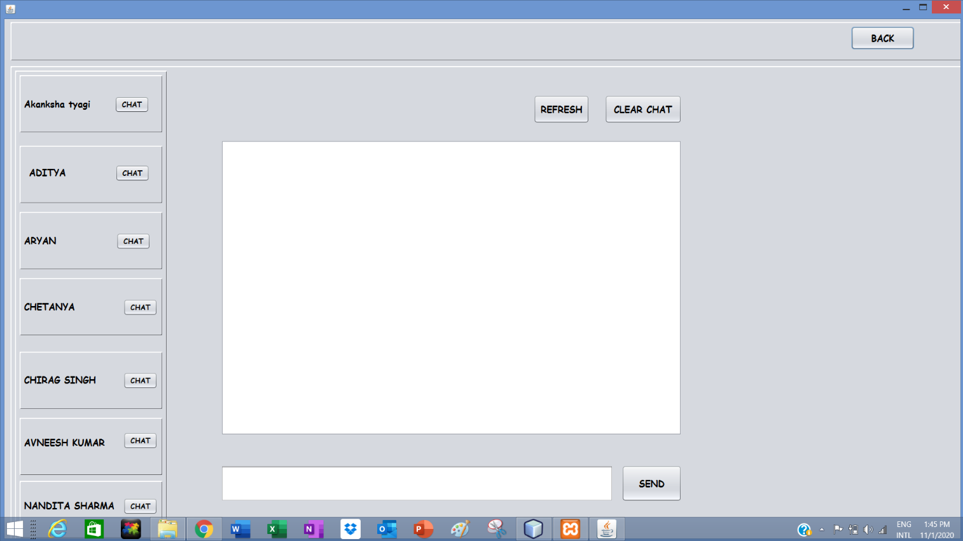

**The clear option is for temp. clean the screen.**

**Conclusion and Future Works**

In this proposed system, we developed the social networking with local area network. Here we are just creating a “client-server application” which acts like a social networking module in the internet and also provides all the facilities that are existing in networking websites. It can be so helpful for the people who are working in the LAN to communicate with others through scraps and chat and can also share the photos. Here compared to WAN, accessing speed in LAN is more.

**We are working on message group and live intraction through our prject and also improving algo. for friends sugg. sytem.**

**References**

<https://www.geeksforgeeks.org/java/>

<https://netbeans.org/kb/docs/java/quickstart.html>

<https://www.geeksforgeeks.org/a-group-chat-application-in-java/>

<https://projectabstracts.com/1088/mini-orkut-using-java.html>

**\*\*\*End of Document\*\*\***